Hampstead Neighbourhood Forum

Over-sized Service, Delivery and Construction Vehicles

Evidence of Impact in Plan Area

The pictures reproduced below, supplied by Hampstead businesses and residents, indicate the area-wide impact of the inappropriately sized vehicles for service, delivery and construction use within the Plan area.

The key impacts recorded are :-

- Damage to kerbs, walls and street furniture, incurring renewal costs.
- Traffic congestion caused by the full or partial blockage of roads
- Safety impact on pedestrians resulting from the blockage of important sight-lines
- Disfigurement of streetscapes and important local views affecting the quality of life of residents and the attractiveness of Hampstead as a commercial centre.

Damage to Walls, Kerbs and Street Furniture

Church Row
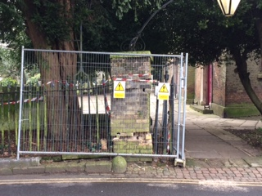

High Street

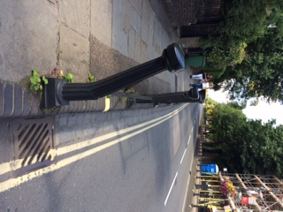

Church Row

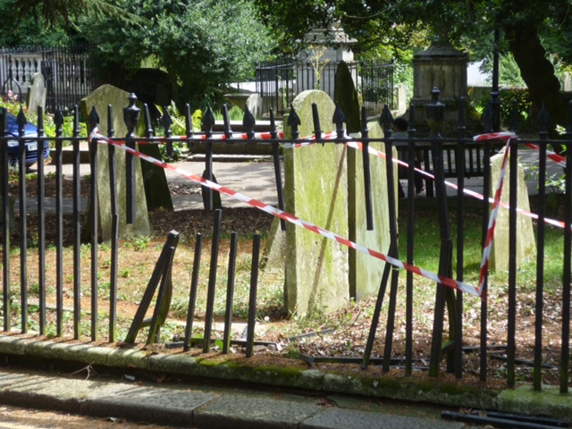

High Street

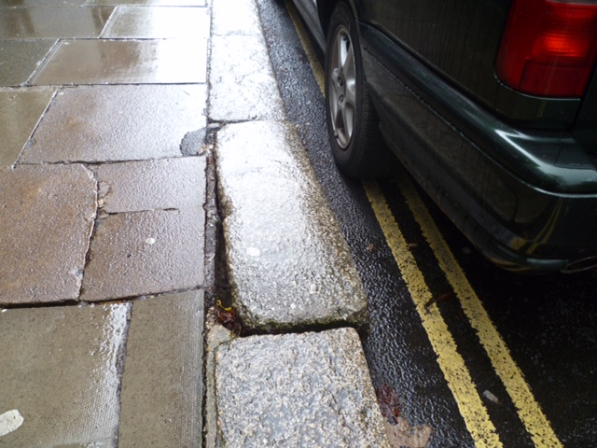

Church Row – repairs to damaged width restriction

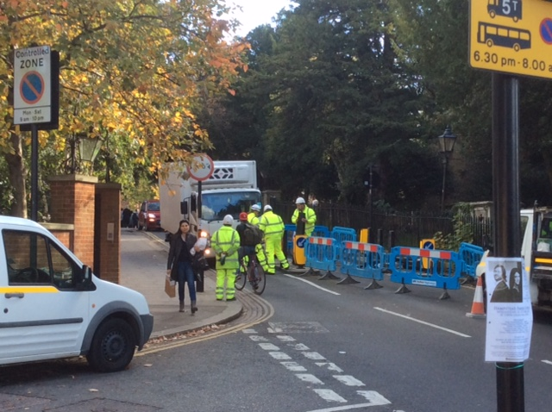

Traffic Congestion

Holly Bush Vale

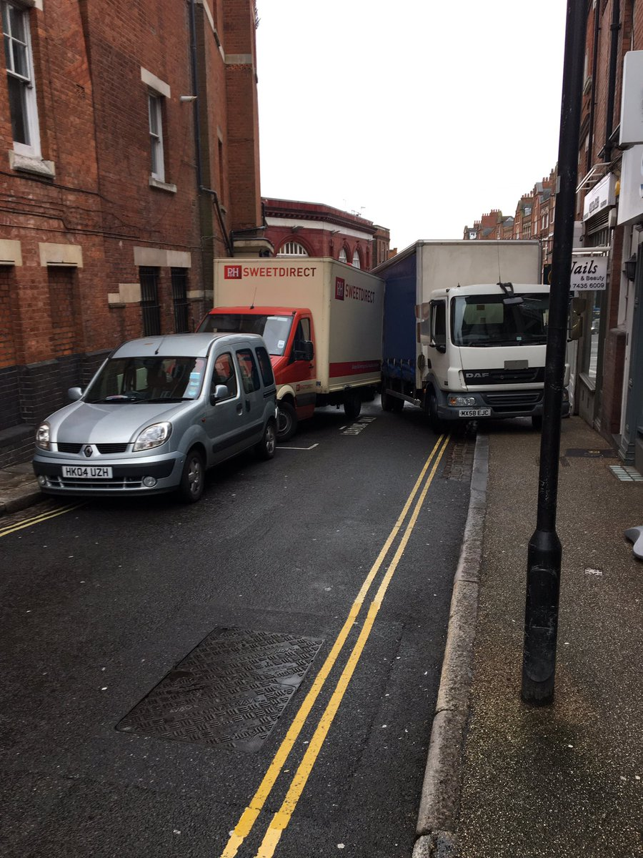

High Street
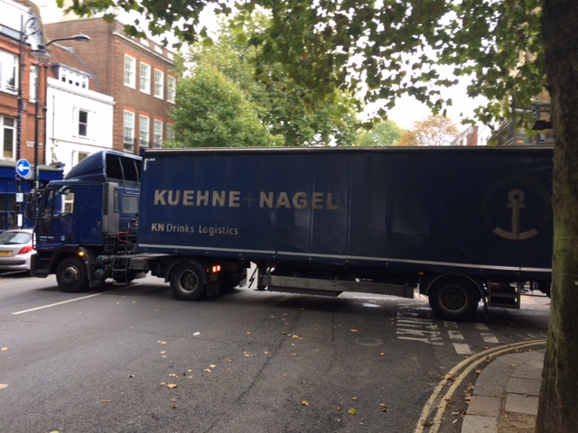

Church Row
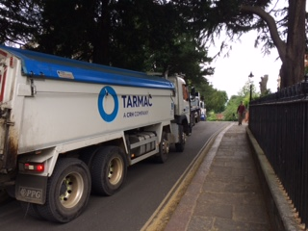

Hampstead Square – parked vehicle
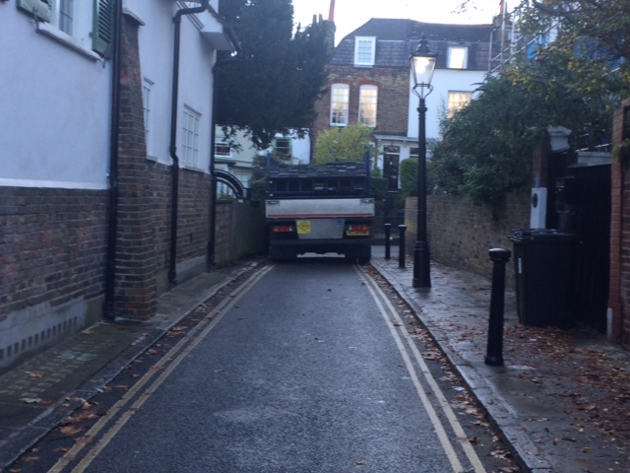

Heath Street
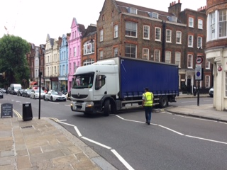

Heath Street
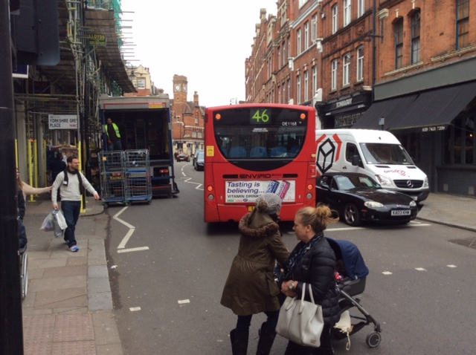

Heath Street
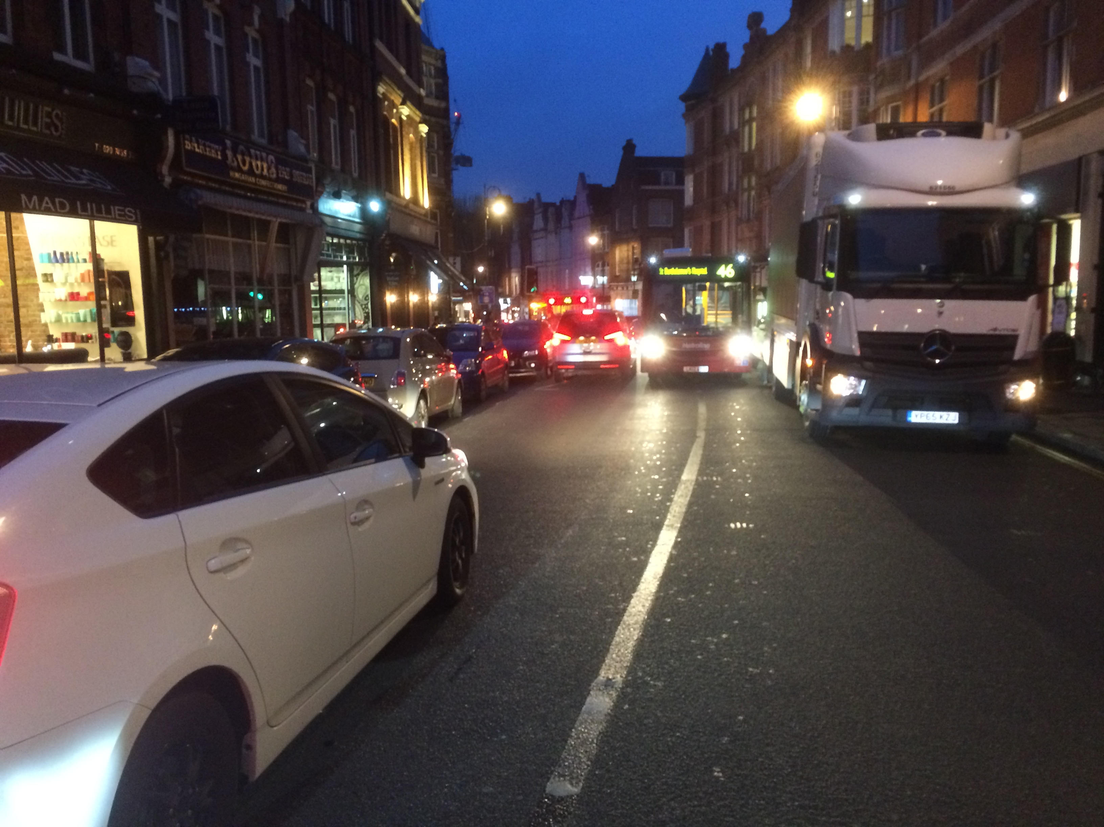

Heath Street
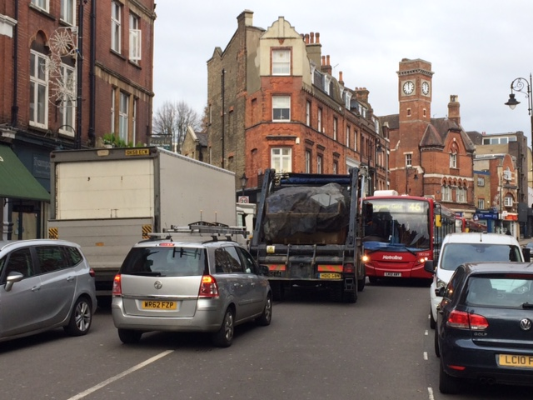

Safety Impact

High Street

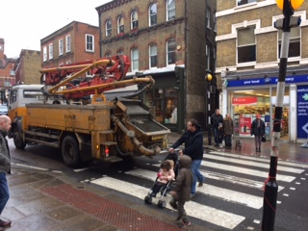

Heath Street

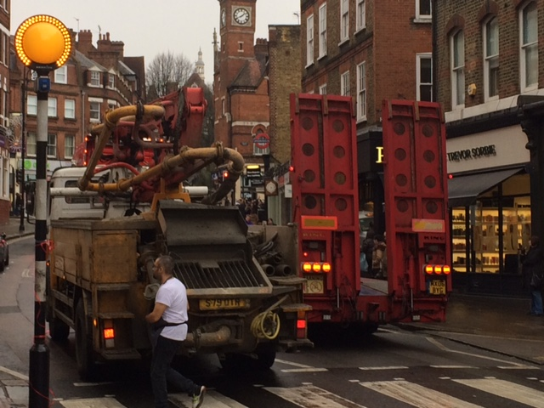

Heath Street


