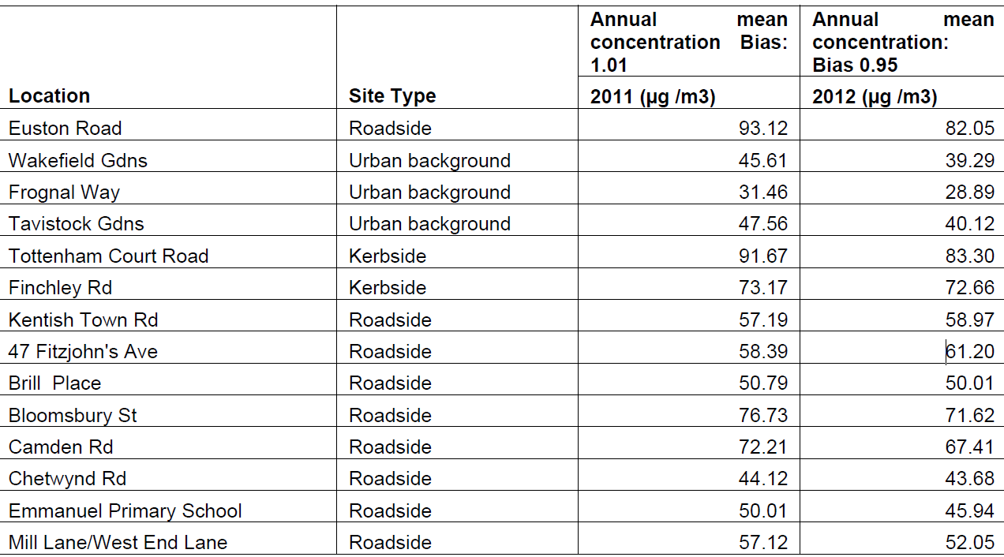

Highate Green Party data from 2013 using diffusion tubes over a period of 1 month

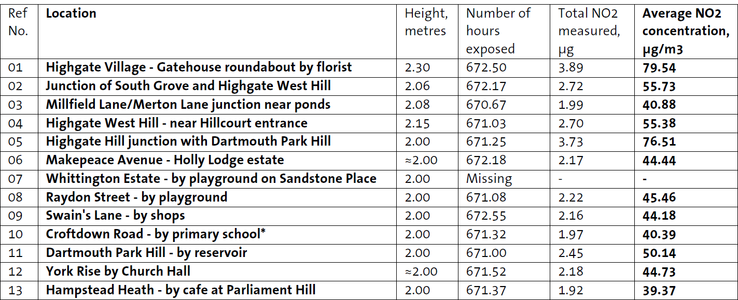

NO2 (Nitrogen dioxide) 40 max. ¼ from power stations, ½ from motor vehicles, rest from industrial and domestic combustion

PM (Particulate Matter) 40 max. 80% generated by road traffic, followed by construction sites

NO emissions sources

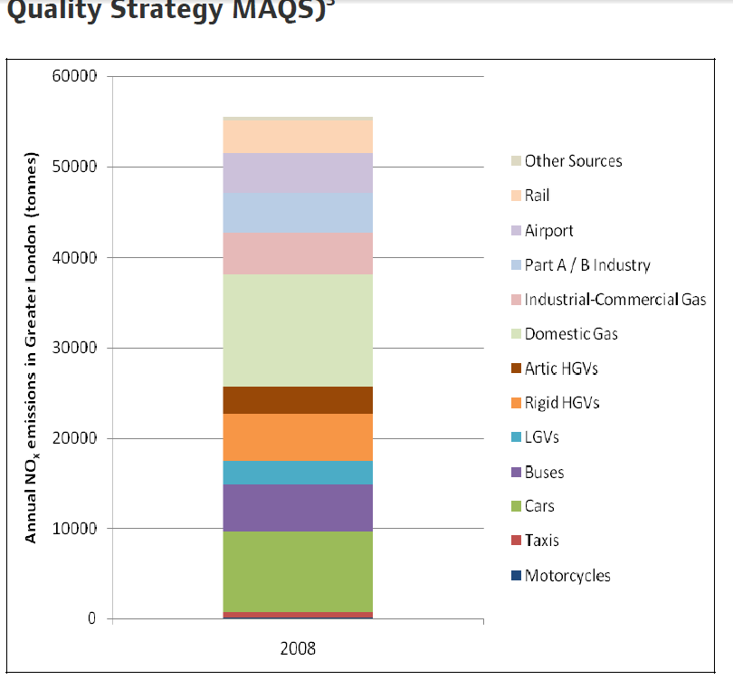

PM10 emission sources

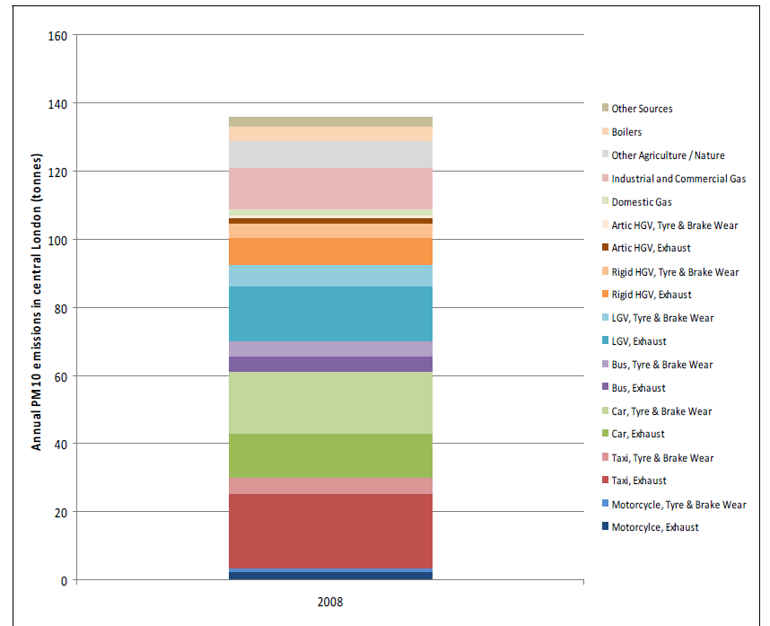

Air pollutants

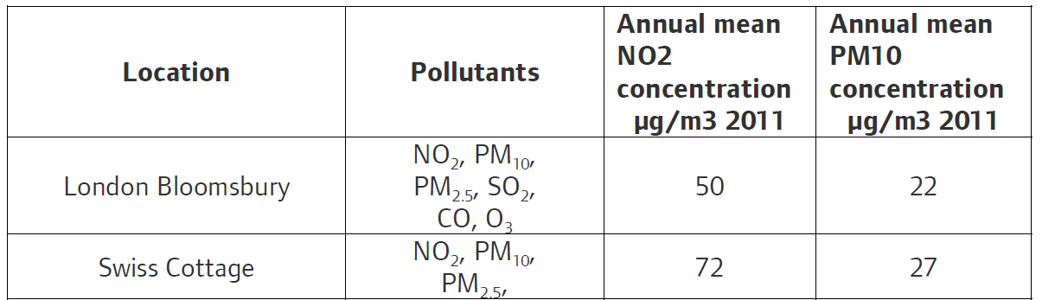

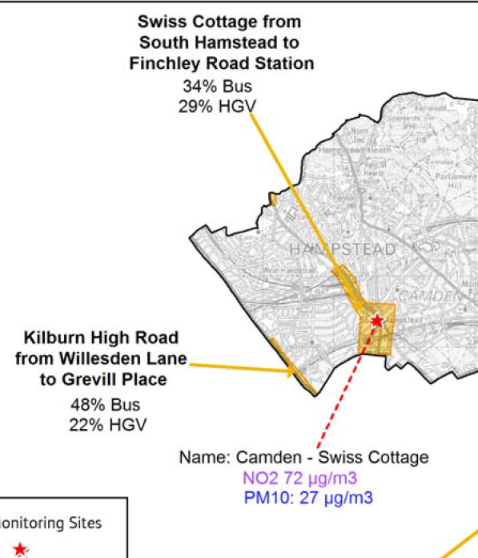

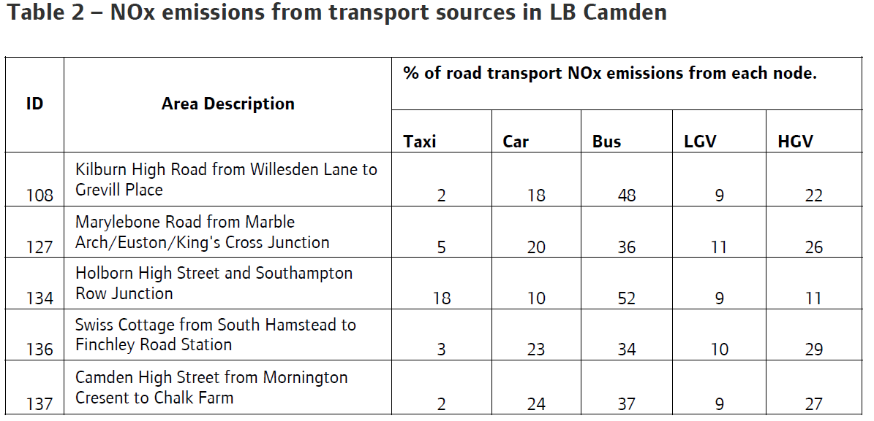

Recent Pollution episodes

