**Edited extract from Unified Screening Assessment 2015**

**Air Quality Monitoring Data: May 2015**

The following tables represent monitoring data from Camden’s diffusion tube monitoring network and its automatic monitoring stations. This data is being provided to Defra as part of Camden’s statutory duties as an Air Quality Management Area. The data for 2014 has not yet been ratified by Defra and therefore is not currently publically available; as such figures for 2014 should be read as provisional and subject to change.

The data in this document represents Camden’s monitored air quality levels. For more information on the data collected and how it compares to European emission targets, please visit the relevant page of the Camden website ([here](http://camden.gov.uk/ccm/content/environment/air-quality-and-pollution/air-quality/twocolumn/policies-reports-and-research/?page=2)).

Adam Webber, Senior Sustainability Officer (Air Quality); [adam.webber@camden.gov.uk](mailto:adam.webber@camden.gov.uk); 0207 974 2901

1. **Diffusion tube monitoring**

**Locations:**

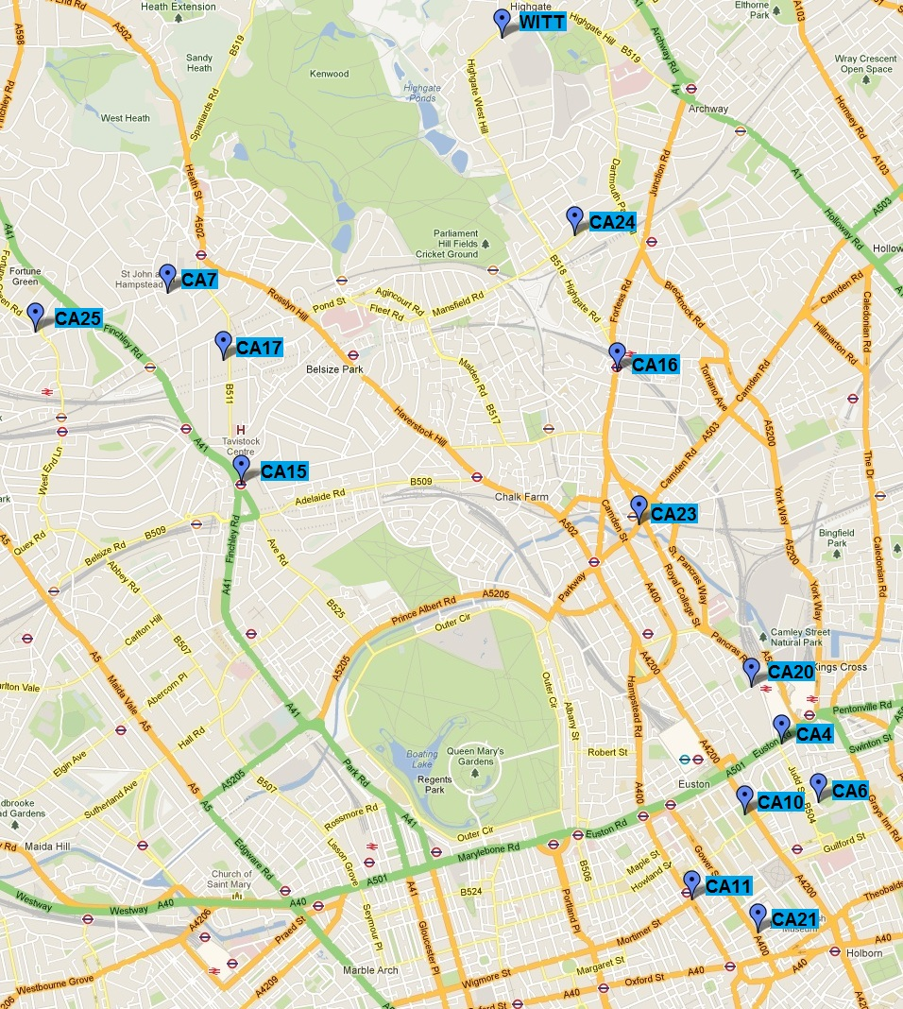

**Results:**

Nitrogen Dioxide

| **Site ID** | **Location** | **Annual mean concentration (adjusted for bias) μg/m3** | | | | |
| --- | --- | --- | --- | --- | --- | --- |
| **2010\***  **(Bias Adjustment Factor = XX)** | **2011\***  **(Bias Adjustment Factor = 0.95)** | **2012\***  **(Bias Adjustment Factor = 0.95)** | **2013\***  **(Bias Adjustment Factor = 1.00)** | **2014**  **(Bias Adjustment Factor = 0.97)** |
| CA4 | Euston Road | **82** | **93.12** | **82.05** | **107.75** | **89.74** |
| CA6 | Wakefield Gardens | 34 | **45.61** | 39.29 | **40.32** | 36.44 |
| CA7 | Frognal Way | 29 | 31.46 | 28.89 | 31.95 | 28.55 |
| CA10 | Tavistock Gardens | **52** | **47.56** | **40.12** | **49.37** | **46.50** |
| CA11 | Tottenham Court Road | **92** | **91.67** | **83.30** | **88.09** | **86.75** |
| CA15 | Swiss Cottage | **71** | **73.17** | **72.66** | **83.08** | **74.34** |
| CA16 | Kentish Town Road | **74** | **57.19** | **58.97** | **65.32** | **57.83** |
| CA17 | 47 Fitzjohn’s Road | **73** | **58.39** | **61.20** | **65.24** | **60.30** |
| CA20 | Brill Place | **54** | **50.79** | **50.00** | **49.37** | **52.34** |
| CA21 | Bloomsbury Street | **41** | **76.73** | **71.66** | **76.08** | **80.82** |
| CA23 | Camden Road | **84** | **72.21** | **67.40** | **77.85** | **72.21** |
| CA24 | Chetwynd Road | **68** | **44.12** | **43.67** | **47.75** | **44.76** |
| CA25 | Emmanuel Primary | **-** | **41.5** | **45.94** | **57.91** | **48.36** |
| WITT | Wittanhurst Lane | **-** | **-** | **-** | **53.10** | **48.26** |

1. **Automatic Monitoring**

**Locations:**

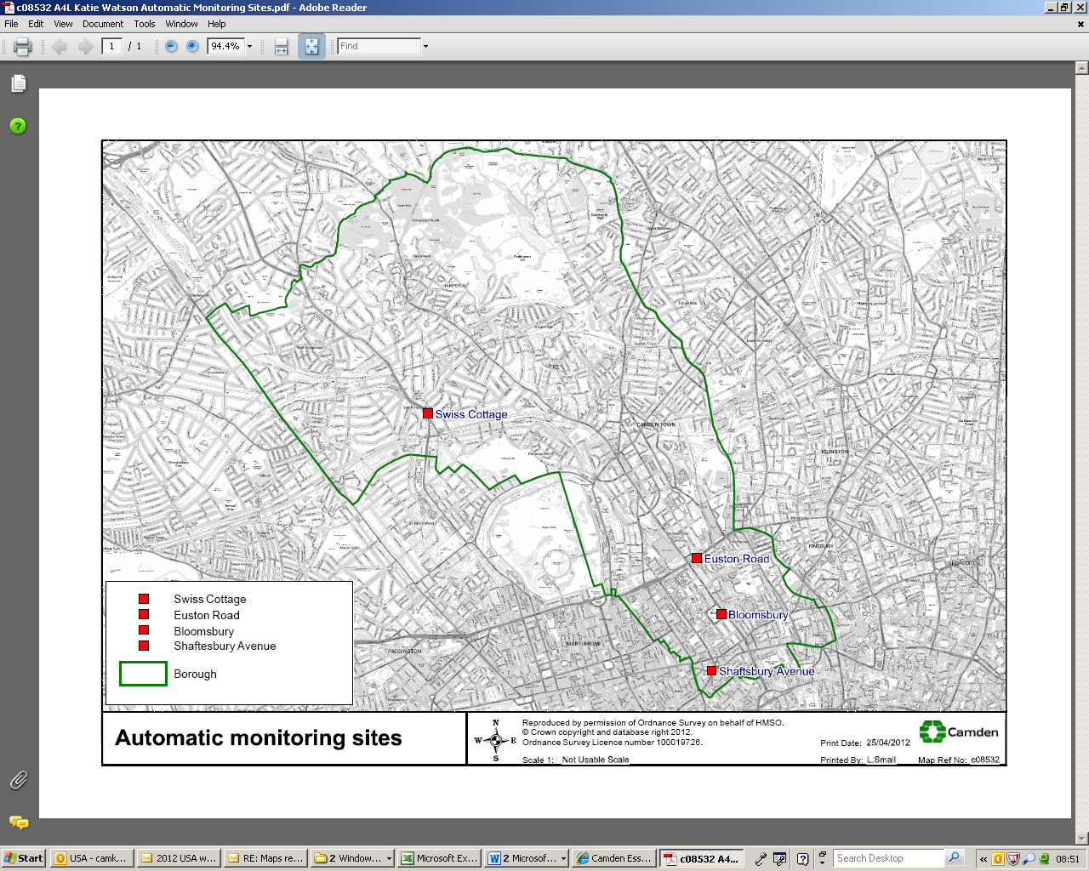

**Results:**

Nitrogen Dioxide

| **Site ID** | **Nitrogen Dioxide (NO2) Annual Mean Concentration μg/m3** | | | | |
| --- | --- | --- | --- | --- | --- |
| **2010* c** | **2011* c** | **2012* c** | **2013* c** | **2014 c** |
| LB: London Bloomsbury | 55 | 50 | **55** | **44** | **45** |
| CD1: Swiss Cottage | 82 | 71 | **70** | **63** | **66** |
| CD3: Shaftesbury Avenue | 89 | 76 | **71** | **74** | **69\*** |
| CD9: Euston Road | - | 122* | **106** | **106** | **98** |

PM10

| **Site ID** | **PM10 Annual Mean Concentration μg/m3** | | | | |
| --- | --- | --- | --- | --- | --- |
| **2010* c** | **2011* c** | **2012* c** | **2013* c** | **2014 c** |
| LB: London Bloomsbury | 18 | 22 | 19 | 18 | 20 |
| CD1: Swiss Cottage | 26 | 27 | 23 | 21 | 22 |
| CD3: Shaftesbury Avenue | 29 | 32 | 29 | 29 | 25 |
| CD9: Euston Road | - | - | - | - | 29 |