Location 23 – Gardnor Road

Tube reference number:

Map grid reference: 51.5571, -0.1760

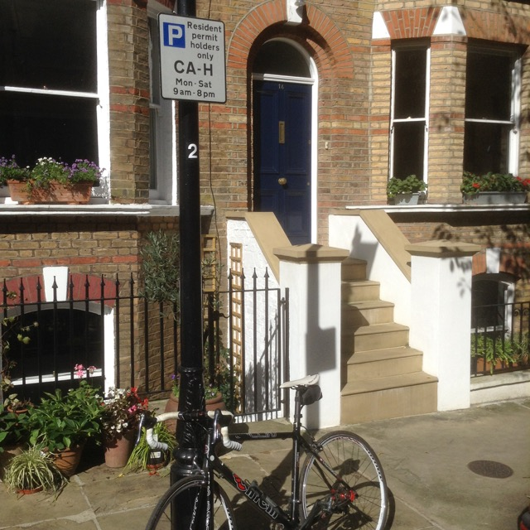 | 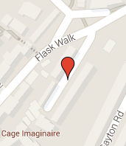

 | Install | Collect
Date
Time tube opened/closed
Height placed  between 2-3 m |  | N/A
Notes on site
(e.g. traffic diversion, road works)
Notes on tube condition  (e.g. found on ground, insect or liquid inside tube) | N/A

