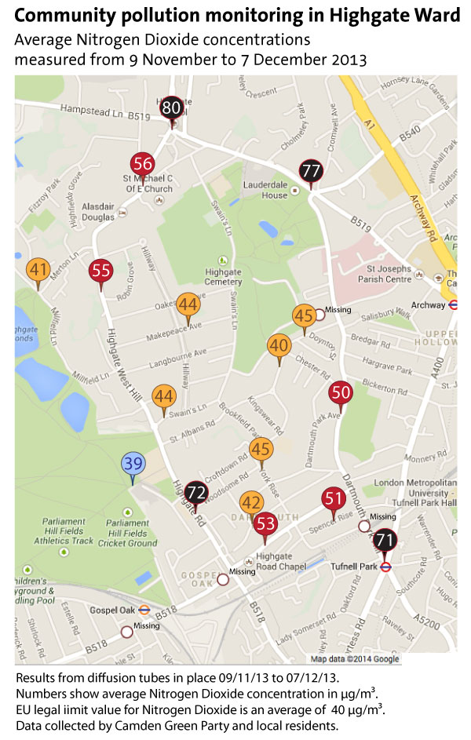

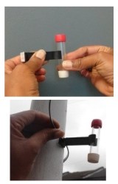
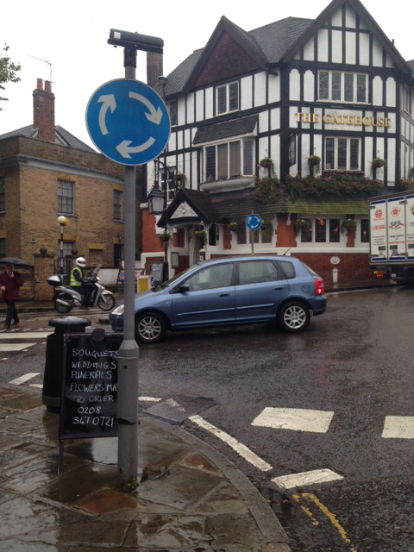
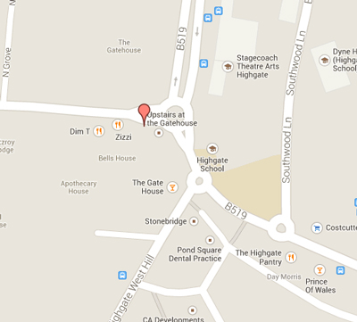
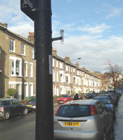
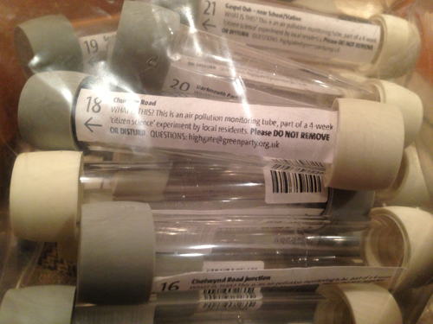
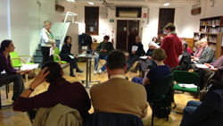
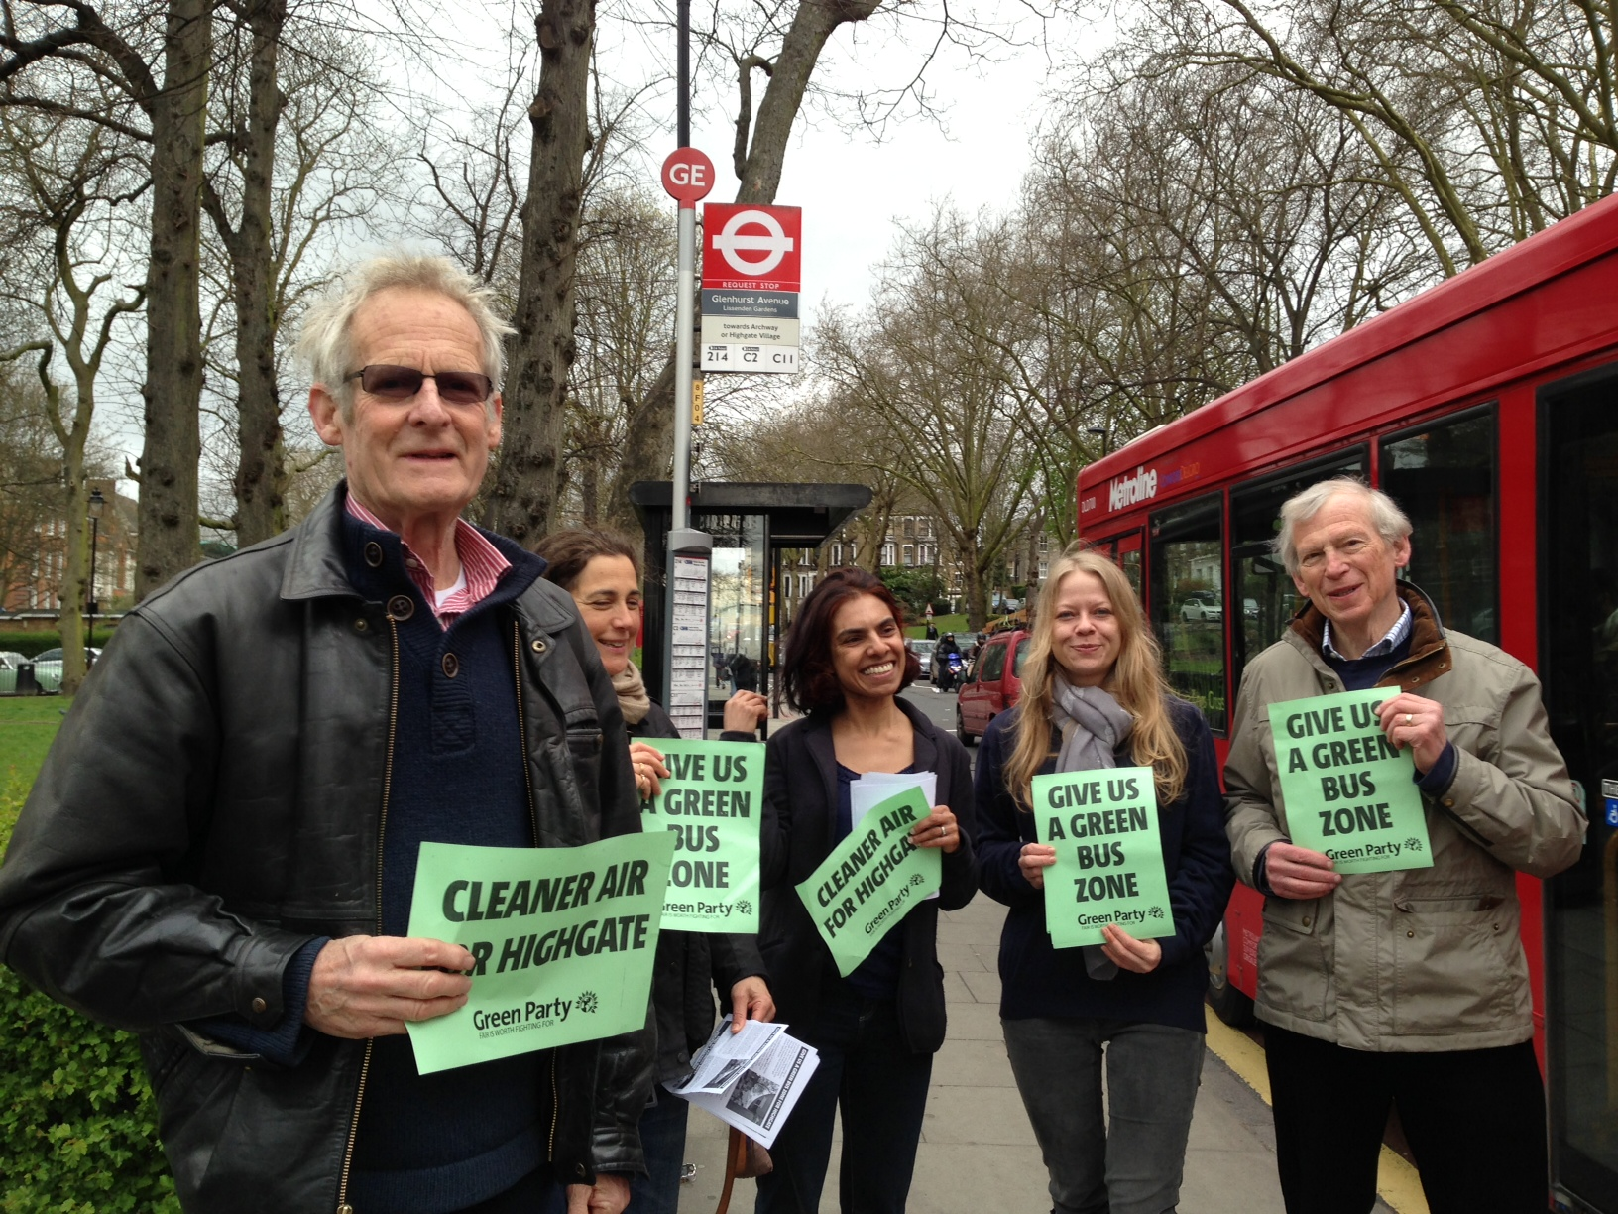
Putting up the NO₂ diffusion tubes

READ through the instructions carefully before starting. Do not remove any cap from the tube until it is fixed in place
Locate Find the correct location to put up your diffusion tube. Make sure the reference number on the tube matches the one for the location.

Assemble Position the tube vertically and insert into holder with WHITE cap facing downwards. Attach cable ties if fixing to a pipe or lamppost.

Fix the tube in place at a height of about 2.2m above the ground (stretch arms above your head) in a secure position. Make sure there is free circulation of air around the tube, but putting it in amongst traffic signs on a post is ok, as long as the tube isn’t actually touching the signs. Once in place, measure the actual height it’s placed at and write this on the record sheet.

Info Each tube has a sticker on it with info about
what it is, and contact details for the Forum if
people have questions. A slightly larger version of the sticker is provided too, and this can be stuck on the post somewhere at head height (with the arrow pointing at the tube) to help explain to curious people why they shouldn’t touch it. You also have small A5 info sheets, which you can give to any passers-by who ask what you’re doing. This has contact details for us on, so you can refer them to us if they have questions, rather than get involved in a long chat!

Remove the WHITE cap (which should be facing downwards) and leave tube for its 4-week exposure period.

Fill in the record sheet ensuring the date and time is recorded. Double check the reference number matches the correct sheet (If you have got two mixed up, don’t worry, just cross out and write in the correct reference numbers so we know which ones ended up where).

Keep safe and bring back the cap and record sheets to base at 14 Denning Road.

Finally, if you can take any camera phone pics of the tube in place and (if you’re willing) of you putting them up, that would be brilliant for our records and website etc. Email them afterwards to info@hampsteadforum.org

Any problem or question at any location: call Gus for advice on 07918 533858. (In an emergency: the Forum secretary, Stephen Taylor, on 07713 400852.)

