# Air pollution monitoring workshop

17 August 2015

Main steps in brief:

1. **Decide on the locations to monitor** 
   * Map them (see page 2 – use google maps – ‘my maps’)
   * Make sure to include control locations
2. **Order tubes from Gradko** 
   * See page 3
3. **Set dates for two action days**
   * These need to be 3-4 weeks apart and exclude school holidays (and bonfire night if possible)
   * Recruit volunteers
4. **Make plans and prepare materials for action days**
   * Visit all the locations and decide exactly where to put tubes
   * Pay attention to placing them near kerbs and at suitable heights
   * Take photographs of the exact locations (to help volunteers)
   * Note grid references (google maps point info will show you)
   * See examples of instruction sheets on pages 4 to 8
   * Make a small leaflet for residents (see page 6)
5. **ACTION day 1 – putting up the tubes (keep the caps!)**
6. **Keep records (and back them up) during the experiment**
   * Use the table from the lab to record what’s on the individual site record sheets (see page 9)
   * Visit the sites to check on the tubes every so often – cry over any that go missing
   * Note anything unusual – e.g. a house fire, tube strike days, insects in the tubes
7. **ACTION day 2 – taking down the tubes**
   * Get volunteers to double check each location matches the tube that went up there (see info sheet on page 8)
   * Carefully enter the timing of removal on the sheet for the lab
   * Send off the tubes and record sheets
8. **Map the results** 
   * Use google maps, or photoshop/MS paint etc on a copy of the ward map
9. **Release and publicise the results, and plan some action**
   * Press release
   * Online map and social media
   * Call a public meeting to plan local ideas and actions (see pages 11 and 12)

# Highgate map of locations and results

**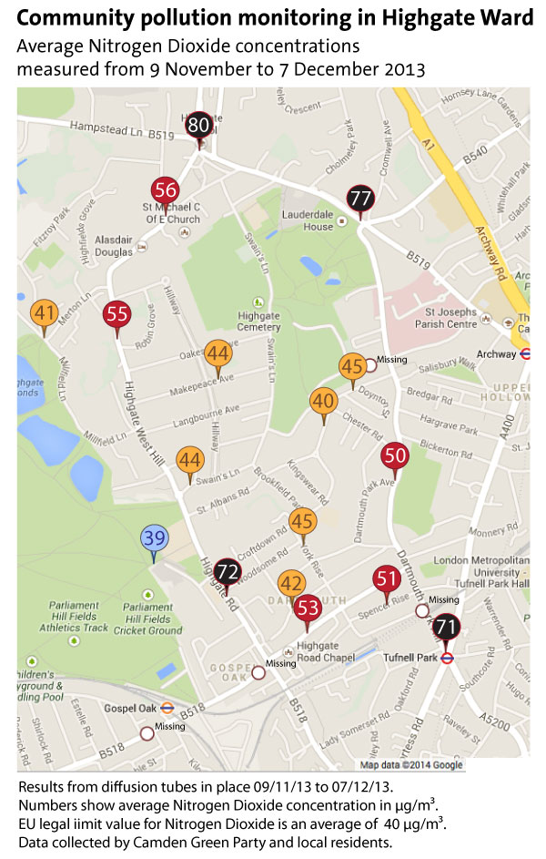**

# Gradko nitrogen dioxide diffusion tubes

[**http://www.gradko.com/environmental/products/no2-and-nitrogen-oxides-diffusion-tubes.shtml**](http://www.gradko.com/environmental/products/no2-and-nitrogen-oxides-diffusion-tubes.shtml)

Email or call to set up an account and order tubes.

Cost (approx £10 per tube) includes analysis.

The tubes can be ordered with little brackets and big cable ties – choose this option.

****

# Clear instructions for volunteers – 1. Putting up the tubes

**Collecting NO2 samples -­‐ Diffusion tube Procedure**

\*\*\* Please READ through the instructions carefully before starting. Do not remove any cap from the tube until it is fixed in place \*\*\*

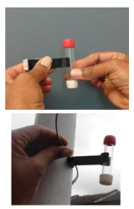

LOCATE: Find the correct location to put up your diffusion tube. Make sure the reference number on the tube matches the one for the location.

ASSEMBLE: Position the tube vertically and insert into holder with WHITE cap facing downwards. Attach cable ties if fixing to a pipe or lamppost.

FIX the tube in place at a height of 2m above the ground in a secure position. Make sure there is free circulation of air around the tube, but putting it in amongst traffic signs on a post is ok, as long as the tube isn’t actually touching the signs. Once in place, measure the actual height it’s placed at and write this on the record sheet.

INFO: Each tube has a sticker on it with info about  
what it is, and contact details for Highgate Greens if  
people have questions. A slightly larger version of the  
sticker is provided too, and this can be stuck on the post somewhere at head height (with the arrow pointing at the tube) to help explain to curious people why they shouldn’t touch it. We’ll also give you small A5 info sheets, which you can give to any passers by who ask what you’re doing. This will also have contact details for us on, so you can refer them to us if they have questions, rather than get involved in a long chat!

REMOVE: the WHITE cap which should be facing downwards and leave tube for its 4 week exposure period.

WRITE: Fill in the record sheet ensuring the date and time is recorded. Double check the reference number matches the correct sheet (If you have got two mixed up, don’t worry, just cross out and write in the correct reference numbers so we know which ones ended up where).

KEEP SAFE AND BRING BACK: the cap and record sheets to base at 13 Kingswear Road.

**Finally, if you can take any camera phone pics of the tube in place and (if you’re willing) of you putting them up, that would be brilliant for our records and webite etc. Email them afterwards to** [**highgate@greenparty.org.uk**](mailto:highgate@greenparty.org.uk)

**Any problems at any of the locations, or any other questions: call Sian for advice on 07900 523496**

# Clear instructions for volunteers - 2. Location record sheets

## Location 1 - Highgate Village – junction by Gatehouse

## Tube reference number: 249248

## Map grid reference: -0.14977991580963135,51.5712467199432

|  |  |  |
| --- | --- | --- |
| 1_HighgateVillage.JPG | 1_Highgate_Village.jpg | |
| Details | Fill in when putting out tubes | Fill in when taking in tubes |
| Date | 9/11/13 |  |
| Time tube opened/closed | 13.38 |  |
| Height placed (between 2 and 3m) | 2.30 m |  |
| Notes on site (e.g. traffic diversion, road works) |  |  |
| Notes on tube condition (e.g. found on ground, insect or liquid inside tube) | N/A |  |

# Clear instructions for volunteers – 3. Info for neighbours

These were printed up as A5 sheets to put through a few doors nearby and to give to anyone who asked what was going on

Dear local resident,

**AIR POLLUTION MONITORING ON YOUR STREET**

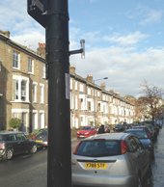

This is just to let you know that an air pollution monitoring tube has been put up near your home.

There are 21 of these going up around Highgate for the next 4 weeks, as part of a ‘citizen science’ experiment by local residents, alongside volunteers from Highgate Green Party.

The monitors are small glass tubes attached to lampposts and parking posts, and these will collect pollutants during the time they are fixed in place. After 4 weeks, our volunteers will return to collect them and send them off to a lab to be analysed.

We’ll inform local residents of the results and we hope these will be useful to see what pollution we are breathing as we go about our daily lives, to see which streets are better and worse, and to prompt some new ideas to help reduce traffic and congestion in our area.

During the experiment, please do not remove or disturb the tubes. If you notice the tube near you has gone missing or been damaged, please let us know.

Or if you have any questions at all, please contact Sian Berry at highgate@greenparty.org.uk.

# Clear instructions for volunteers – 4. Collecting in the tubes

# Collecting NO2 samples - Diffusion tube collection process

\*\*\* Please READ through the instructions carefully before starting. \*\*\*



LOCATE: Find the correct location of your diffusion tube. If the tube is missing, note this on the sheet and go straight to ‘SNIP’ to collect the bracket.

CHECK: Check the tube is intact. Note anything odd on the record sheet – e.g. liquid, insects in the tube (leave them in). Also make a note is there are road works or anything that may be dramatically affecting traffic flows like that.

REMOVE: Take the tube out of the bracket carefully. It should click out when twisted.

CAP: Seal the bottom end with the white rubber cap. Place it in the plastic bag.

SNIP: Cut the cable tie holding the bracket onto the post and don’t leave any bits behind.

WRITE: Fill in the record sheet with the date and time. Double check the reference number of your tube matches the correct sheet.

BRING BACK: Everything, including the record sheet, to base at 13 Kingswear Road.

**Finally, if you can take camera phone pics of the tube in place and (if you’re willing) of you taking them down, that would be brilliant for our records and website etc. Email them afterwards to** [**highgate@greenparty.org.uk**](mailto:highgate@greenparty.org.uk)

# Any problems at any of the locations, or any other questions: call Sian for advice on 07900 523496

# Labels for tubes

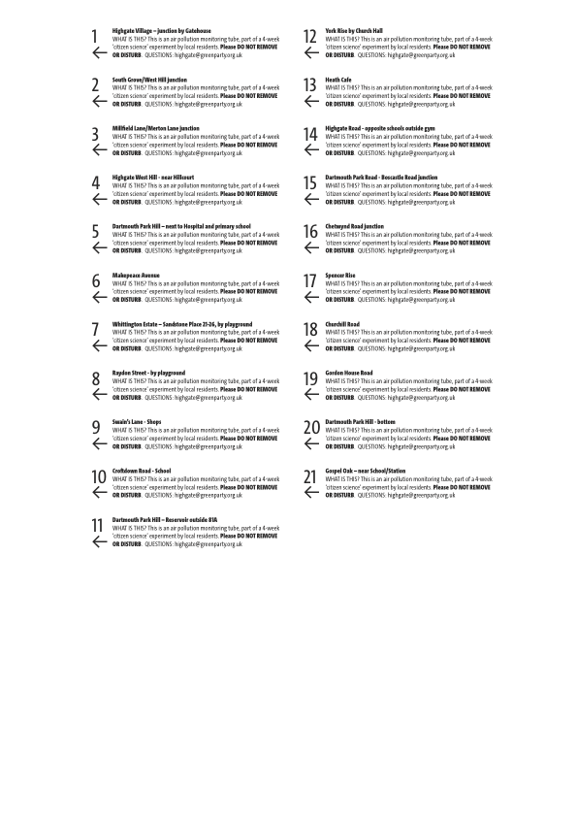You need to put numbers on the tubes to correspond with your tables and instructions

# tubes-in-bag_small.jpgRecord sheet

**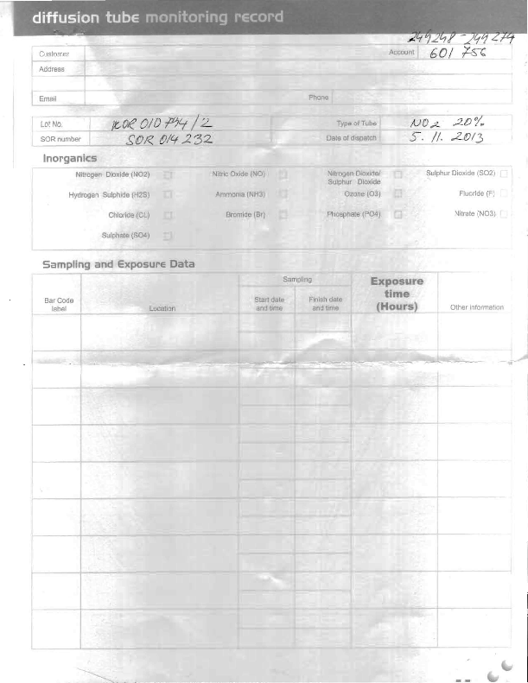**

# Results

**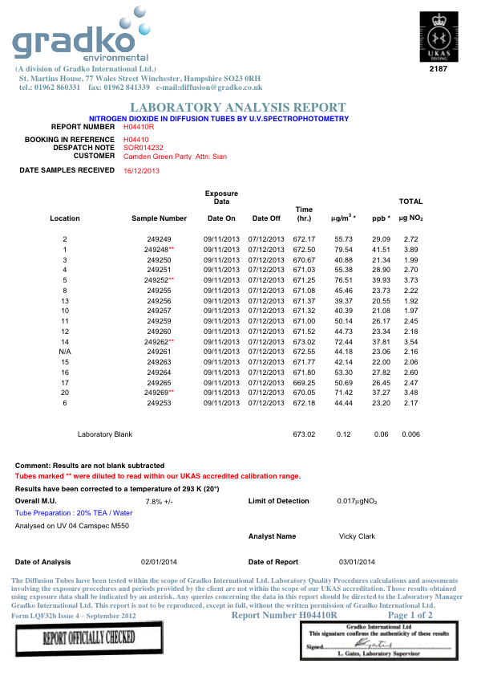**

# Public meeting

**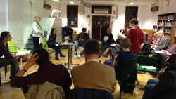**

**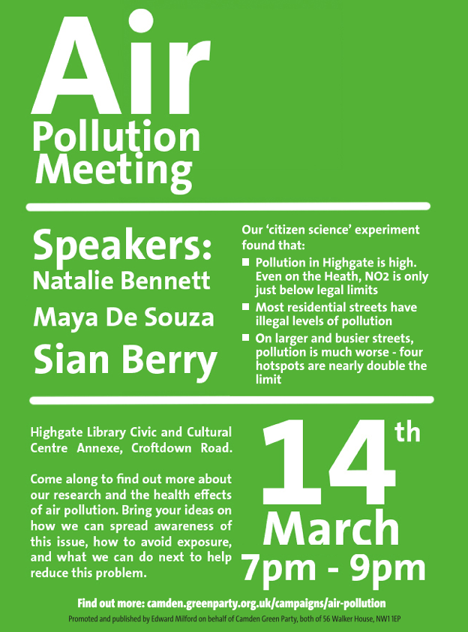**

# Information and action:

**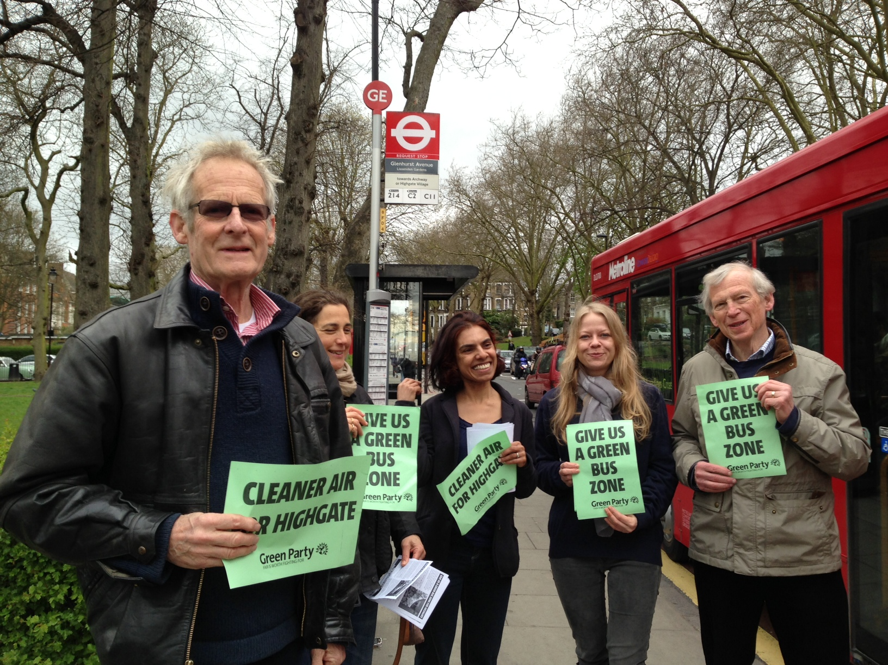**

**Report:** <https://camden.greenparty.org.uk/campaigns/air-pollution.html>

**Press release:** <https://camden.greenparty.org.uk/news/2014/01/23/230114-air-pollution/>

**Action plan following public meeting:** <https://camden.greenparty.org.uk/news/2014/03/21/210314-green-bus-zone-highgate/>

**Our actions:**

**1. Education and schools**

With many primary and secondary schools in the area, Maya and Sian will be writing to Headteachers to propose working together on ways to reduce traffic and pollution, including:

* + Getting pupils involved in monitoring pollution and raising awareness, as part of the curriculum
  + Working with parents and pupils to improve travel plans and reduce the number of cars bringing children to school, through car sharing, and more walking and cycling

**2. Raising awareness and providing information**

Everyone agreed there was a lack of awareness of the extent of pollution and the risks to health. Some of the ideas to improve things here were:

* + Provide information on choosing cleaner cars along with parking permits (e.g. diesel cars are up to 17 times worse than the equivalent petrol cars for particulate pollution and nitrogen dioxide)
  + Using social media to raise the profile of the problem and actions to improve things
  + Getting local papers to publish a weekly air pollution forecast with advice on how to reduce exposure

**3. Simple local actions to reduce emissions**

Idling vehicles and swapping diesel buses and vans for lower emission vehicles were particular targets for action, including:

* + Writing to supermarkets and postal companies to ask for our area to be prioritised for bicycle rounds and electric vans, and for idling to be reduced when making deliveries
  + Getting the council to create a bigger incentive to chose smaller petrol vehicles through residents’ parking permits, and to write to drivers when sending out permits with information on eco-driving and turning off engines when stuck in traffic
  + A petition to ask the Mayor and Transport for London for a ‘Green Bus Zone’ to target routes on Highgate High Street, Dartmouth Park Hill and Highgate Road for new hybrid buses