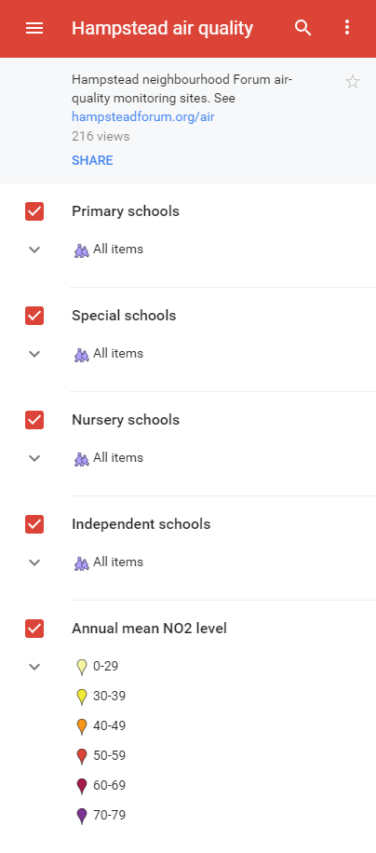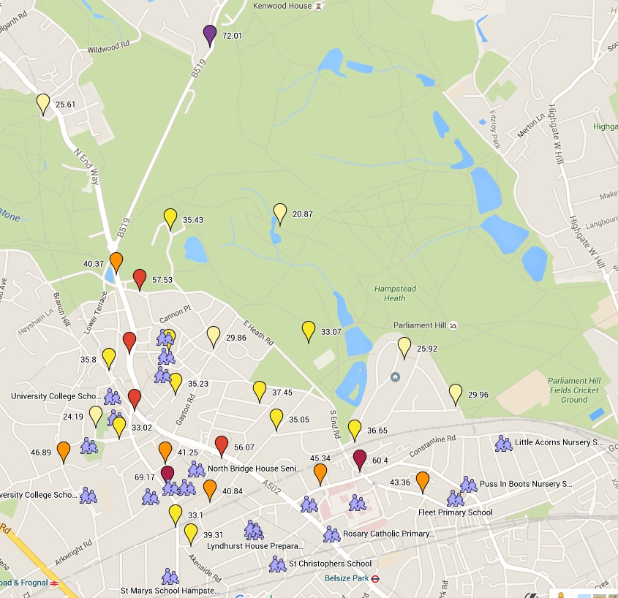

Hampstead Neighbourhood Forum Air Quality Monitoring Project – autumn 2015