Address | Species, proposer | Tree photograph
Branch Hill allotments | Sycamore and copper beech  Jeffrey Culpepper | 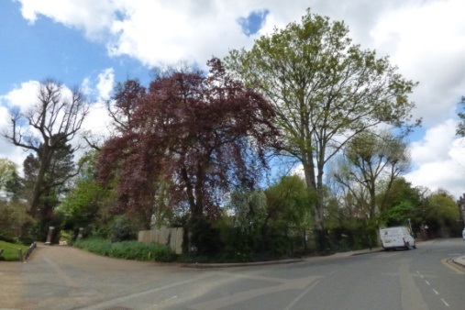
4 Carlingford Rd rear | Horse chestnut  Vivienne Menkes-Ivry  menkesiv@dircon.co.uk | 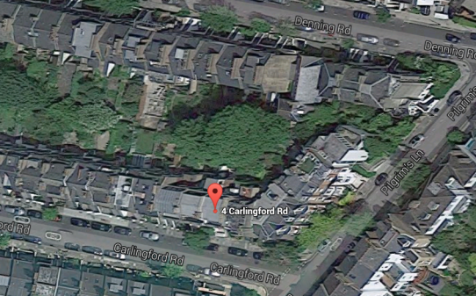  a mature tree which attracts squirrels and many birds.
1 Christchurch Hill. | Horse chestnut. N.B. Street Tree  Joanna Goldsworthy  joannagoldsworthy@hotmail.com  Also Hilary King  hilaryking@talktalk.net | 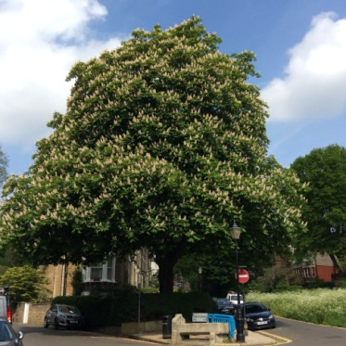 Magnificent tree, marking the junction at Christchurch Hill and Willow Road.
3 Downshire Hill | Oliver Froment  oliverfroment09@gmail.com  purple-leafed plum - prunus | 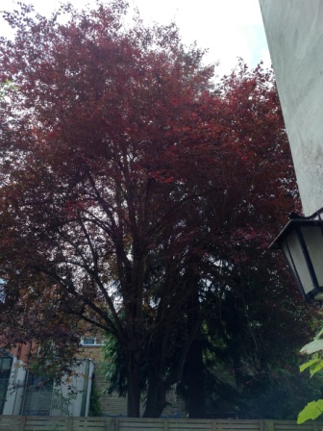
6 Downshire Hill | Horse chestnut  Margaret Rogers margaret.rodgers3@btinternet.com | 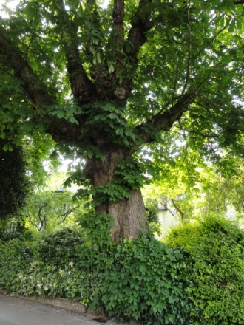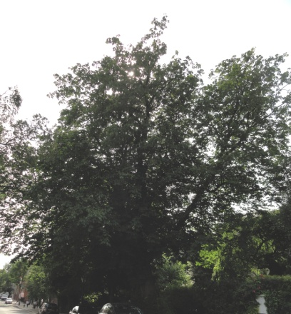
12 Downshire Hill | 2 Magnolias  Margaret Rogers margaret.rodgers3@btinternet.com | 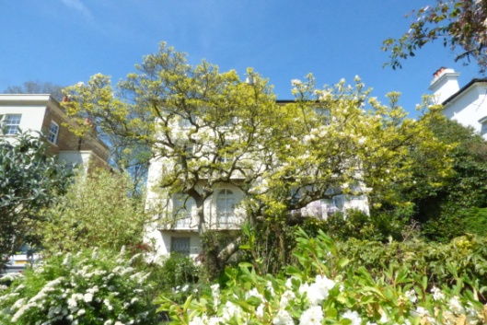
16 Downshire Hill, rear | An ancient pear tree  Martha and Michael James  mjandmatj@btinternet.com | The blossom on the pear tree is an annual delight. We understand that the area used to be orchards... probably in Keats' time. The pear tree is very large and gnarled so it must go back some time......
14 Downshire Hill, rear | A Robinia (mock acacia)  Martha and Michael James  mjandmatj@btinternet.com | The Robinia is a very elegant and beautiful tree and - when in leaf - hides our view of The Royal Free!
East Heath Road | Cedar  anon | 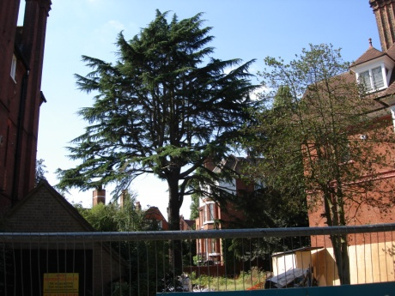
Border of 71 Fitzjohns Ave and Devonshire house school | large acer  Patricia Orwell  patricia.orwell@btinternet.com | Picture requested  I watch it from my living room window all year round and it gives me great pleasure.
Fitzjohns Ave to the right of Munro House | Cherry  Linda Chung | Beautiful cherry - its bountiful bloom each Spring is very uplifting, and in the setting with the House behind it, looks particularly special, and lifts up the whole street.
Frognal Way | Wisteria  Christopher & Christine Williams | The previous wisteria was here for 30 years, but it was killed when the road was dug up for the services to be re-laid. This one has been here many years.  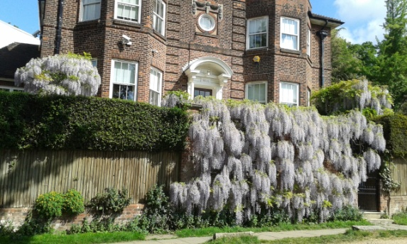
9a Gainsborough Gardens | Ginko  anon | 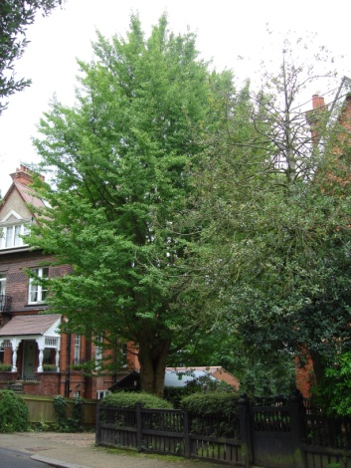
Heath Mansions Hampstead Grove | Copper beech  anon | 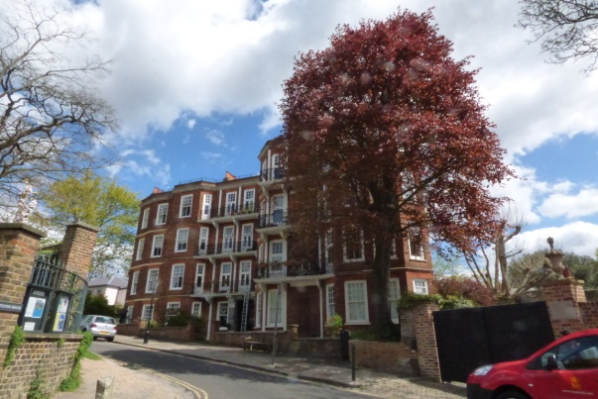
Front garden of South Villa, Heathside. | Copper beech  Joanna Goldsworthy  joannagoldsworthy@hotmail.com | 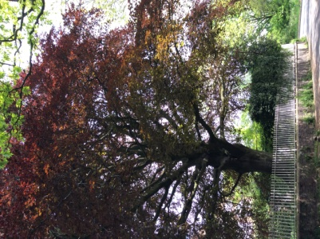  Has an important and beneficial effect on our streetscape, and lifts my spirits around the year
Marty's Yard | Sycamore  Maple  Ash  Jenny Stevens Jenny@jennystevens.net
Front garden, Moreton House, Holly Walk | Horse Chestnut  Richard Livesey-Haworth  richard@hollyplace.co.uk | 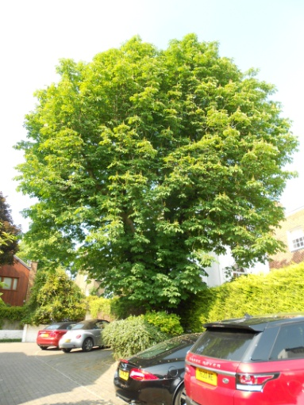  This is a magnificent specimen and provides an important feature of the street landscape.
Front garden, 6 Holly Place | Pine tree  Richard Livesey-Haworth  richard@hollyplace.co.uk | 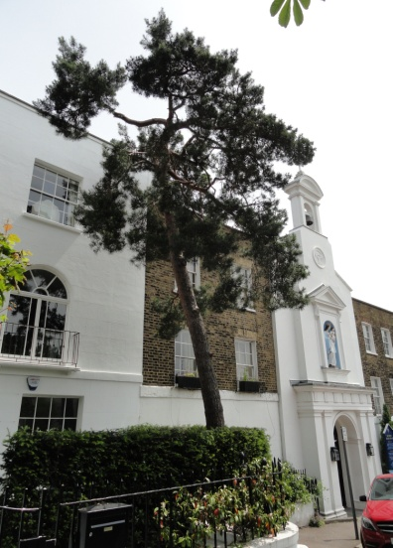  A great specimen which also adds a unique feature to the streetscape and complements the almost Mediterranean style of the Grade 2* listed Roman Catholic Church, St Mary’s, next door but one.
1 Lower Terrace | Plum and Malus (crab apple)  Vicki Harding vickiruthharding@gmail.com | 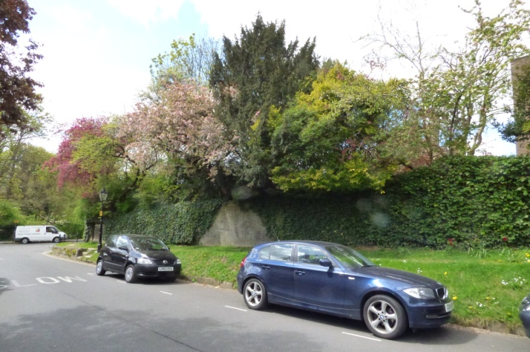
New End, Burgh House | Beautiful wisteria  Linda Chung <lindachung.nw3@gmail.com>
Oriel Place | Plane  Linda Chung <lindachung.nw3@gmail.com>
8 Pilgrims Lane | Thuja  Oliver Froment  oliverfroment09@gmail.com | 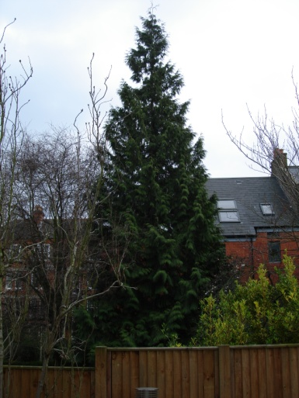  50 near neighbours signed a petition in 2009 to save this lovely evergreen tree when there was talk of removing its TPO. It has continued to beautify and green this area since. In the 1950s the Norwegian businesswoman Ingeborg Lane - famous for placing the mermaid ship’s figurehead on the front wall of 8 Pilgrim’s Lane - planted the thuya tree in her back garden. It is now quite tall and harbours lots of sparrows and other birds.
8 Pilgrims Lane | Cherry  Oliver Froment  oliverfroment09@gmail.com | 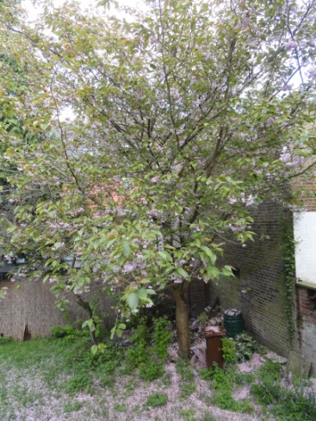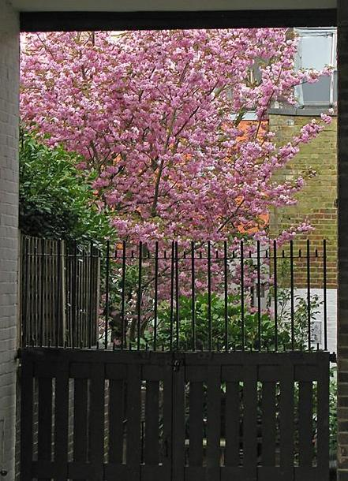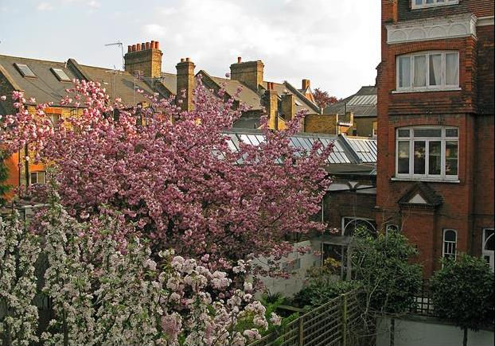  This is a beautiful and much loved tree that received over 100 signatures on a petition to save it when it was at risk from development.
27 Pilgrim's Lane, rear | Ash tree  Vivienne Menkes-Ivry  menkesiv@dircon.co.uk | The tall ash tree in the rear garden of 27 Pilgrim's Lane, which has recently been substantially trimmed and cut back and will hopefully continue to flourish.
Front garden 44 Pilgrim’s Lane | Crabapple  Victoria Chick  v.chick@ucl.ac.uk | Number one on my list
35 Pond Street, front | Lime trees  Marion Wesel  marionwesel@mac.com | 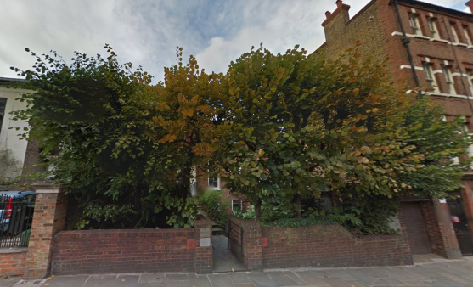  Lime trees here form a wonderful screen, hiding the huge Royal Free Hospital building. If they are used as a screen, rather than a freestanding tree in the street or a park, they have to be cut in such a way, that the branches on two opposite sides are kept and inter-connected to each other with some green wire, whilst the ones towards my house and towards the opposite Royal Free side are cut back. This is how you train them to form a perfect screen giving you privacy.
19 Ruddall Cresc | Lime  Silver Birch  Acers x 2  Jenny Stevens Jenny@jennystevens.net
18 South Hill Park | Horse Chestnut  Penelope Vita-Finzi  22 South Hill Park | 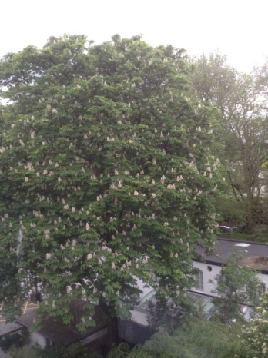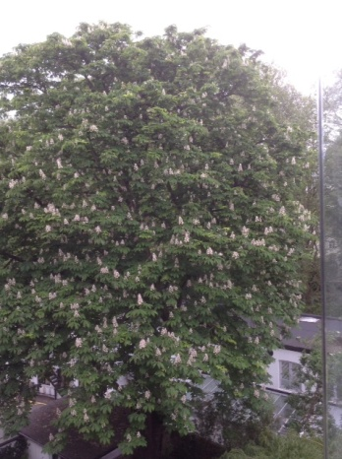
22 South Hill Park, rear | Black plum  Penelope Vita Finzi  pvitafinzi@aol.com | 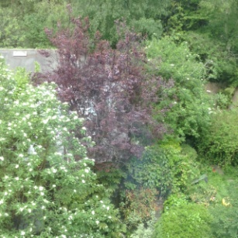  ...we planted in 1970 to celebrate the birth of our son
22 South Hill Park, rear | Rowan  Penelope Vita Finzi  pvitafinzi@aol.com | we planted a few years later [post 1970]
18 South Hill Park, rear | Horse chestnut  Penelope Vita Finzi  pvitafinzi@aol.com | 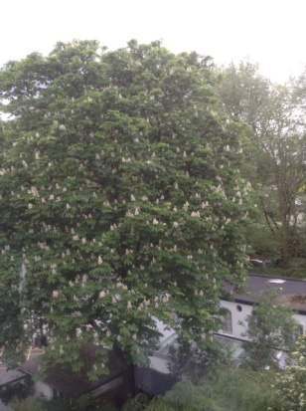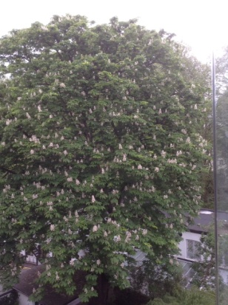  Lovely, huge, magnificent old chestnut which was very large when we moved in to no. 22 SHP 47 years ago
Upper Terrace, street tree | Veteran sweet chestnut  Vicki Harding vickiruthharding@gmail.com | 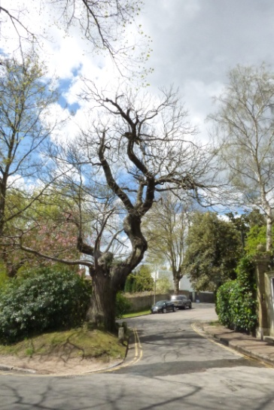
Chestnut Cottage Vale of Health | Horse chestnut  Janice Hardiman | 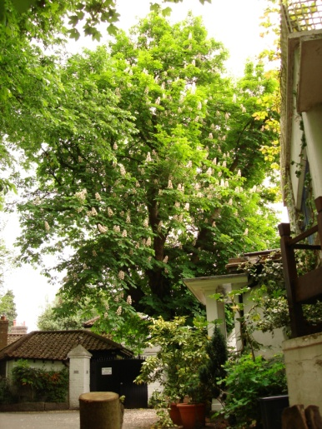
Wellside, Well Walk | 3xLombardy Poplar  Diana Ratzer | 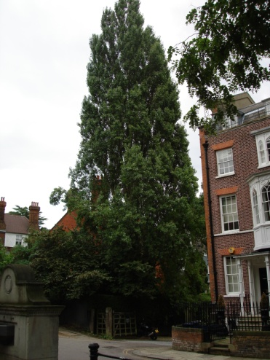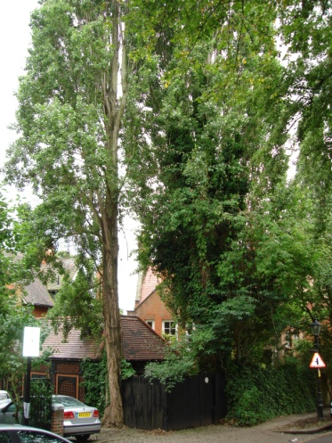
Well Walk | Cherry  Vicki Harding vickiruthharding@gmail.com | 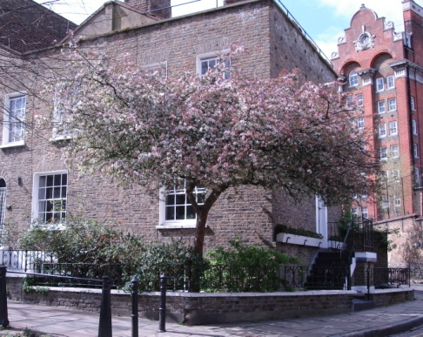
Communal garden to rear of 15 Well Walk | Lime tree  Ken Payne <pyne9@hotmail.com> | 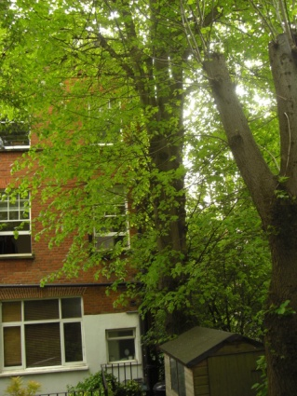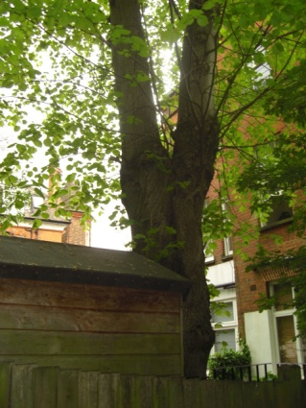  This is a beautiful 50ft Lime Tree
Trees in Well Passage | Ken Payne <pyne9@hotmail.com> | 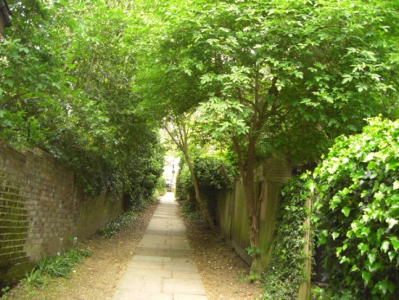
Front garden of 30 Willoughby Road, at corner of Carlingford and Willoughby Roads. | Weeping willow  Joanna Goldsworthy  joannagoldsworthy@hotmail.com | 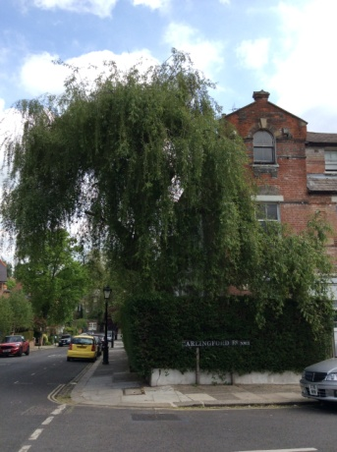  This used to be much more beautiful before it was hacked about. Still has a lovely weeping habit.
23 Willoughby Road | Lime (Tilia Cordata)  Eve Hersov  evehersov@msn.com;  Joanna Goldsworthy  joannagoldsworthy@hotmail.com | 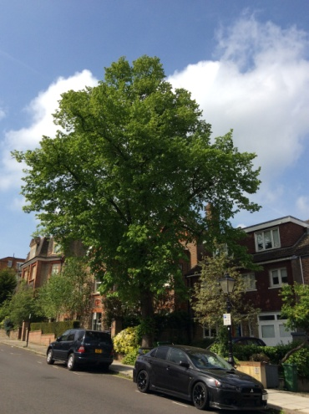  The tree surgeon who looks after it estimates that it is over 200 hundred years old and while I would never nominate the Lime Tree as a favoured ornamental tree, the truth is that our tree provides not just a large green canopy that can be seen from both Willoughby Road and Denning Road and beautifies the street scene - the tree also helps absorb a huge amount of ground water that has been diverted by development of homes and through the loss of front gardens in the area to driveways.  The tree appears on the 1866 Ordnance Survey map  This tree is very well tended by the owners of 23.
35 Willow Road | Camelia, williamsii  Eileen Neilson eileen.neilson@gmail.com | 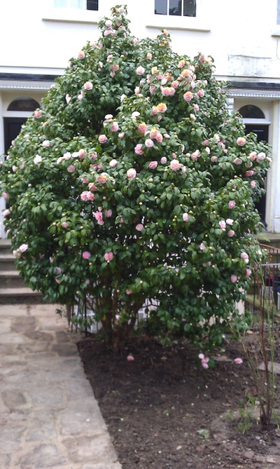
Path behind houses in Willow Road and Christchurch Hill, adjacent to 53 Willow Road. | London Plane  Joanna Goldsworthy  joannagoldsworthy@hotmail.com  Also Hilary King  hilaryking@talktalk.net | 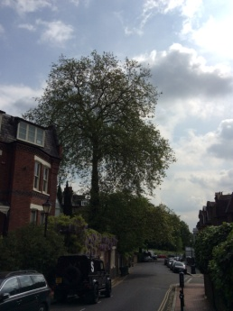 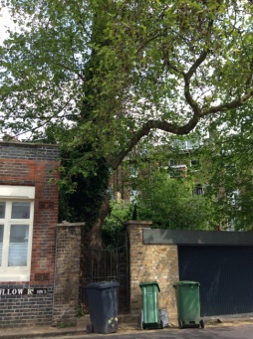Has a massive trunk. This view shows an 'elbow' branch that hangs over the road. Is seen better in the afternoon.
Willow Cottage Windmill Hill | anon | 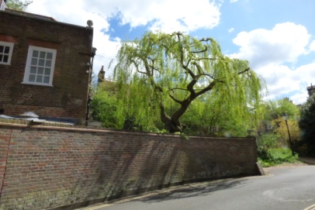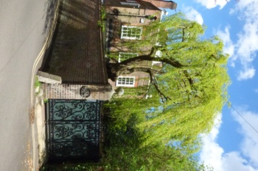
Windmill Hill | Weeping willow  anon | 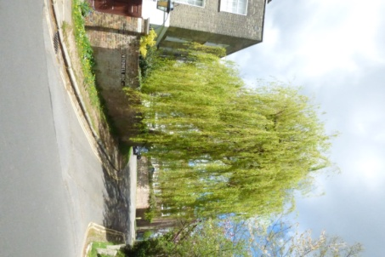
22 Windmill Hill | Copper beech  anon | 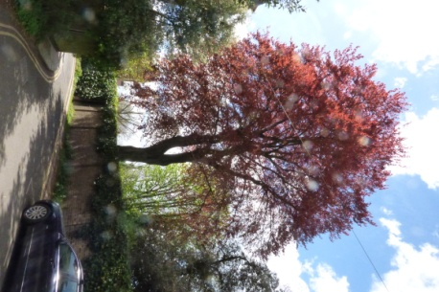
Volta House, Windmill Hill | Horse chestnuts  anon | 