**Local Green Space: Fenton House Garden**

**Local Significance: (Historical and Beauty)**

Fenton House was built c1693 as a merchant's house in Hampstead, receiving its present name after 1793 when the house was bought by the merchant Mr P I Fenton. It now belongs to the National Trust, bequeathed to them in 1952 by Lady Binning, its last owner and resident. The house is kept much as it was 300 years ago. The house has Historic England grade 1 listing. This does not extend to the 1½ acre walled garden, though the garden gates, railings and walls (dating from C17th and C18th with alterations) are listed (grade II) and the garden provides an important setting for the house.

A description of the garden in 1756 records that it had fruit trees and a kitchen garden. The layout today is not dissimilar to that of the 1860s with a lawn to the south with central gravel path leading from the entrance gates to what was then the main entrance of the house. Although there are no longer flower beds here, the South Walk has been planted with over 3,000 snowdrops.

North of the house were terraced gardens with perimeter walks comprising a flower garden and walled kitchen garden. By the 1880s there was a lawn tennis court and vinery.

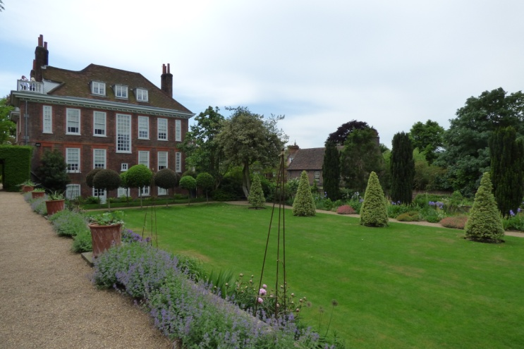 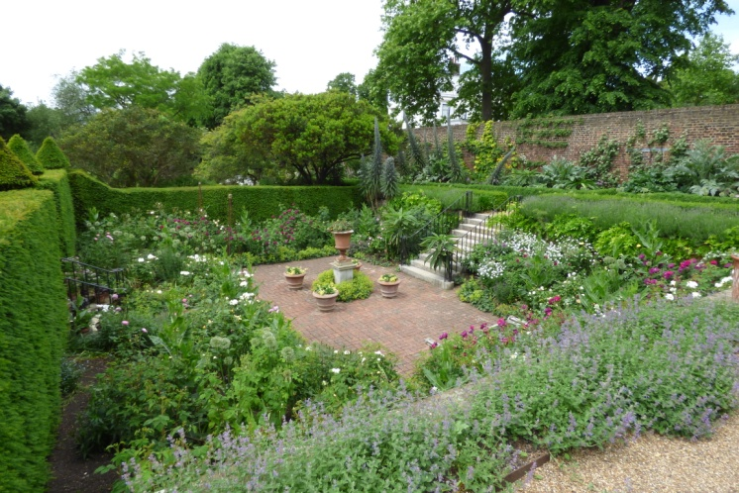

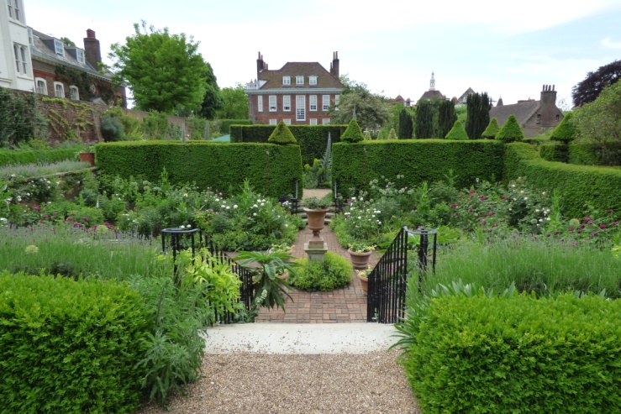 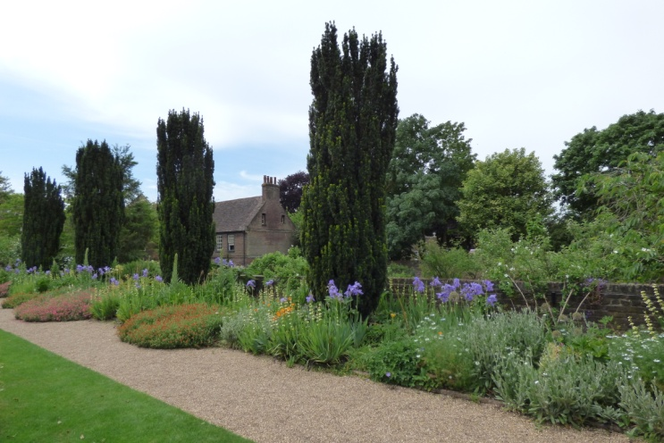

Nowadays Fenton House garden to the north is on three levels: it has a delightful formal walled and terraced garden including a small sunken rose garden, and an orchard and working kitchen garden with a wide range of vegetables. The more formal parts of the garden include colourful herbaceous borders edged with box and a sunken rose garden. Scented herbs include lavender, rosemary and dianthus. It was the regional winner of the National Trust Gardens Award 2000.

**Richness of Wildlife**

The 300 year old orchard is kept unmown all through the summer to encourage the growth of wild flowers, maintaining this area as supportive of a wide range of insects. There are spring bulbs including native bluebells amongst the fruit trees in the orchard that boasts over 30 varieties of apple.

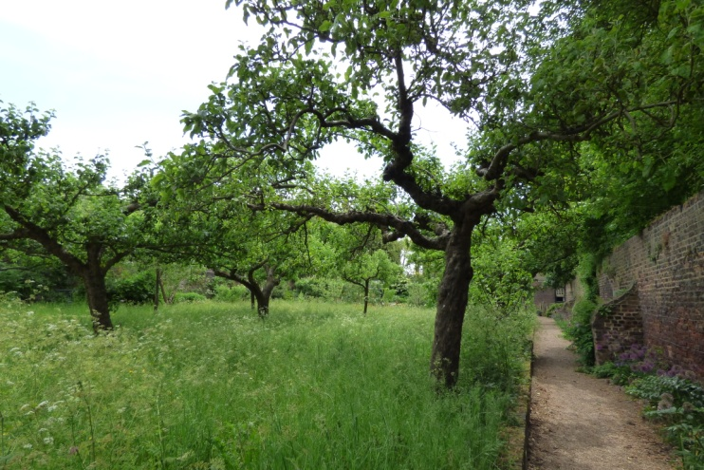 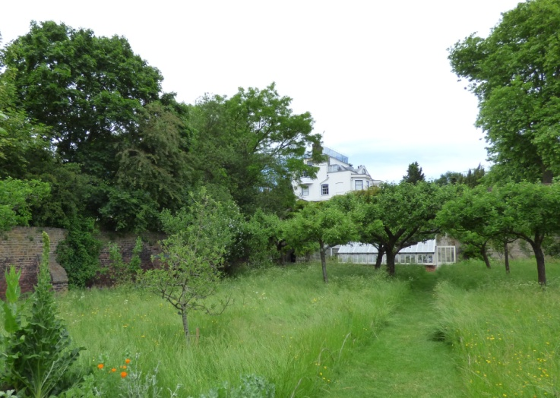

**Use by the Local Community**:

Fenton House Gardens are open to the public with a voluntary donation every day except Mondays during the open season - March: Sat/Sun 2-5pm; April- Oct: Wed-Fri 2-5pm/Sat/Sun/BH 11-5pm. There is a self-guided walks leaflet. Local people are frequently to be found sitting within the garden, quietly enjoying its peace and tranquillity, while visitors walk around looking at the wide range of flowers and shrubs. The *Fenton House garden volunteers* are mainly drawn from local people who gain enjoyment and gardening experience while regularly working here.

In addition various events take place in the gardens:

Open Garden Square weekend

National Garden Scheme

Garden Easter Egg Trail

Apple Weekend

Bank Holiday picnics

**Special Policy Area:** The garden is within the Area of Special Character: Hampstead & Highgate Ridge.

**Other LA designation:** Fenton House and garden is within the Hampstead Conservation Area.

**Supports Local Plan Policies**:

Designation of Fenton House Gardens as a Local Green Space would support **Camden's Local Plan Policy A2 'Open Space': c, e, f, h; A3 'Biodiversity': a, c, e, f, h and i. Through its provision of a restful and beautiful space with facilities for National Trust visitors, local people and children,** it is consistent with Local Plan Policy C1 'Health and well-being': a, and Policy C2 'Community facilities'.

**Hampstead Local Plan:**

Biodiversity corridors, Historic tree lines.

**Links to other Green Space in the Hampstead Local Plan area**

Fenton House gardens hold a key place within the Plan's Biodiversity Corridor H that runs from Hampstead Heath and Upper Terrace Reservoir, through the Lower Terrace and Admiral's Walk area, and along Hampstead Grove towards the SINC 'Hampstead Parish Churchyard'. It is close to Local Green Space 'Footpath Admiral's Walk to Windmill Hill' and to public Open Space and London Square 'Holly Bush Hill' and public Open Space 'Heath Street Shrubbery'.

**How will the green space be managed in the future?**

*The National Trust* employs a gardener Andrew Darragh to work full-time in on-going design and maintenance of the garden and activities taking place in the garden, which he does with the help of the *Fenton House garden volunteers*.

**Have the landowners been consulted and if so what were their views on designation?**

[The National Trust have been contacted via Andrew Darragh but have not replied yet.]

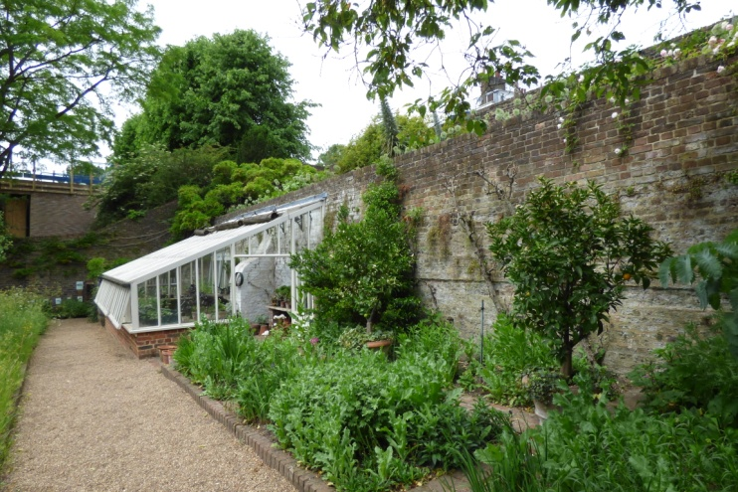

|  |  |
| --- | --- |
| 'APPLE DAY' AT FENTON HOUSE - a poem by Christine Fox (2009) | |
| Sunday morning, late September,  apple skims the edge of country  in an urban garden.  Lined up in rows, partitioned, named,  on trestle tables in the sun,  Lemon Pippins,  Beauty of Kent,  by the cash till, Worcester Pearmaines -  the sort we stole that day, you and I,  from next-door's garden:  top of the tree,  big and sweet,  glistening white flesh -  apples, like years,  we didn't doubt would be renewed  over and over.  My memory reaches out  to the textured redness,  leafy scent,  juice-dribble on the chin  and flavour of us, my brother,  our theft and our delight;  a childhood steal stashed safe and | memorised in glossy fruits,  under Turner and Constable skies.  This is no sunstruck vicarage garden  in a country lane.  It's city grown but ancient,  seeming rural, as the house it borders;  a watercolour, closely framed  in michaelmas daisy mauve.  And each September Apple Day  the need for something still and quiet,  round, core-centred,  smelling freshly of past life,  draws me,  along with all these others here,  to covet and secure  cool country treasures,  pieces of the years.  While you, my brother,  fourteen years dead,  inhabit the same deep earth  that nurtures apple roots,  plumping their blossoms,  swelling their progeny. |