**Local Green Space: Holly Hill**

**Description of Site**

'Holly Hill' is the area of planting bounded by the roads Holly Hill and Mount Vernon and the tarmac footpath going up to the top of Mount Vernon. It is a raised-up bank due to the steepness of the hill here with a wall and drop on the west side of the road Holly Hill.

**Historical Significance**

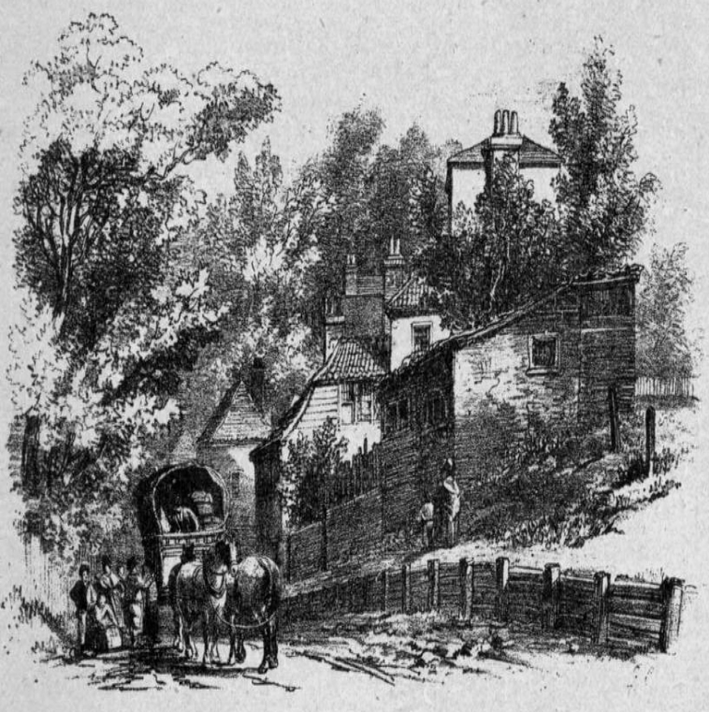 Holly Hill in 1840

The site of 'Holly Hill' can be seen to the west of the steep cart track that was Holly Hill in a painting of 1840. In c.1900 Holly Hill was under threat for road widening in connection with railway works but opposition from local people prevented this, meaning that the green bank 'Holly Hill' was retained for locals to continue to appreciate.

**Recent History**

Since the late 19th century / early 20th century it has been maintained by Hampstead Borough Council as an area of regularly mown grass.

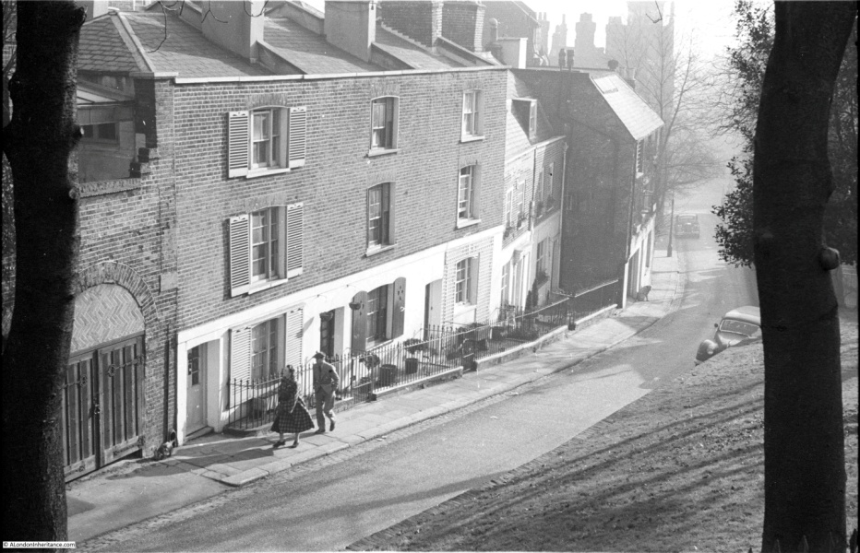

This was continued by LB Camden Parks & Open Spaces Department, but it eventually turned to scrub.

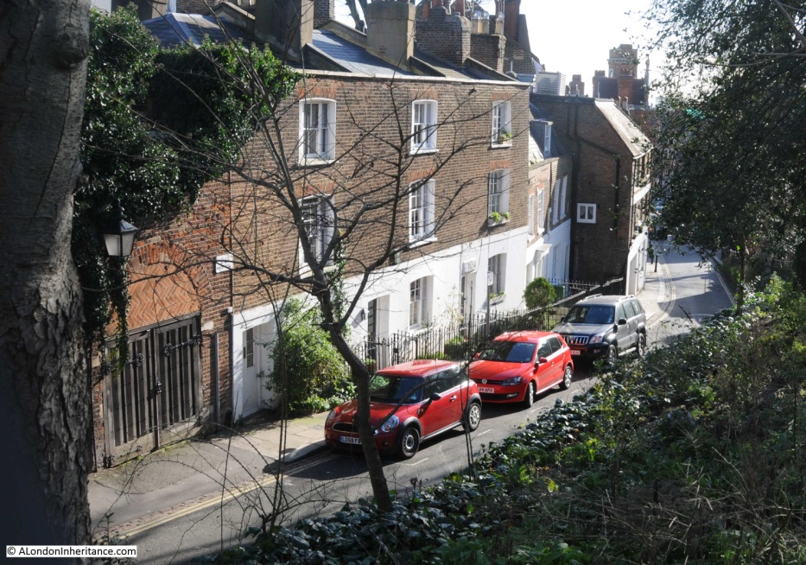

**Use by local community**

The original desire of the local community to protect and improve this area is continuing. The Holly Hill Conservation Volunteers were formed in October 2013, signing an agreement with Camden in September 2014 for permission to access the Holly Hill site to enhance it. This would be by clearing the ivy, brambles and scrub and sowing, growing and maintaining this area for plants, flowers, fruits, grasses, herbs and shrubs.

The group is a member of The Conservation Volunteers and has around 20 members, of which about half regularly help with gardening on the site. The annual membership fee goes towards the cost of insurance and plants; plant donations also received. Access is otherwise not safe for members of the public.

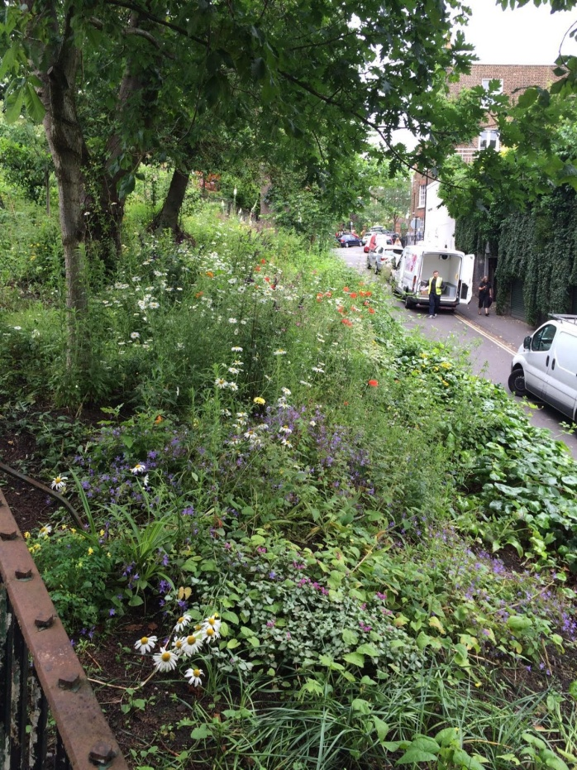 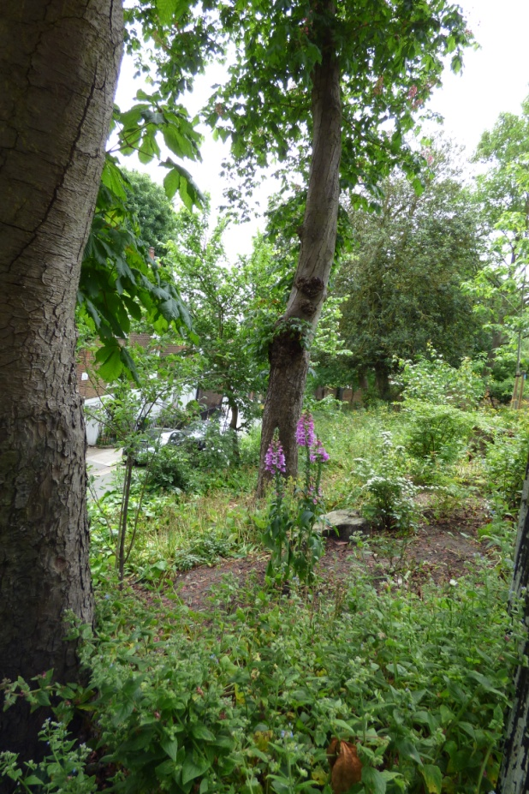

**Richness of Wildlife**

An area within the site is retained for wild flowers and by using organic methods, insects and birds can visit without harm. The site is very popular with bats who swoop around the area on warm evenings. The volunteers have put up a bat box on the Holly Hill bank and have a bat detector. This demonstrates the regular seasonal presence of bats and is useful for introducing children to the fascination of our local bats.

**Beauty and Tranquility**

While it is on a moderately busy thoroughfare it nevertheless provides visual beauty through its interplanting of a variety of trees, shrubs, bulbs, garden flowers and wild flowers. It has become a local amenity in the sense that people often stop to admire the view/flowers and children enjoy learning the names of the plants as they come into bloom. The planting is of native varieties e.g. evening primrose, foxgloves, damson and sage. Snowdrops, primroses and daffodils provide beautiful early cover until the (pre-existing) bluebells come out.

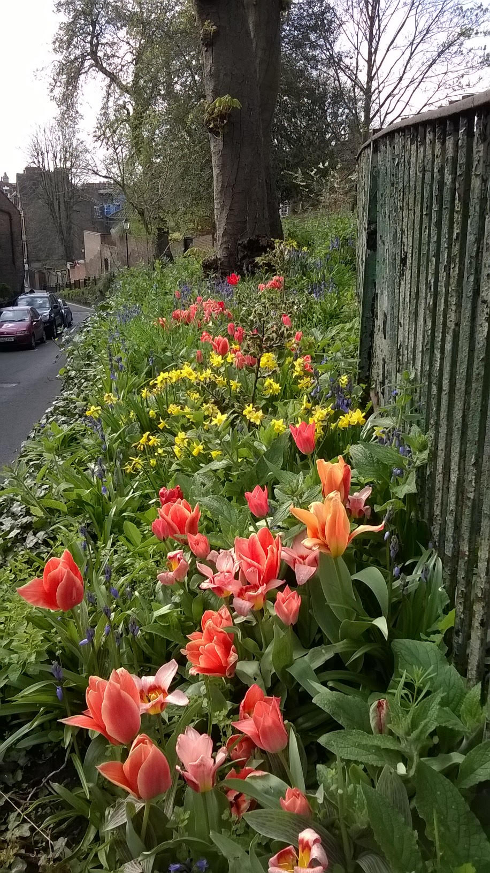 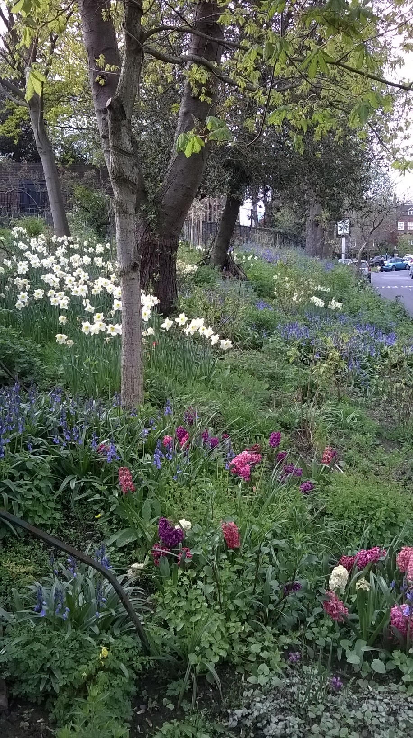

**Owners of the land**

London Borough of Camden

**How will the green space be managed in the future?**

It is expected that LB Camden ownership will continue, with the Holly Hill volunteers continuing to maintain it.

**Special Policy Area:**

Area of Special Character: Hampstead & Highgate Ridge.

**Other LA designation:**

Holly Hill Bank is in the Hampstead Conservation Area.

**Hampstead Local Plan:**

Holly Hill Bank lies east of the Plan's Biodiversity Corridor H (Hampstead Grove, Admirals Walk, Upper and Lower Terrace) and Local Green Space 'Fenton House Garden' in the Plan Area.

**Supports Local Plan Policies**:

Designation of Holly Hill Bank as a Local Green Space would support **Camden's Local Plan Policy A2 'Open Space': c, e, f, h; A3 'Biodiversity': a, c, e, f and h. Through its provision of a beautiful space for local people to nurture and to admire and of interest to children,** it is consistent with Local Plan Policy C1 'Health and well-being': a, and Policy C2 'Community facilities'.