**Local Green Space: Keat's House Garden**

**Local Significance: (Historical and Beauty)**

The house, originally called Wentworth Place, was built between 1814-6 by William Woods for Charles Wentworth Dilke and Charles Armitage Brown, as a pair of semi-detached houses sharing a common garden. The land was enclosed from Hampstead Heath, and Dilke and Brown were among the first to build here. There were stables to the south-west and a kitchen garden to the north-west of house; the stables were later converted to house a collection relating to Keats and branch library, and what was the kitchen garden became the approach path to the library. John Keats (1795- 1821) lived here with Charles Brown for 17 months from 1818-1820 at which time the house was known as Lawn Bank, and from April 1819 his next door neighbour was Mrs Brawne and her three children, who had taken Wentworth Place when the Dilkes went to Westminster. Keats and the eldest daughter Fanny met and fell in love. The earliest references to the garden appear in the letters of Keats himself from his time living here in the years 1819-20. He recounts walking in the garden, seeking inspiration there and gazing at the outside world from his parlour when consumption had rendered him weak.

The garden in Keats' day was a woodland garden and a second entrance used to exist to the north; Keats referred to a 'grass plot' in front of the windows. An ancient plum tree that stood near the front of the house has been replaced and a plaque beneath it relates how the 'Ode to a Nightingale' was written there.

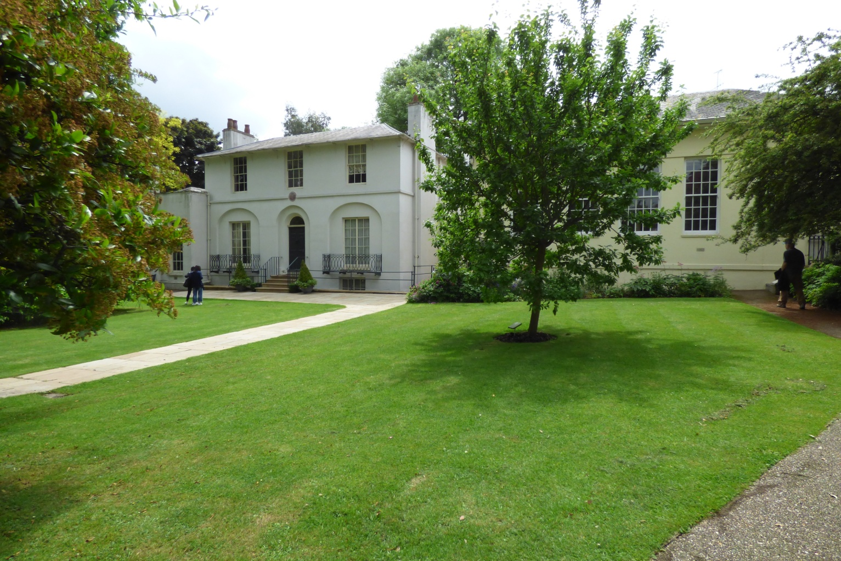

In 1920-21 the house was threatened with destruction, but was saved by money raised by public subscription and it was vested in Hampstead Borough Council to be maintained in perpetuity in Keats' memory. It was opened to the public on 25 May 1925.

In 1974-5 LB Camden, who succeeded Hampstead Borough Council, restored the house with funding from the Historic Buildings Council. The garden was replanted in the late 1970s with advice from Peter Goodchild and included flowering shrubs within a north fenced boundary, with mature trees including plane and lime. The approach path to the house was flanked by lavender hedges and had a mixed border along the east boundary. Ash, beech, sycamore were planted along the south boundary.

In 1998 City of London took over responsibility for the house, which was managed by London Metropolitan Archives and some restoration was undertaken. Although formerly on the English Heritage Register of Parks and Gardens of Special Historic Interest, Keats House was removed in 2003.

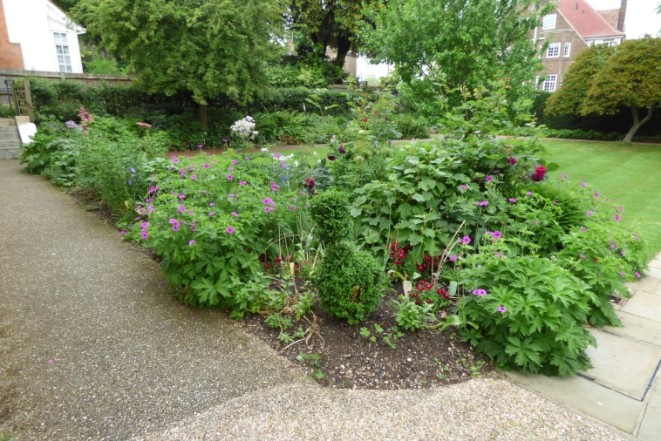 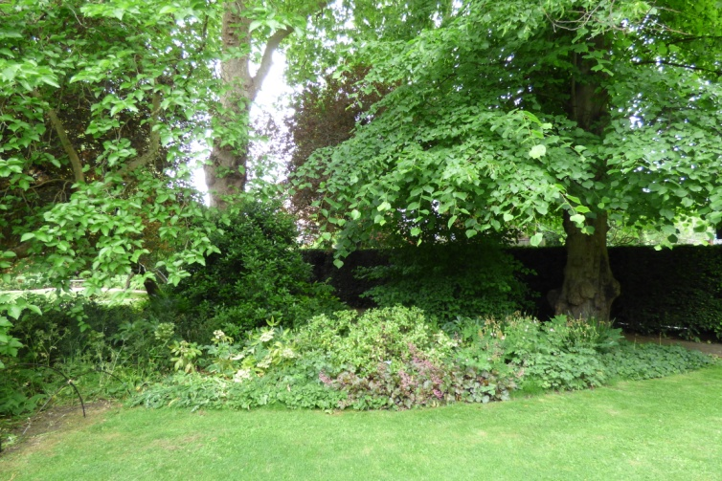

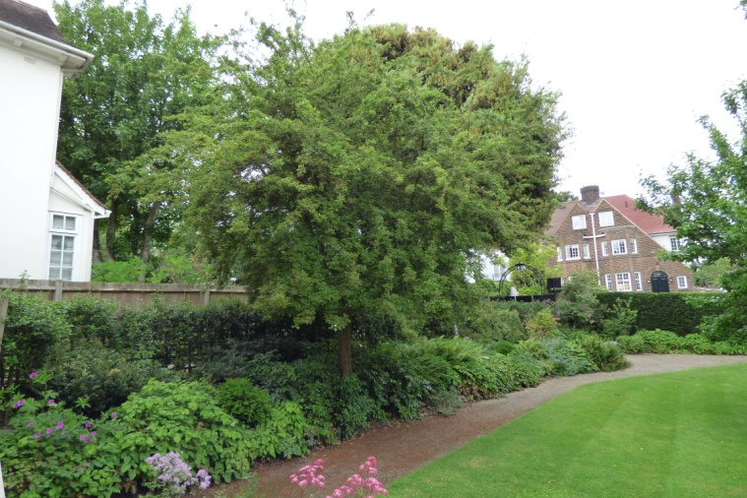 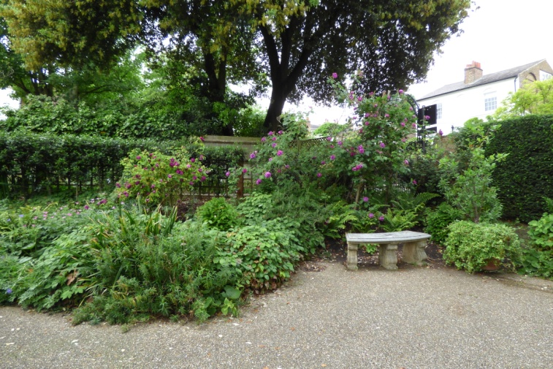

In 2007, Keats House was awarded a Heritage Lottery Fund grant of £424,000 to undertake substantial restoration and it re-opened in 2009. In tandem with the refurbishment of the house, the garden was also redesigned. In October 2008 and with the assistance of the volunteer group *Heath Hands,* a new hedge was planted around the border of the garden and new fruit trees, plants and shrubs, all in keeping with the Regency period, were put in place. Each border of the garden reflects an aspect of Keats’s poetry: Melancholy, Autumn and Nightingale. A group of volunteers from *Heath Hands* have continued to take part in weekly Wednesday maintenance sessions.

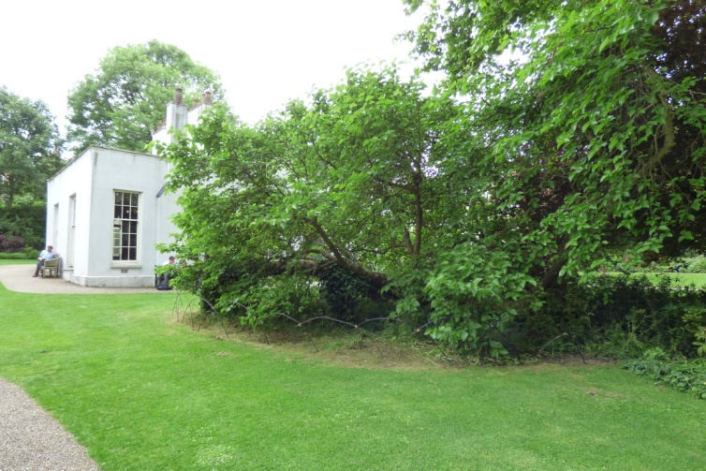 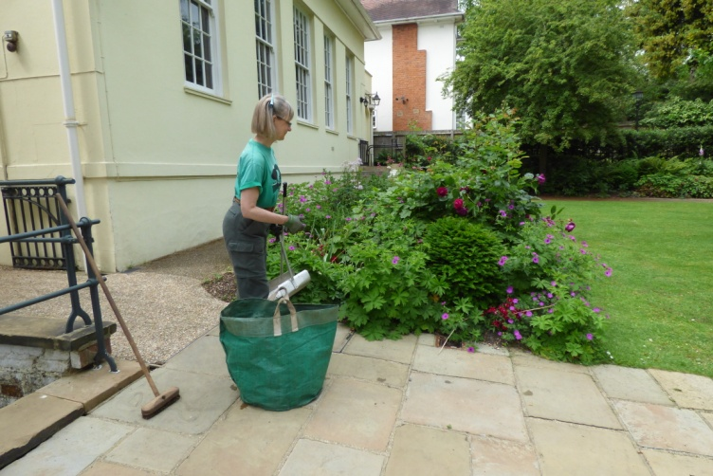

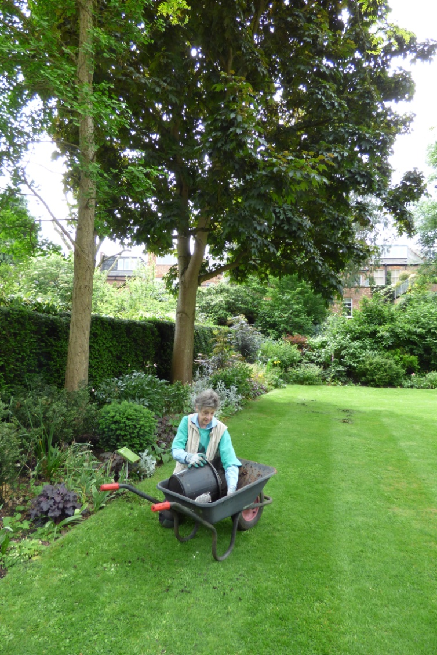 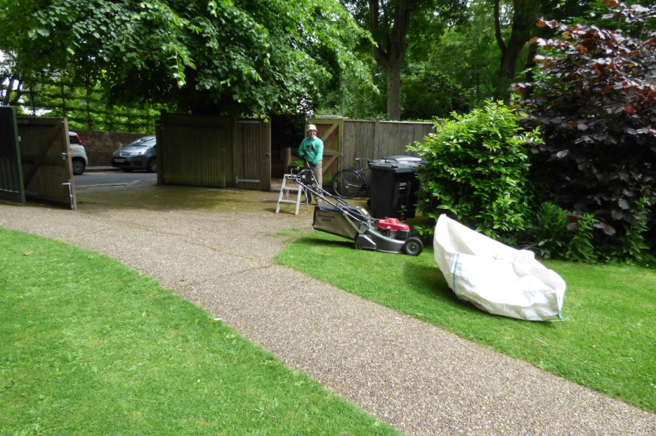

**Use by the Local Community**:

Keats House and Garden are open all year round Wednesday to Saturday and Good Friday and Bank Holiday Mondays 11am to 5pm. While there is a fee for entry to the house, entry to the garden is free. The toilets in the garden are also wheelchair accessible.

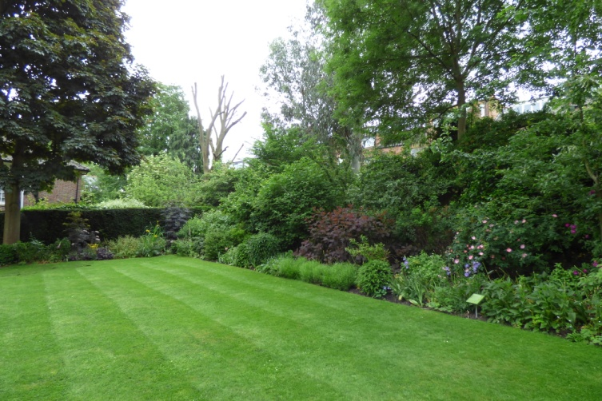 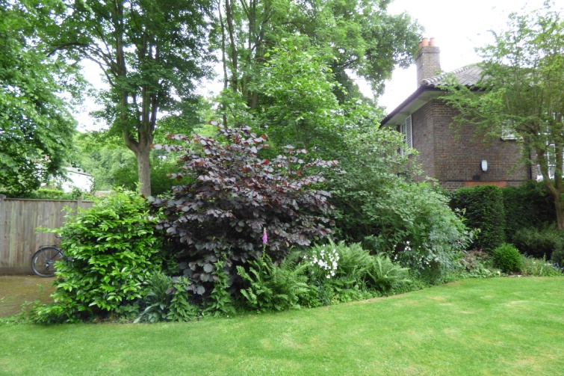

The gardens have supported and been a part of Open Garden Squares weekend for many year where they are described as

"providing a moment of calm in bustling Hampstead. Mere steps away from the Heath, our beautifully tended garden allows you the opportunity to walk in the steps of one of the most well-loved of the Romantic poets – John Keats. .... aiming to highlight the inspiration and dedication behind the tranquillity of our garden, as well as the hard work carried out by the volunteers and skilled horticulturists who tend the garden."

Families are welcome to picnic or play in the garden during their visit; the garden makes a lovely setting for a picnic when the weather is fine. **Family Days are also organised and advertised locally such as the 'Minibeast Safari':**

**"**Pick up a wildlife spotter sheet and see what birds and beasties you can spy. You can also make a miniature bug hotel to encourage minibeasts into your own gardens and outdoor spaces.

Free, just drop in."

School visits include interactive sessions investigating insects, flowers and trees in the garden. They

support National Curriculum requirements for Science Key Stage 2: Life Processes and Living Things - Green Plants and Living Things in Their Environment.

Free guided tours of the Keats House garden are regularly organised, exploring elements of Keats’s poetry and how it inspired the existing planting schemes. **Minibeast Safaris are also run for children, and some evenings in the summer the garden remains open until late for experiencing dusk in the garden.**

**Special Policy Area:** Area of Special Character: Hampstead & Highgate Ridge

**Other LA designation:** Public Open Space (Small Local)

English Heritage Grade I listing [not Garden, though this importantly forms the setting of the Grade I listed house]

**Supports Local Plan Policies**:

Designation of Keat's House Gardens as a Local Green Space would support **Camden's Local Plan Policy A2 'Open Space': c, e, f, h; A3 'Biodiversity': a, c, e, f, h and i. Through its provision of a restful and beautiful space with facilities for local people and children,** it is consistent with Local Plan Policy C1 'Health and well-being': a, and Policy C2 'Community facilities'.

**Hampstead Local Plan:**

Heath Fringes, Biodiversity Corridors

**Links to other Green Spaces in the Hampstead Local Plan area**

Keat's House Gardens is very near to the southern part of the Heath and is in line with the strategic biodiversity corridor 'North London Line railway corridor'. It is close to Local Green Spaces 'Heath Hurst Gardens' and 'World Peace Garden', close to Private Open Space 'Keats & Downshire Gardens ', and lies between the Plan's biodiversity corridors E (South Hill Park and South Hill Park Gardens including Heath Edge Gardens and Parliament Hill) and F (Hampstead Hill Gardens).