Local Green Space: Hampstead Green

History
Hampstead Green is the remains of what was once a much larger area of manorial waste. On the John Rocque map (1746) and the Survey Map of Hampstead Manor (1762) it is shown as an open space with an avenue of 2 rows of trees flanking it’s eastern side, surrounded by a few buildings; in the 1830s it was described as 'a grassy playground for children with a fine double row of trees'; in 1862 it appears that the common waste had by now been enclosed as Stanford’s map shows ‘Hampstead Green’ divided into four enclosures. Part of the green was taken when St Stephen's Church was built in 1869-75, gifted by Lord of the Manor Sir Thomas Maryon Wilson. The site then came into the ownership of the church who also had responsibility for its maintenance. By 1915 the OS map shows the remaining 2 areas as one, in 1928 it was referred to as Pond Street Enclosure, a 'small grass plot planted with shrubs and trees', soon to be protected under the London Squares Act of 1931.

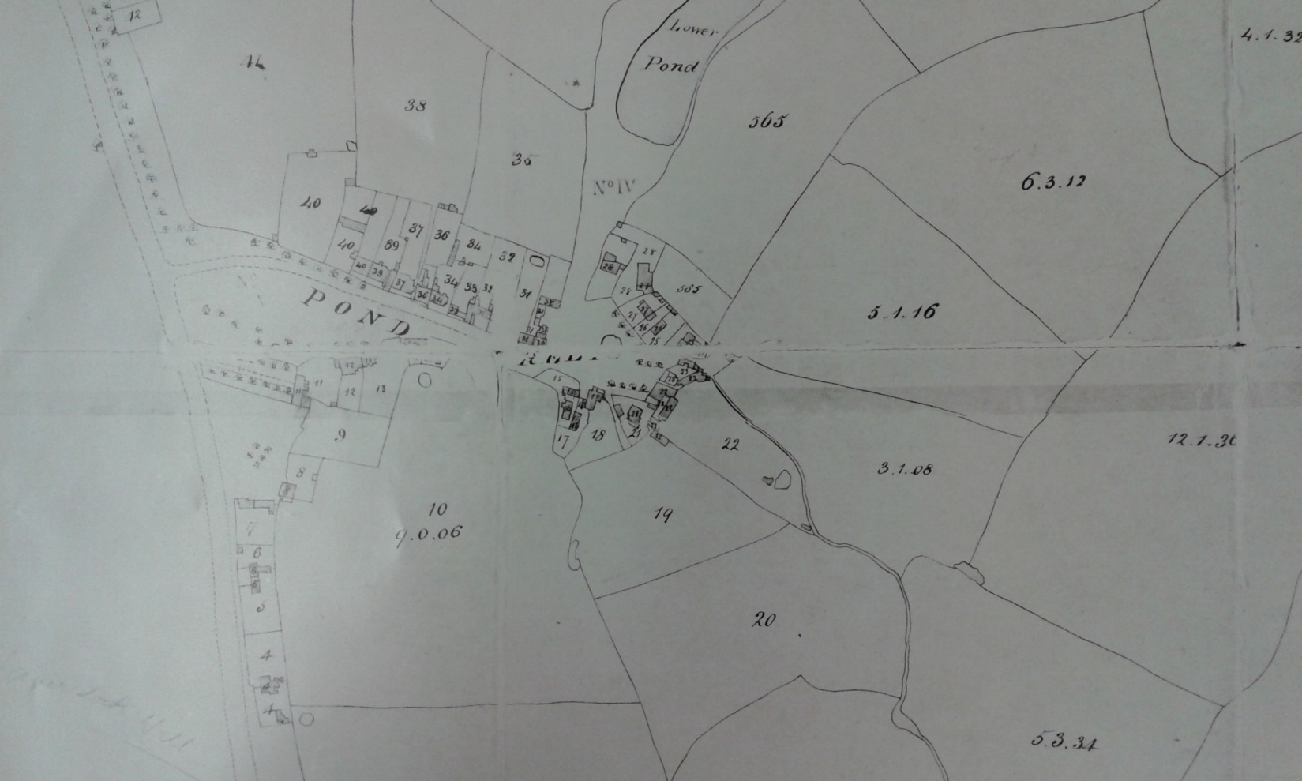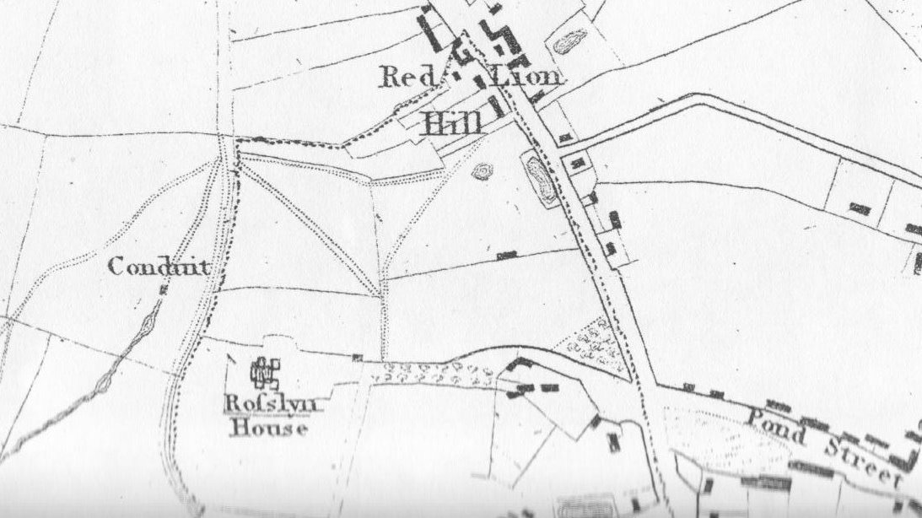
Manorial map 1762 Roque's map, 1746
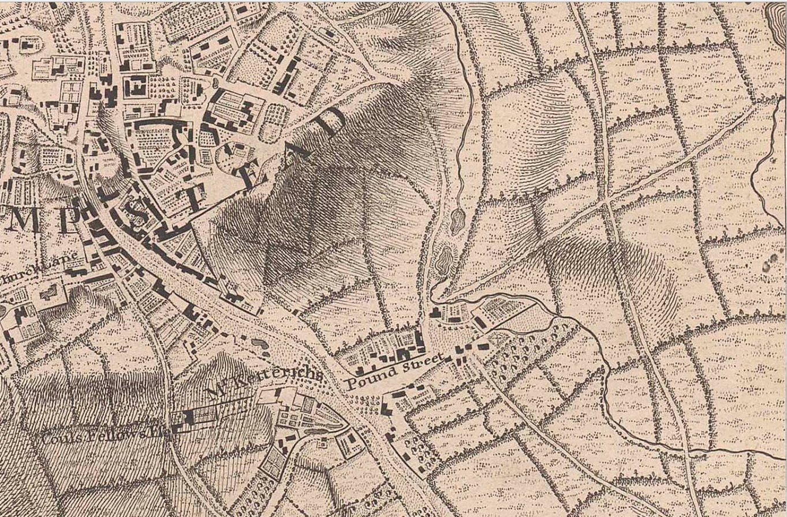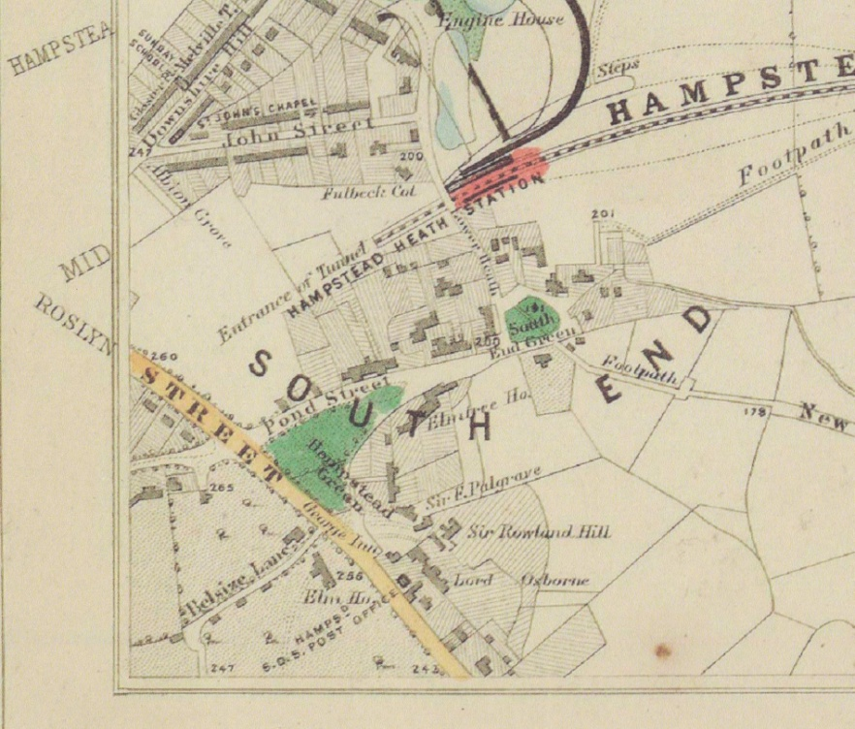
Newton's map, 1814 Stanford's Library map 1862
Red arrows point to Hampstead Green area, south east of corner of Pond Street and Rosslyn Hill

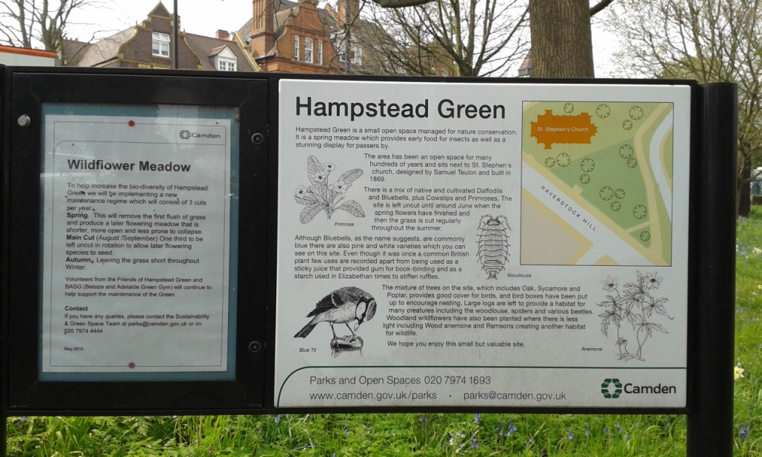

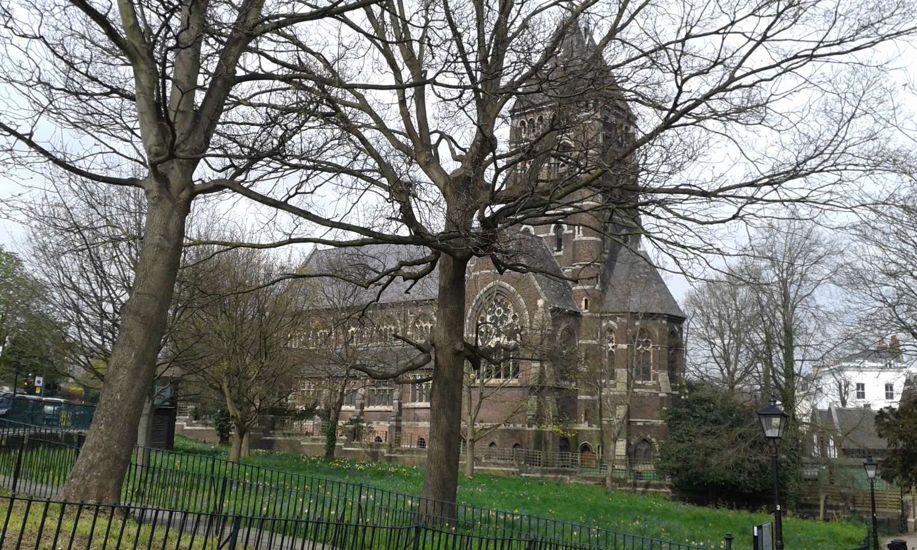

Richness of Wildlife:
Hampstead Green has remained an undisturbed wild flower meadow for hundreds of years. It was neglected for many years and became overgrown until the local community cleared the area and transformed it into a natural open space. The railed triangular site is now grass and wild flowers with around nine trees remaining, species including cherry, red oak, sycamore and poplar.

The area is owned by the LB Camden and is managed for nature conservation with bird boxes, large log piles for insects and an insect hotel. Hampstead Green is not generally open for public access and is left as a site for wildlife, principally as a wild flower meadow to encourage butterflies; a small haven for wildlife, particularly insects, in this busy built up area. In spring it is a blaze of colour: full of crocuses and primroses, followed by daffodils and bluebells. This attractive site can be easily viewed from paths which run around most of its perimeter.

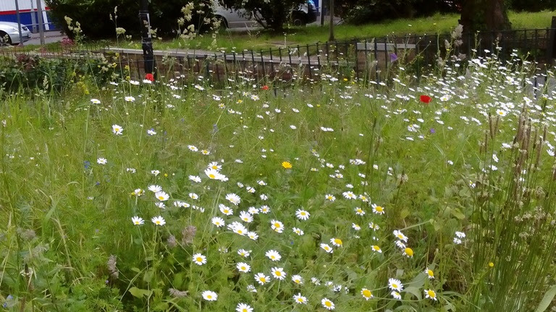

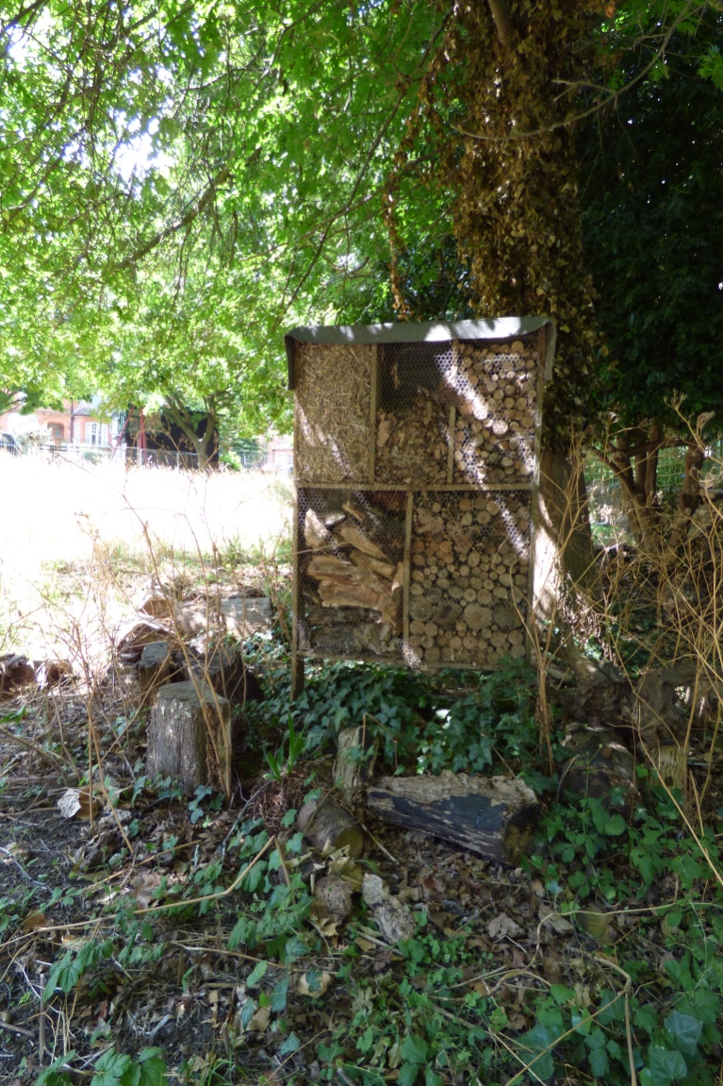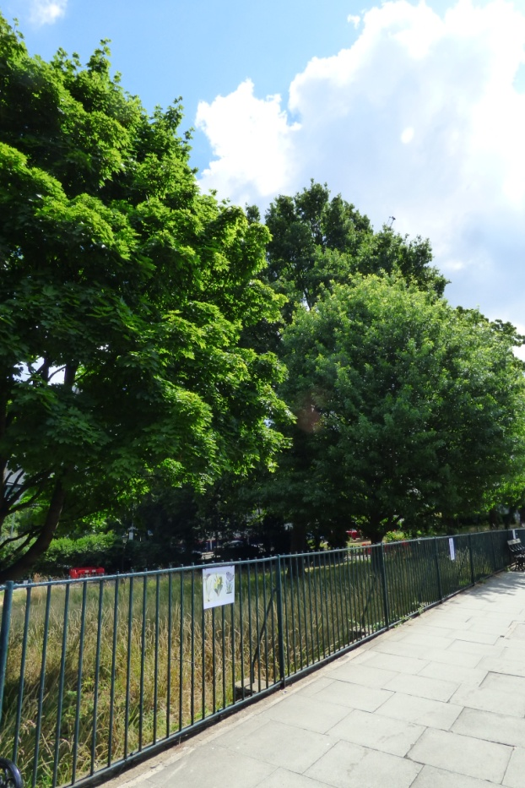

Use by Local Community:
Hampstead Green is within Hampstead, near its south border. It is owned by Camden, but subject to a covenant that restricts its use to “an enclosed open space”. It is between St Stephen's church and the Royal Free Hospital, and is fairly close to South End Green area.

In 2009 local volunteers formed 'Friends of Hampstead Green' and worked to clear some trees and invasive plants. returning it to a butterfly-friendly meadow. Green Gym also took part in this joint venture. The Friends of Hampstead Green have continued and are a group of local people who
… care about preserving the meadow, this precious, unspoilt natural space, and preventing it being turned into just another ordinary 'park’.
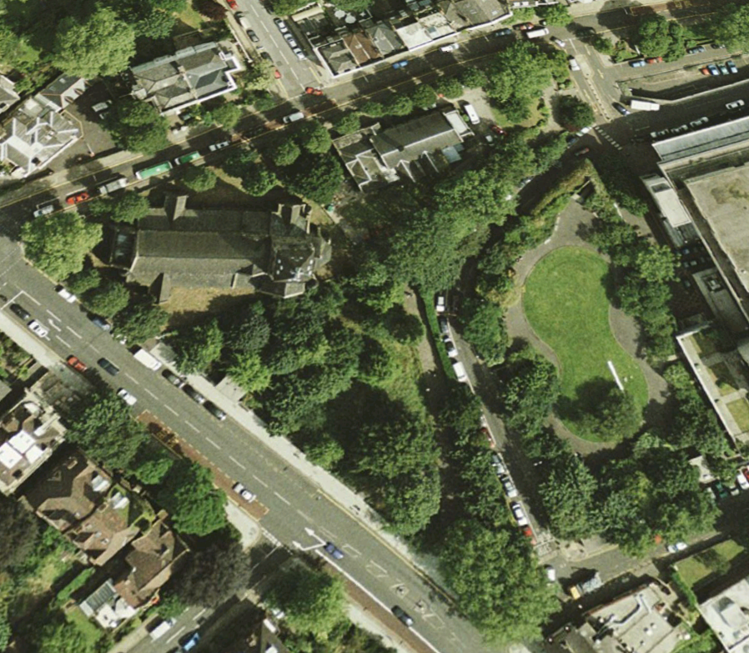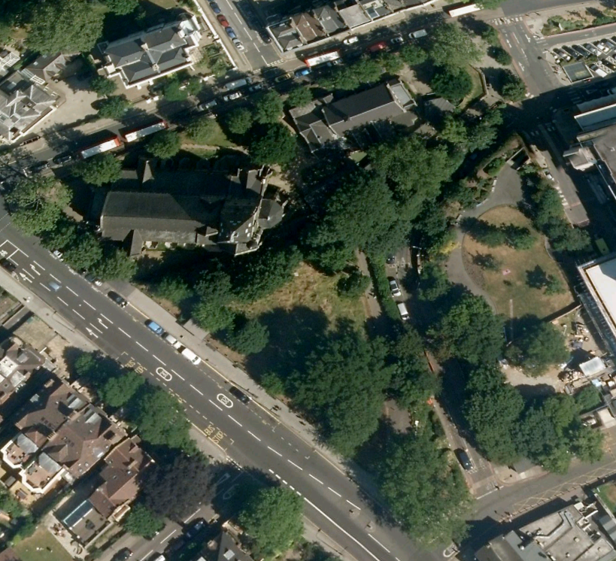
Hampstead Green (Google Earth) prior to selective tree & sapling removal (2003) and after (2015)

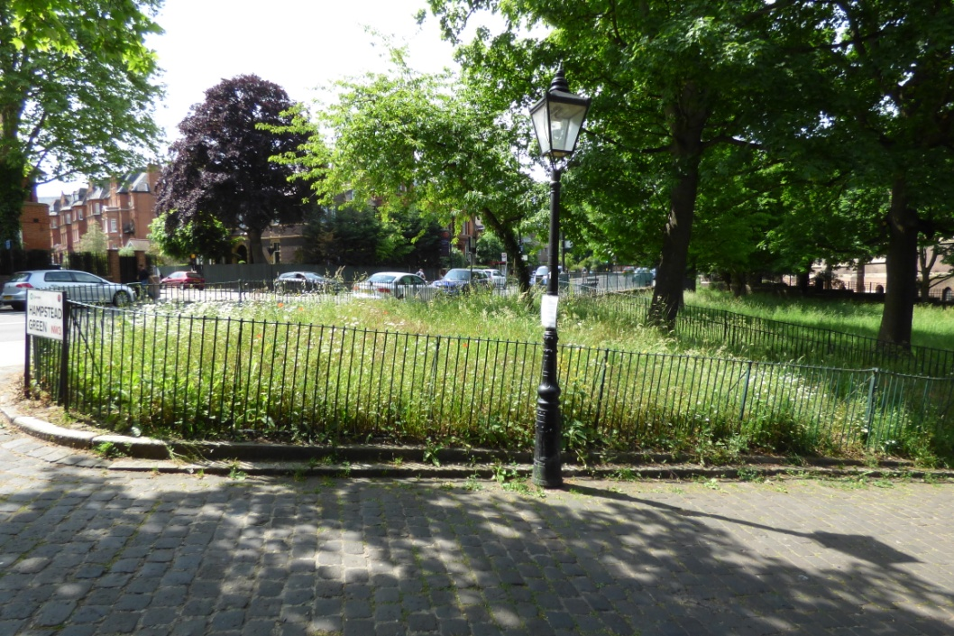

The Friends of Hampstead Green have now linked up with the local volunteer group Heath Hands. Both groups contribute regular maintenance, and concern and support for its future protection.

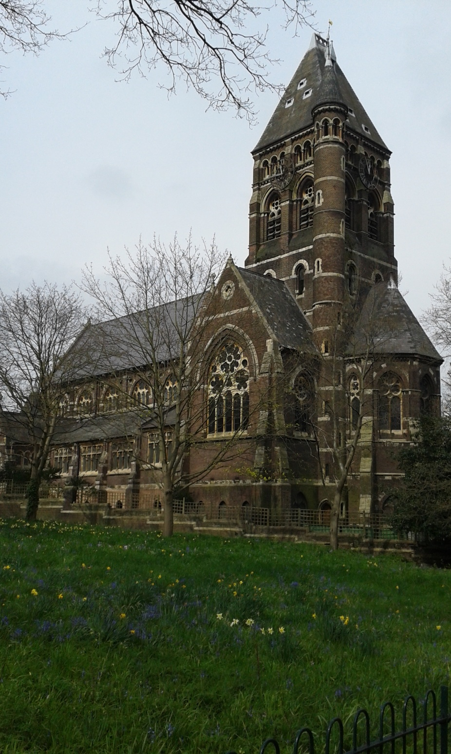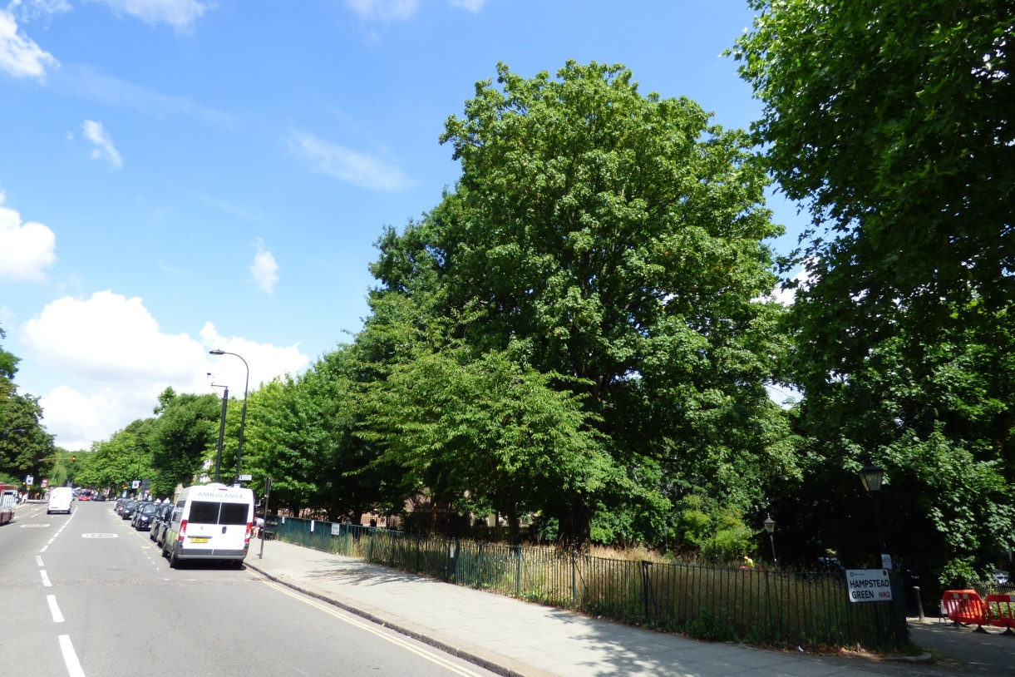

Special Policy Area:
Area of Special Character: Hampstead & Highgate Ridge.
Hampstead Green has recently been made a Local Site of Importance for Nature Conservation: CaL17. Its site description is as follows:
Hampstead Green is a small triangular grassland area, surrounded by roads and pedestrian paths. The grassland is dominated by Yorkshire fog (Holcus lanatus), common bent (agrostis cappilaris) meadow foxtail (Alopecurus pratensis) and rough meadow-grass (Poa trivialis). It is managed as a wildflower meadow and supports a variety of herbs, such as bluebells (Hyacinthus sp.), red and white campion (Silene dioica and S. latifolia), common knapweed (Centaurea nigra), common vetch (Vicia sativa), yarrow (Achillea millefolium), cow parsley (Anthriscus sylvestris) and oxeye-daisy (Leucanthemum vulgare). Mature oak trees stand around the perimeter of grassland.

Other LA designation:
Hampstead Green is listed as Public Open Space 49 in the LB Camden Unitary Development Plans Schedule of Open Spaces. Hampstead Green is in the Hampstead Conservation Area.

Hampstead Local Plan: ***
Hampstead Green lies close to Biodiversity Corridor F (Hampstead Hill Gardens) and Local Green Space Heath Hurst Gardens in the Plan Area.

It is thus precious and warrants stronger statutory protection which the status of 'Site of Importance for Nature Conservation' - being non-statutory - does not give it.

Supports Local Plan Policies:
Designation of Hampstead Green as a Local Green Space would support Camden's Local Plan Policy A2 'Open Space': c, f, h; A3 'Biodiversity': a, c, e, f, h and i. Through its provision of a beautiful space for local people to nurture and to admire and of interest to children, it is consistent with Local Plan Policy C1 'Health and well-being': a, and Policy C2 'Community facilities'.

