**Local Green Space: Oak Hill Park**

**History**

Oak Hill Park Estate was formed from the demesne land to the west of Frognal, originally part of the anglo saxon North Wood though latterly fields and farmland: demesne land leased from the Lord of the Manor.

**Oak Hill Park Estate:**  The builder, Thomas Clowser built 10 houses in the 1870s in what he called Oak Hill Park estate after the new road running from Frognal to Oak Hill House and Lodge was built. Florence Nightingale was a frequent visitor to Oak Hill Park, where Manley Hopkins, an authority on maritime law, lived in the 1850s with his family, including Gerard, the future poet.

The Oak Hill Park development was built in 1961-65 by Michael Lyell Associates, with landscaped grounds. Oak Hill Park is a private estate managed by Dawlin, Oak Hill Park's freehold management company.

**Oak Hill Lodge and Oak Hill House** Thomas Neave sold Branch Hill Lodge and built two houses to the west on former demesne land: Oak Hill Lodge where he was living by 1840, and Oak Hill House. George Smith (1824- 1901), founder of the Dictionary of National Biography, lived from 1863 to 1872 in Oak Hill Lodge, where he entertained leading writers and artists. Oak Hill Lodge became part of the new Oak Hill Estate, the house was demolished and the present block of flats was built in the 1960s, now managed by the estate's property management company Dawlin.

Oak Hill House is still privately owned and separate from the Oak Hill Park Estate management. Part of its rear garden was sold in the 1960s to extend the rear garden of 28 Redington Road (this part of the garden is now within Redington Frognal Neighbourhood Forum area) and several other houses have been built within its garden: Weeping Ash and the Garden House.

**Richness of Wildlife**

The Oak Hill Park Local Green Space area contains some areas of woodland and a range of trees, both indigenous and non-indigenous, and importantly a wide range of tree ages. Being surrounded by dense woodland on two sides it is also an important area of habitat for nesting owls, other bird species, bees and bats. The range of flowering shrubs, planted flowers and wilder areas means that this is a rich habitat for invertebrates, and hence the birds and bats that feed on them.

**Veteran trees**

Oak Hill Park Estate and Oak Hill House contain a number of veteran trees of 250 or more years old, and quite a number with veteran features. One of the veteran trees in Oak Hill House grounds contains a wild bees nest within a hole in the trunk. These veteran trees are of immense importance to the other veteran trees and the wildlife specific to this special habitat in the area, being part of a bridge between these local veteran trees and those on Hampstead Heath, and also the veteran trees of the future.

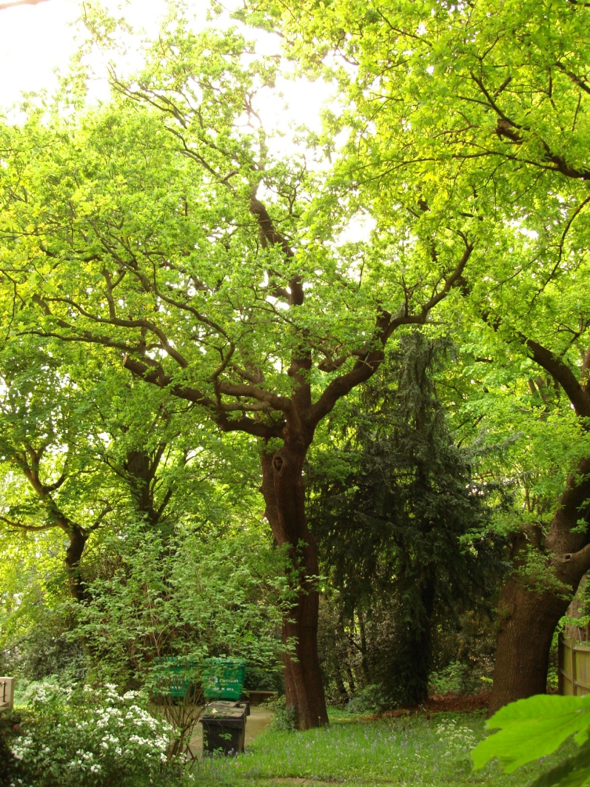 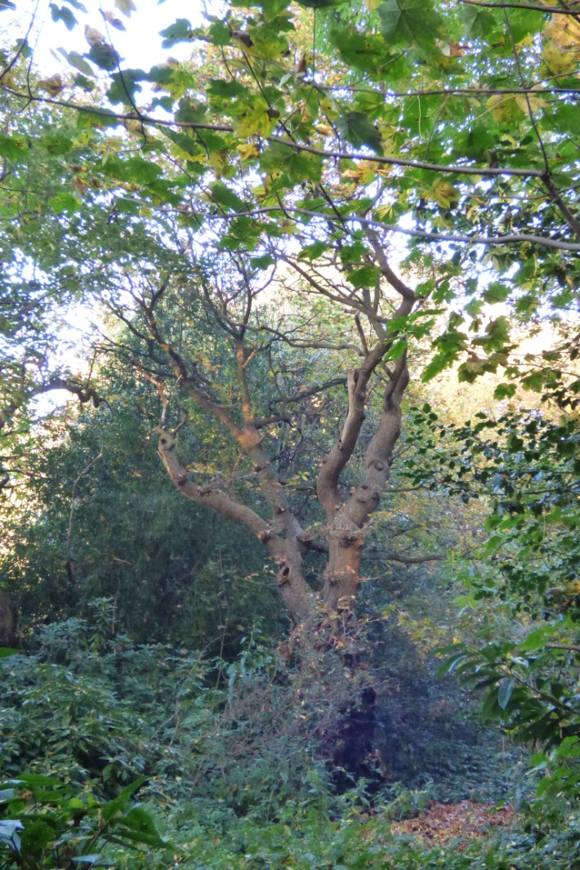

**Veteran oak by fence on the right with wild bees nest Another oak with veteran features: good habitat**

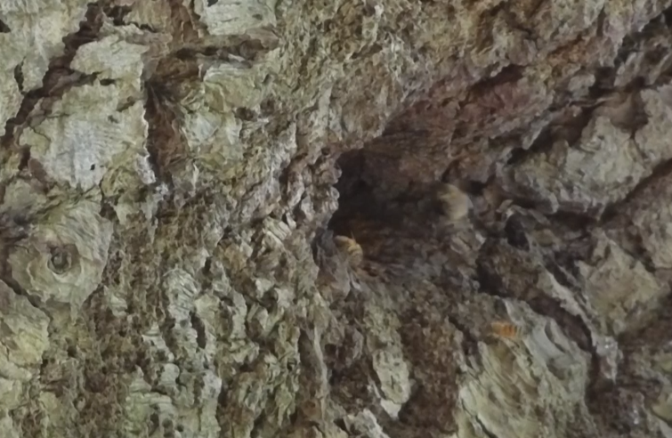 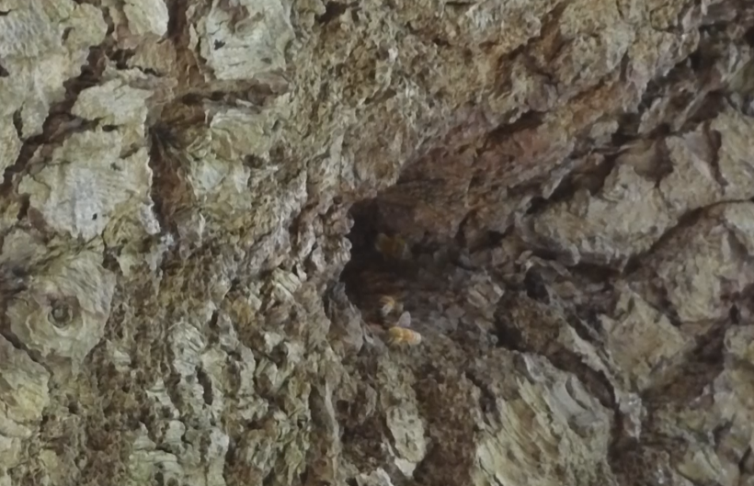

**Wild bees nest within the trunk of the veteran oak tree above**

**Owners**

All residents of Oak Hill Park Estate are members of Dawlin, the freehold management company for Oak Hill Park. The board of Dawlin declined to support the proposal to make Oak Hill Park a Local Green Space due to their concern that it is a private, not public open estate.

**Management**

Dawlin manages the green areas of Oak Hill Park, clearly with a mind to protecting wildlife and looking after the many trees of which there are upwards of 140, some part of group TPOs Hampstead 5 and 11.

**Special Policy Area:**

Area of Special Character: Hampstead & Highgate Ridge.

**Other LA designation:**

Hampstead Conservation Area.

**Supports Local Plan Policies**:

Designation of Oak Hill Park as a Local Green Space would support **Camden's Local Plan Policy A2 'Open Space': c, e** (bearing in mind that Oak Hill Park Estate is not open space: it is a large private estate open to all its residents)**; A3 'Biodiversity': c, e and j. By providing informal play space for its residents children, and a tennis court as well as a restful and beautiful private space for all its adult residents** it is consistent with Local Plan Policy C1 'Health and well-being': a, and Policy C2 'Community facilities', while recognising that the community is limited to that of the Oak Hill Park Estate which consists of about 80 residences.

**Links to other Green Space in the Hampstead Local Plan area**

Oak Hill Park Estate sits between Local Green Space and SINC Branch Hill and the Plan's Biodiversity Corridors G (North-western Frognal) and K (Western Frognal rear gardens from south Redington Road to HNF boundary). As such it is in a key position to link Hampstead Heath with significant parts of the Plan Area, but also Redington Frognal Neighbourhood Forum, and Church Row and Perrins Walk Neighbourhood Forum with its Borough level SINC CaBI08 Hampstead Parish Churchyard. A particularly important role here is the link it provides, along with Branch Hill Local Green Space, between the veteran trees on Hampstead Heath with veteran trees and trees with veteran features within the Plan Area, and also those in the Redington Frognal Neighbouring Forum and to the south west of the Plan Area.