**Local Green Space: The Pryors**

**Description of Space**

The Pryors are two blocks of private flats, Block A and Block B, situated on the edge of and within Hampstead Heath with a large communal garden between them. It is mainly laid to grass but has many specimen trees, hedges, shrubs and flower beds.

**Local Significance: (Historical and Beauty)**

The Pryors was originally a large single house with stabling and extensive gardens, owned by the Pryors family. It is shown as present on Rocque's Map of London (1741-5). Walter Field, water colour artist of some repute, and main founder of the Hampstead Heath Protection Society, lived here up until his death in 1901. He was untiring in his efforts to preserve the natural beauties of Hampstead Heath. The whole plot of 1¾ acres was sold the following year with its grounds described as charming and secluded, shaded by cedar and other trees. The house was then pulled down and the present two large blocks of flats built, but retaining much of the gardens.

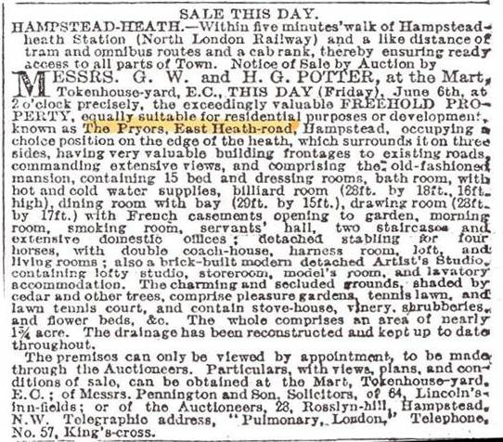

**1902 sale announcement for the old house and its garden**

Thomas J Barratt in his 'The Annals of Hampstead' of 1912 reported (vol iii, page 214) 'A fine Copper Beech stands immediately in front of a new block of buildings known as The Pryors in the East Heath Road.'

The Pryors Ltd was set up in 1976 when the lessees bought the freehold. It is expected to continue into the future with the continued help of a managing company. The garden is managed by the 'Garden Group' which is a subcommittee of the Board of The Pryors Ltd. They produce a newsletter about the garden twice a year for the residents.

The Pryors garden is important to residents; a very popular amenity particularly with young families giving safe enjoyment to people of all ages, including children. It has 550 yards of hedges, 115 yards of planted beds around Block B, further beds in the car park and in the main garden. In addition there are hanging baskets and tubs adjacent to both blocks, a rose garden between Block A and the Heath, and a composting area for both garden and kitchen waste. There is an important and much used huge area of grass and 27 trees.

The trees in the garden are inspected annually. There are 17 different tree species, including maples, beeches, holly, birch, cedar, oak, whitebeam, oriental plane, ash, tulip tree and various fruit trees.

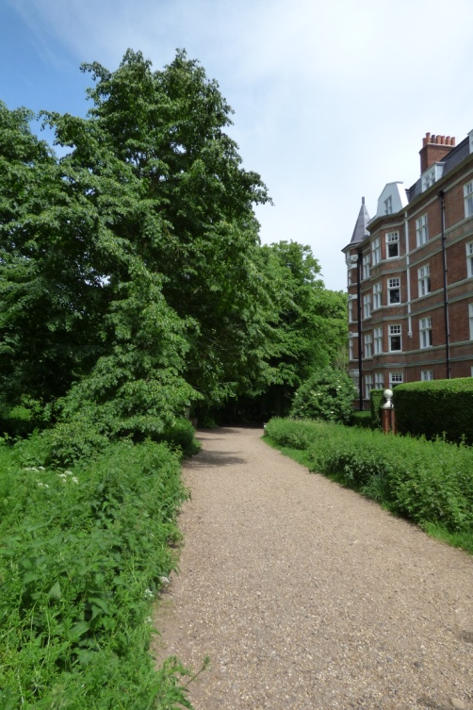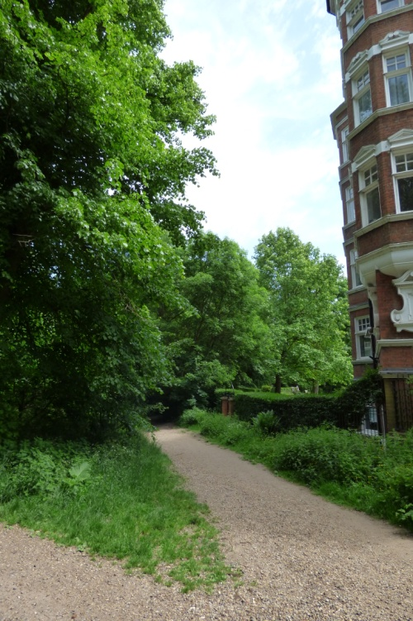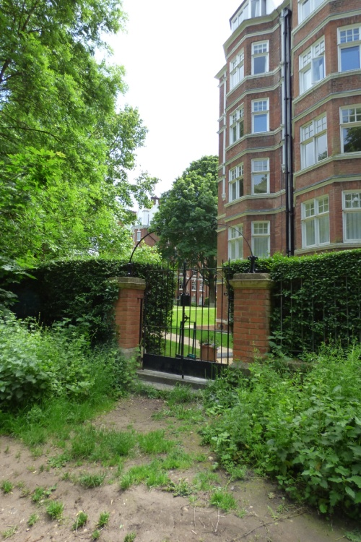

**The Pryors taken from Hampstead Heath demonstrating how well it blends into its surroundings**

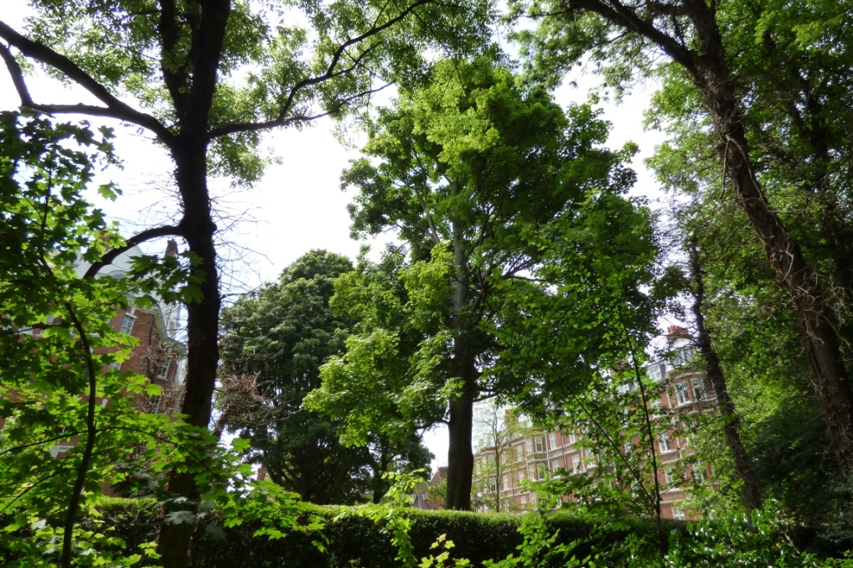 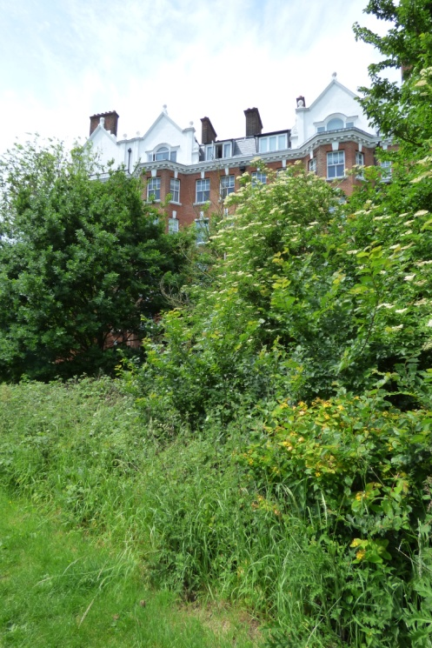

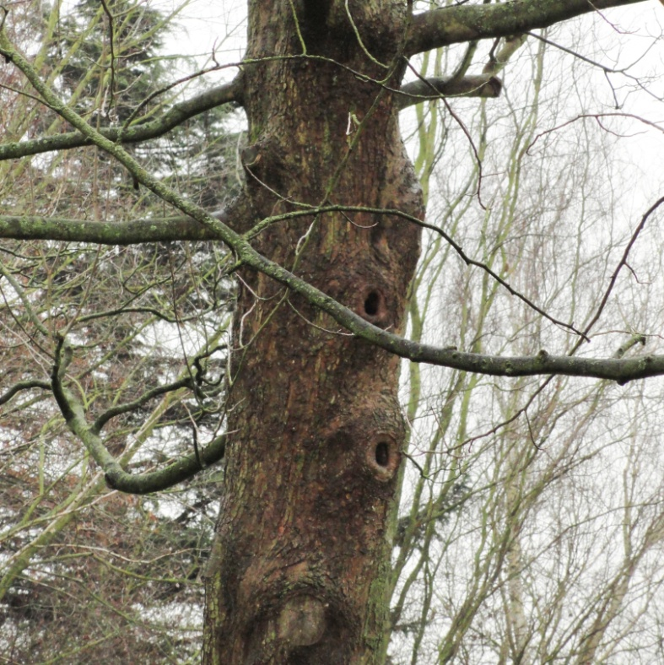

**Richness of Wildlife**

Being quite literally within the Heath, the trees in the gardens here are managed for their habitat as well as their beauty; one can be seen from the Heath with a splendid set of holes. The smaller bats are regularly seen to fly around in the garden and the larger noctule bats are known to fly high over the Heath at dusk from this direction.

**Special Policy Area:**

Area of Special Character: Hampstead & Highgate Ridge

**Other LA designation:**

The Pryors are in the Hampstead Conservation Area.

**Supports Local Plan Policies**:

Designation of the gardens of The Pryors as a Local Green Space would support **Camden's Local Plan Policy A2 'Open Space': c, e, j; A3 'Biodiversity': c and j. By providing informal play space for its residents children as well as a restful and beautiful space for adult residents** it is consistent with Local Plan Policy C1 'Health and well-being': a, and Policy C2 'Community facilities'.

**Hampstead Local Plan:**

Heath fringes; Biodiversity corridors