Local Green Space: Heath Hurst Gardens

This communal garden is sited over the entrance of the tunnel for the North London line west of Hampstead Heath rail station. The communal garden is approached via a pathway between 21 and 23 Heath Hurst Road on the south side of Heath Hurst Road. It is run by the Heath Hurst Gardens Association (HHGA) for all the residents of all houses in Heath Hurst Road, both north and south. HHGA have leased this garden since 1970.

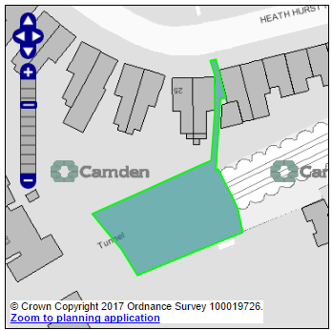
Entrance to the
North London line tunnel

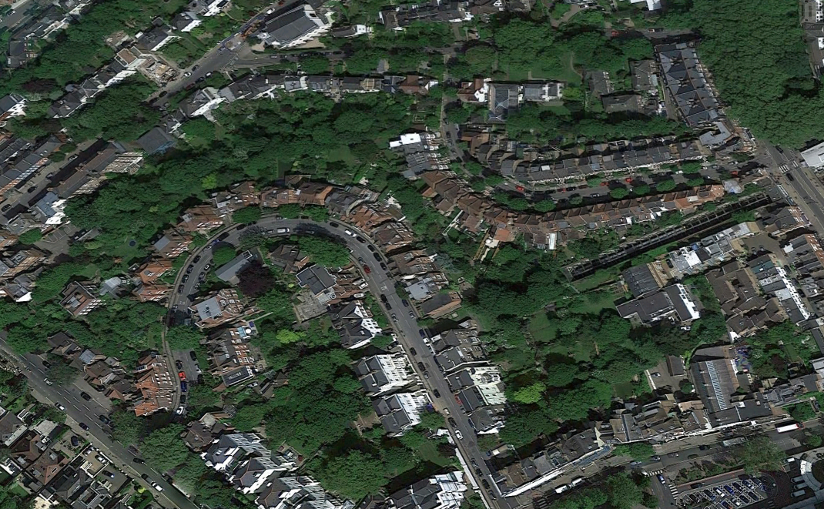

Use by local community
Heath Hurst Gardens are kept locked with all residents of all houses of Heath Hurst Road having access. Principally it is an area for children from Heath Hurst Road to play safely, and for adults to have a tranquil green area for relaxation. This is very welcome as some Heath Hurst Road houses - due to the railway line and lay-out of other roads in the area - do not have large private rear gardens. HHRA maintain the communal garden and trees, and the access.

Richness of Wildlife
The communal garden consist mainly of grass (a large area with football goal posts), trees including poplars, sycamore, ash and elder, shrubs and flowers both wild and cultivated, and a play area with swings and a climbing frame.

Wildlife that the residents note include foxes, squirrels, many bird species, newts, frogs, abundant insect life hence bats that hunt here too, and bees that are enticed by the flowers and flowering shrubs.

Special Policy Area:
Heath Hurst Gardens are a short distance from the western end of the strategic biodiversity corridor 'North London Line railway corridor'. This railway corridor is a narrow corridor across the Borough and although in places is of limited value for wildlife, the areas of greenspace are valuable ‘stepping stones’ for wildlife movement.

It therefore has recognised links to the strategic Hampstead Ridge corridor (a hilly ridge that bisects Camden and runs through from the neighbouring boroughs of Barnet and Haringey) and the Nash Ramblas Link corridor (a link corridor running up from Parliament Square and the Thames, through the Royal Parks and Primrose Hill to Parliament Hill and Hampstead Heath).

Other LA designation:
Heath Hurst Gardens are in the Hampstead Conservation Area.

Supports Local Plan Policies:
Designation of Heath Hurst Gardens as a Local Green Space would support Camden's Local Plan Policy A2 'Open Space': c, e, j; A3 'Biodiversity': c and j. Through its provision of safe and secure play facilities for its residents' children, it is consistent with Local Plan Policy C1 'Health and well-being': a, and Policy C2 'Community Facilities'.

Links to other Green Space in the Hampstead Local Plan area
Heath Hurst Gardens are a link in a local chain. They connect the most southerly part of Hampstead Heath, along the rail sides with the South End Green and Mansfield Allotments (also part of the SINC CaB104), then on to Hampstead Local Plan Biodiversity Corridors F (the rear gardens of Hampstead Hill Gardens, Heath Hurst Road and Keats Grove) which is an historical tree line and hedgerow, Biodiversity corridor D (an historical tree line between Downshire Hill and Pilgims Lane) and thence on to Biodiversity corridor J along Shepherds Walk, Spring Walk and Spring Path.

How will the green space be managed in the future?
HHRA wish to maintain the communal garden and trees and are about to re-sign a further lease on this plot.

Owners of the land
Age Concern, Camden are the freeholders.

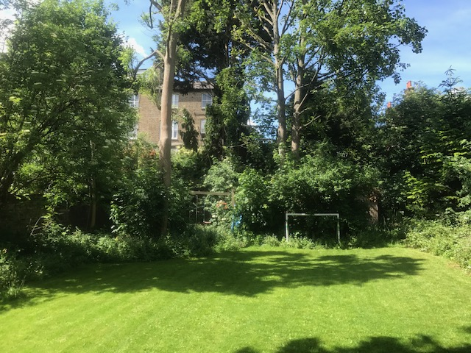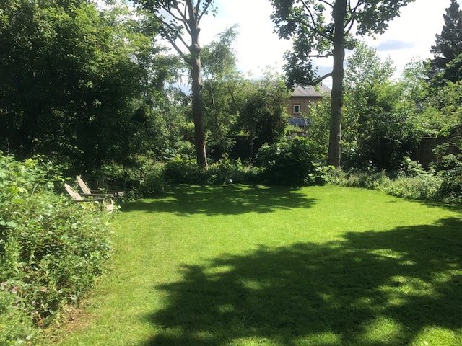

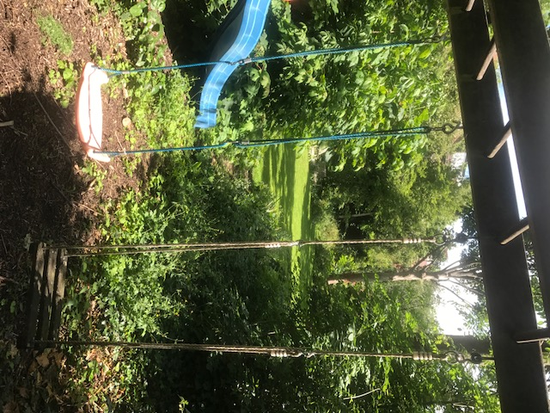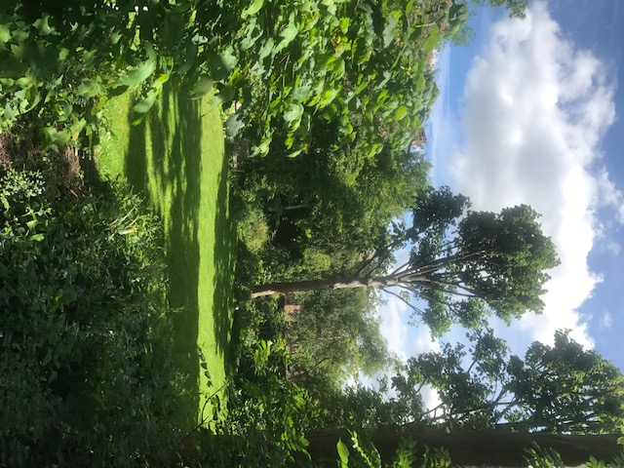

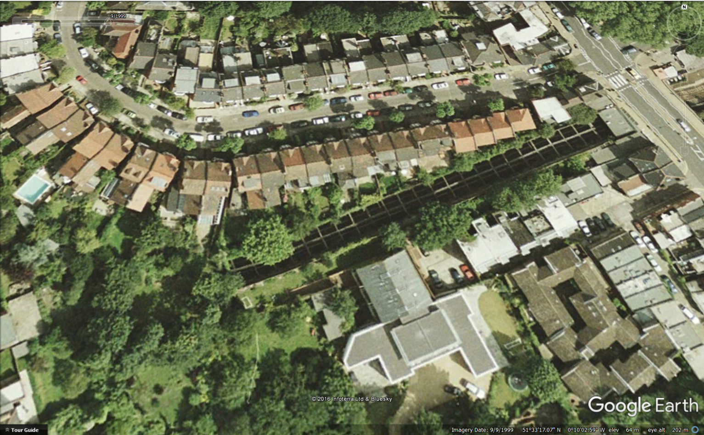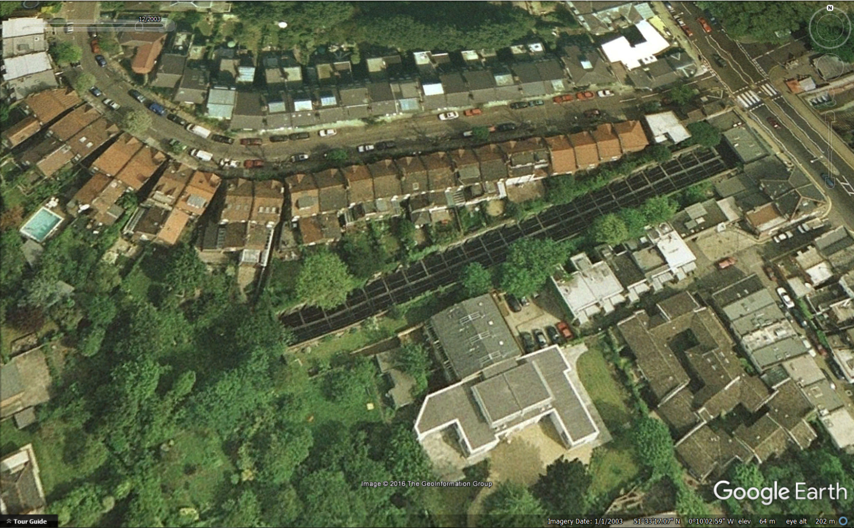
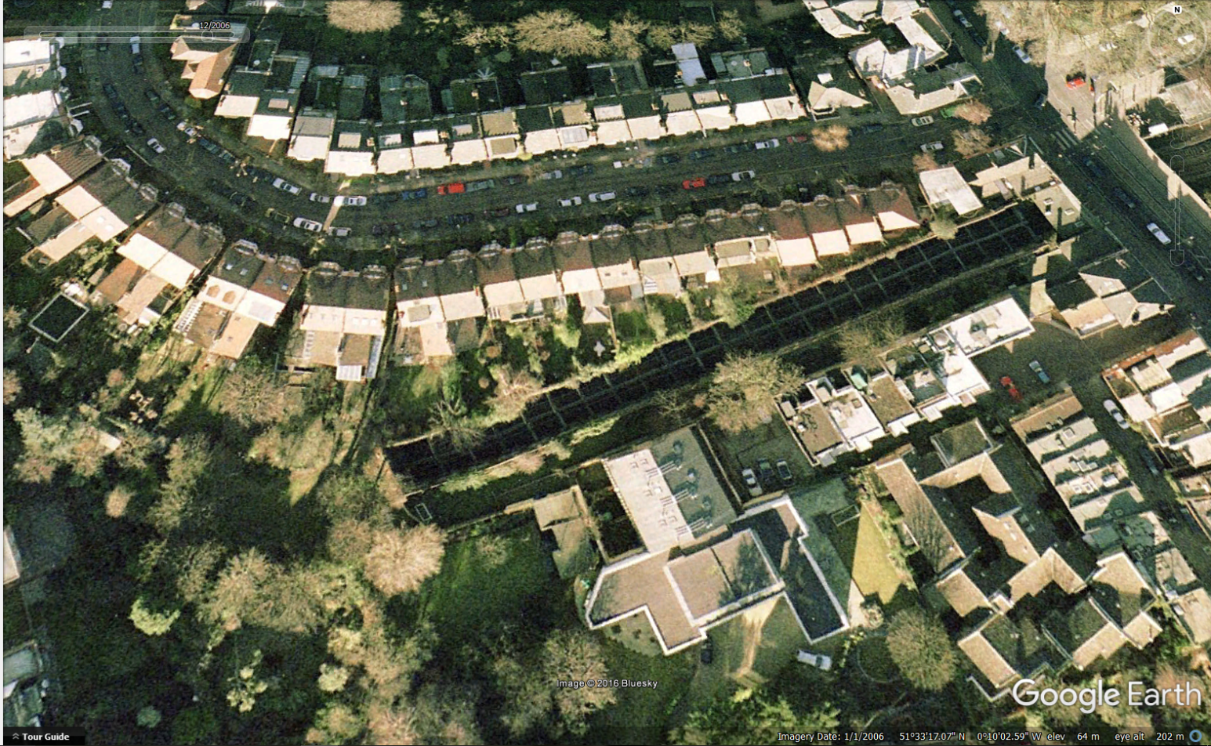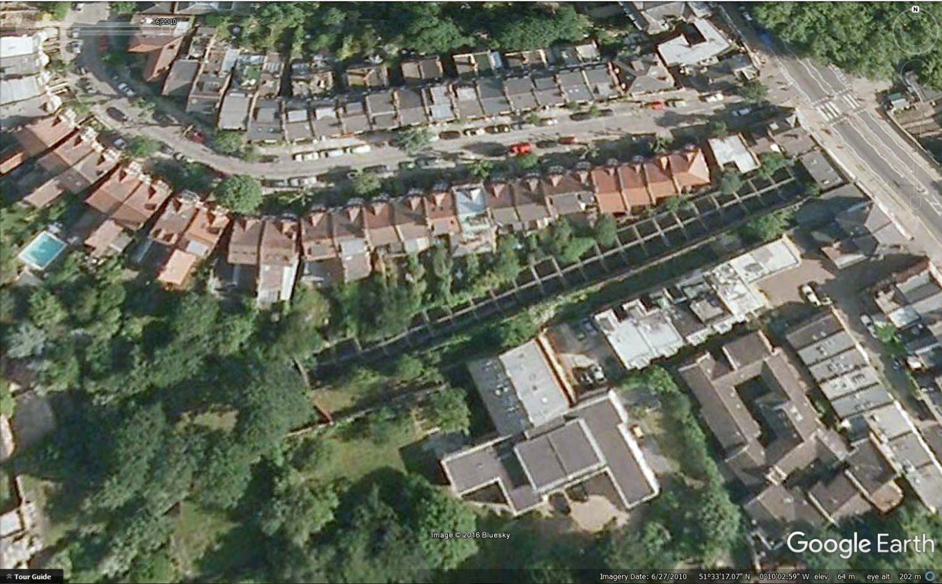
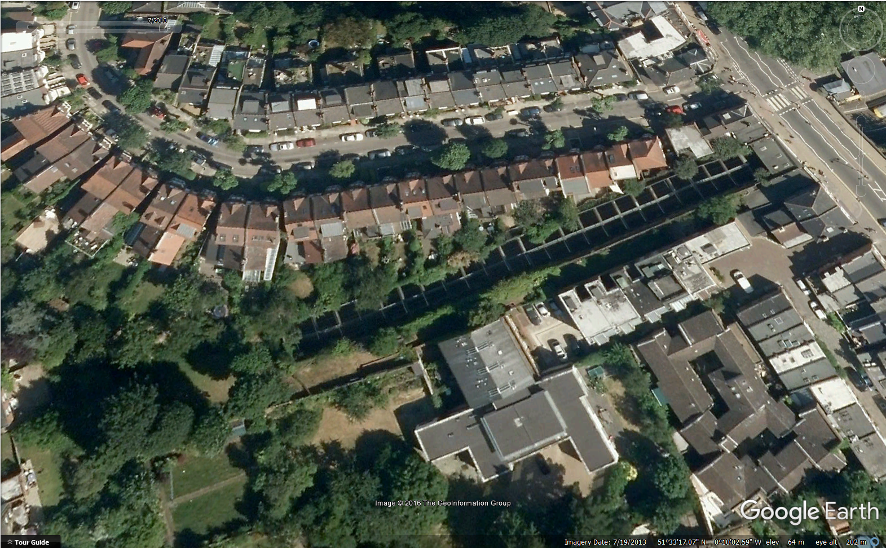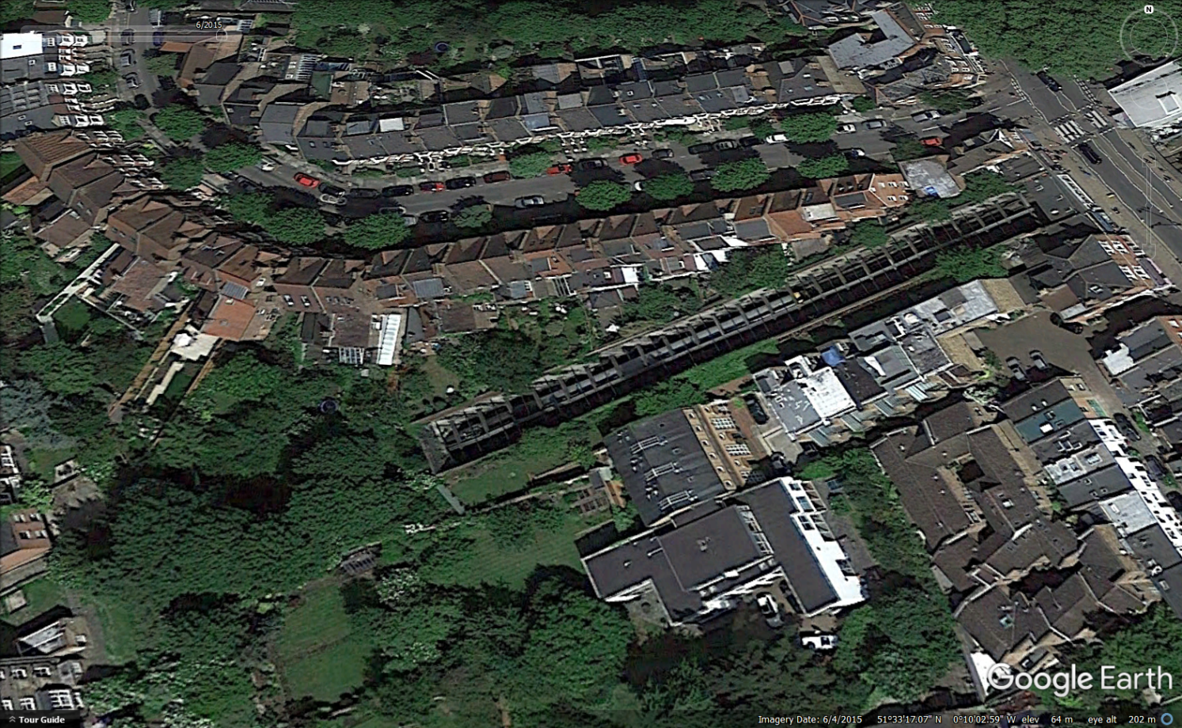
Communal gardens stability over the years as seen with Google Earth: 1999, 2003, 2006, 2010, 2013, 2015

Mayor of London's 'Green Infrastructure and Open Environments: The All London Green Grid' Supplementary Planning Guidance March 2012

