**Local Green Space: Communal Gardens of Wells House and**

**Gertrude Jekyll’s Garden**

**Description of Site:** The communal gardens of Wells House and Gertrude Jekyll gardens, Well Walk are part of the estate owned by Camden. Many of the flats have been bought under the Right to Buy scheme. The grounds are mainly laid to lawn with geometric bedding and planters around the lawns, and some trees.

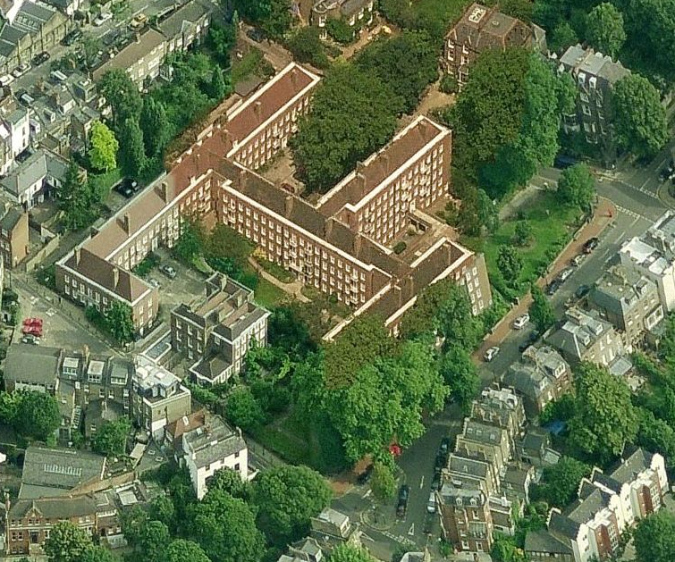

**Local Significance: (Historical and Beauty)**

The flats and grounds are built on the site of the second Long Room and Ballroom of the Spa revival in the 1730s. These Spas buildings were converted to residencies, but bombed in WW2 and the current housing built in 1948. The Gertrude Jekyll gardens in front of Burgh House were originally part of Burgh House gardens. Jekyll was one half of one of the most influential and historical partnerships of the Arts and Crafts movement, thanks to her association with the English architect, Edwin Lutyens, for whose projects she created numerous landscapes.

Jekyll is remembered for her outstanding designs and subtle, painterly approach to the arrangement of the gardens she created, particularly her "hardy flower borders".  Her work is known for its radiant colour and the brush-like strokes of her plantings.

Dr George Williamson commissioned Gertrude Jekyll in 1908 to design the gardens of Burgh House, and this is the main remaining section. While Camden have re-built the gardens and put new walls around them, nevertheless there are areas of path that retain the original materials and the outline of paths and beds that is so typical of Gertrude Jekyll have been retained.

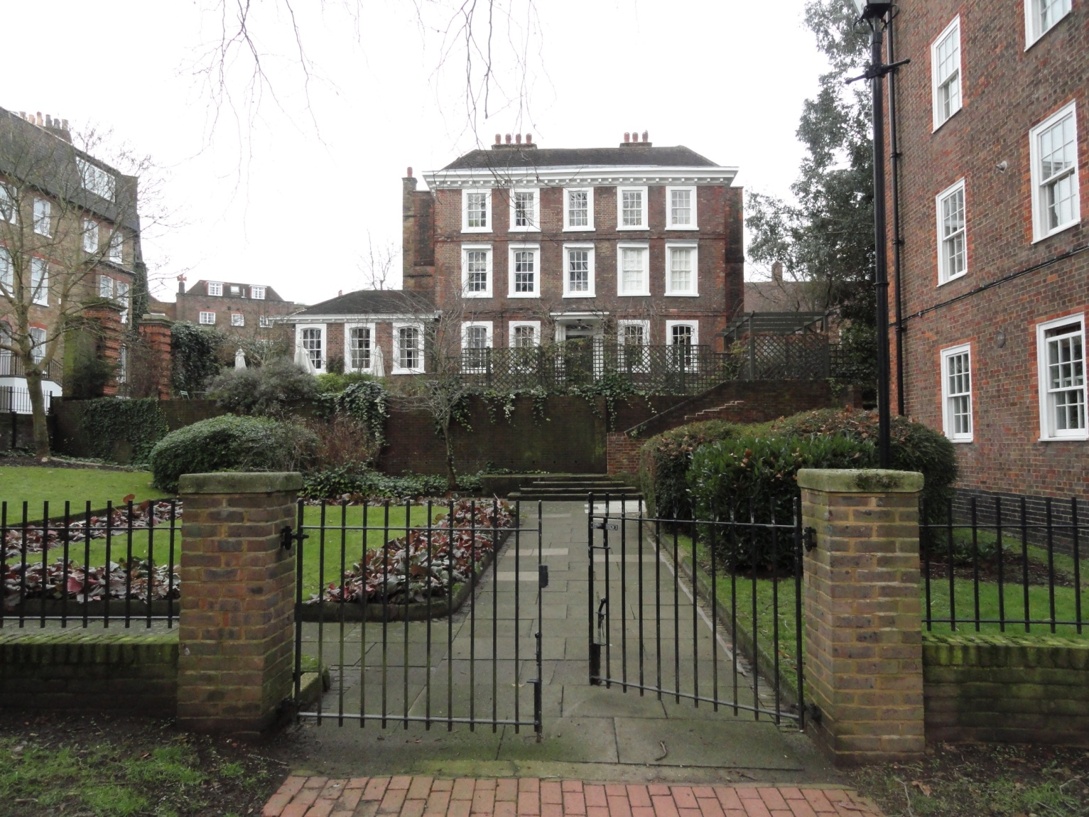

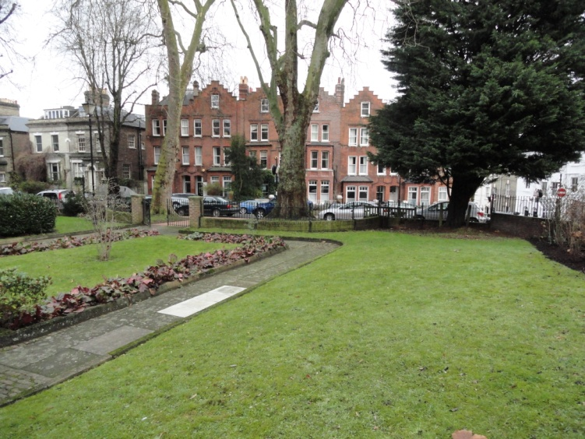 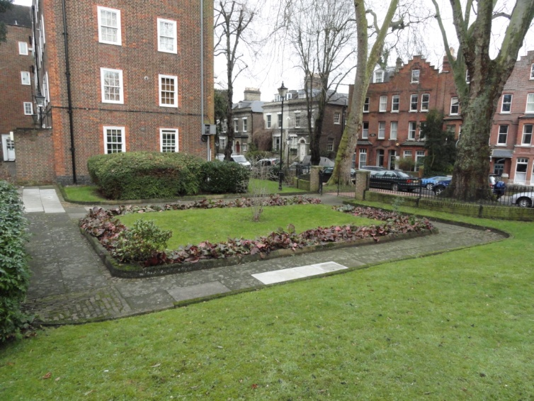

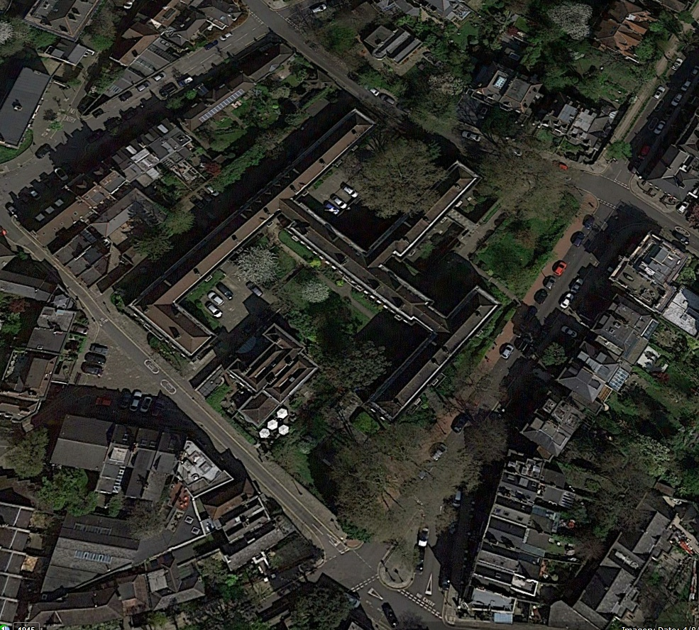

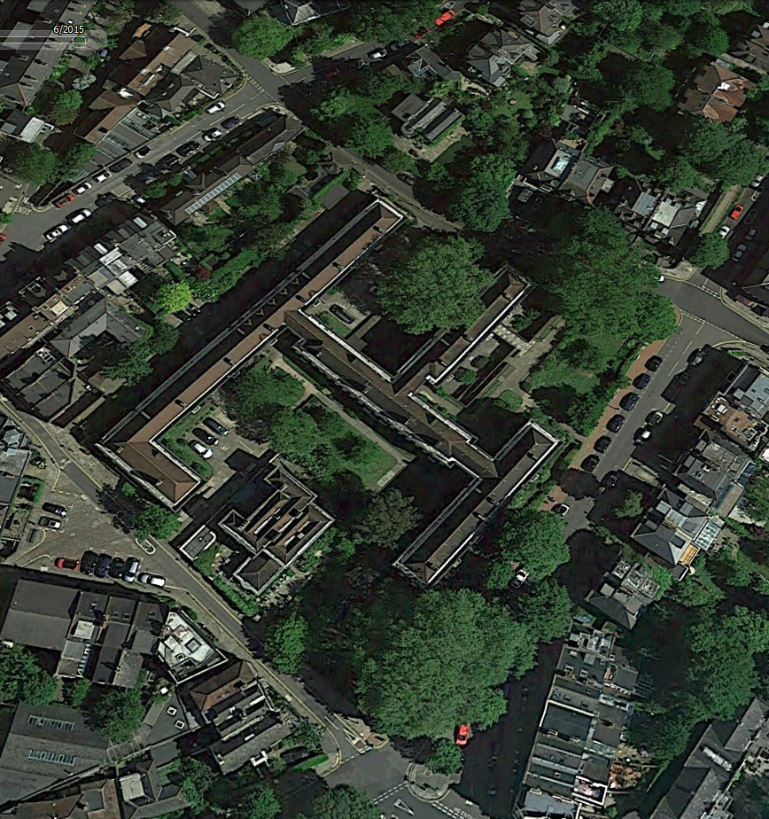

Google Earth: The communal gardens of Wells House and Gertrude Jekyll gardens, winter and summer

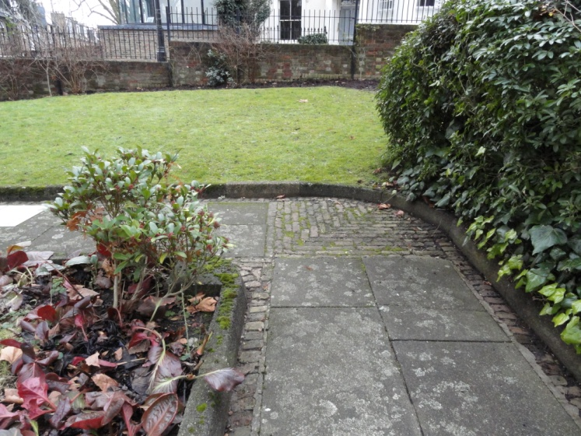

Some of the retained brickwork and materials

**Use by Local Community:** The flats of Wells House have no private outdoor space; these communal green spaces are residents’ sole amenity for children’s play, dog walking, gardening and outdoor recreation. Estate residents contribute towards caring for the garden, managed by Camden's Housing district area manager.

Hampstead Ward has only 0.1sqm of play space provision per child, by far the lowest in the borough, where the proposed quantity standard for children’s play provision 0.65 sq.m per child. Atkins Camden Open Space, Sport and Recreation Study Version 1.0 24 February 2014.

**Special Policy Area:**

Area of Special Character: Hampstead & Highgate Ridge.

**Other LA designation:**

Hampstead Conservation Area.

**Supports Local Plan Policies**:

Designation of the Communal Gardens of Wells House and Gertrude Jekyll gardens as a Local Green Space would support **Camden's Local Plan Policy A2 'Open Space': b, c, f, h; A3 'Biodiversity': a, c, e, f and h. By providing informal play space for its residents children as well as a restful and beautiful space for adult residents** it is consistent with Local Plan Policy C1 'Health and well-being': a, and Policy C2 'Community facilities'.

