**Local Green Space: Burgh House Gardens**

**History**

Burgh House was built in 1704 by Henry and Hanna Sewell. The garden was already a key feature of the house.

## Auction particulars from *The* *Times*, 24th April 1822:

'The house has a handsome approach, commanding extensive and delightful views of the hills of Kent and Surrey ... butlers' offices detached, housekeeper's room, with servants sleeping rooms, a double coach house and a four stall stable, large brewery and laundry, with plenty of excellent water and dry and capacious cellaring: a detached kitchen garden, enclosed with lofty walls covered with fruit trees in good bearing, with greenhouse, hothouse and cold bath; the whole replete with every convenience requisite for a highly respectable family.'

In 1911, Dr George Williamson who owned and occupied the house from 1906-1924, commissioned renowned garden designer Gertrude Jekyll to renovate the grounds. Though little remains of the garden today, her legacy lives on through her signature mill-wheel designs on the paving stones, the continuation of some of her favourite plants and flowers and the terrace that bears her name.

When the Burgh House Trust took over the running of the House in 1979, they enlisted volunteers to clear up and replant the garden, which was overgrown and suffering from years of neglect. The garden is still cared for by a dedicated team of volunteers, led by Head Gardener Chris Coll, which works tirelessly all year round to ensure that it stays looking beautiful.

The Burgh House gardens were originally more expansive than the space seen today. At the front of the House, there was a large lawn that extended beyond the terrace. There was also a garden at the back as well as one to the right, which extended all the way from where Wells House now stands to Christchurch Hill and Well Road.

## Sales particulars by Hamptons Estate Agents, 1924

'Charming formal garden with fruit trees and Yorkstone paved paths with ornamental column in centre, greenhouse, forcing frame, rustic summer house, etc. Soft water in tank area. Separate garden with entrance from New End Square.'

## Sales particulars by Potters Surveyors and Valuers, late 1930s

'Queen Anne Residence to be sold with delightful well planned and laid out secluded gardens of over one acre, planted with Roses, Rhododendrons, Lilac, Azalea, Clematis, Japonica, Wisteria and a charming variety of choice flowering shrubs and mature trees. Sloping lawns, terraces, lily ponds, flagstone walls, Dutch garden.'

In 1946 the house and gardens were in a poor state after the war, and Hampstead Borough Council bought and restored the house. In 1979 Camden Council awarded a lease to the Burgh House Trust and the house was opened to the public.

Within the gardens of Burgh House, only the front terrace now remains of Gertrude Jekyll's garden which is maintained in her style. The lower gardens now associated with Wells House still exist though much altered (see Local Green Space 'Gertrude Jekyll's Garden & Wells House Gardens').

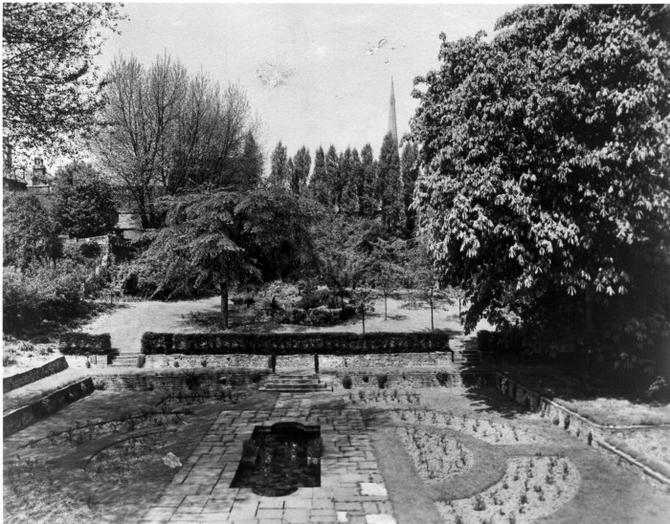

**Burgh House rear gardens 1930s**

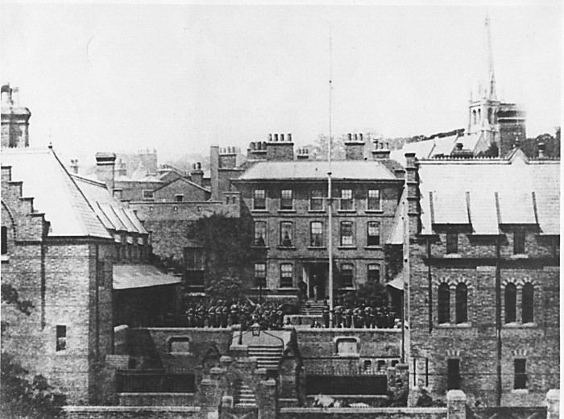

**Burgh House and its front garden with the Royal East Middlesex Militia, 1870**

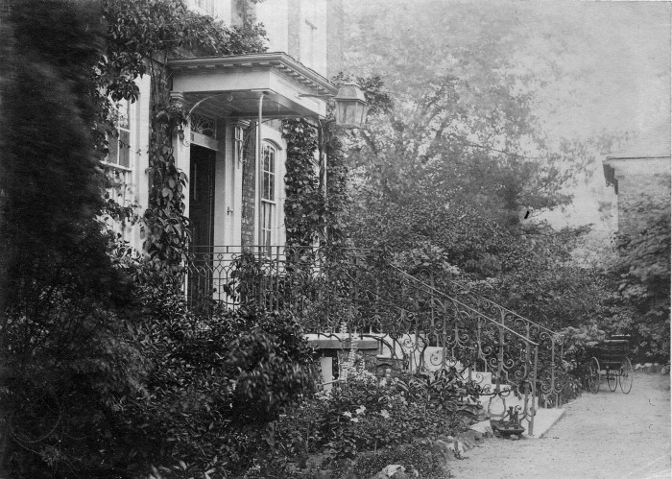

c1884-97 Burgh House front steps

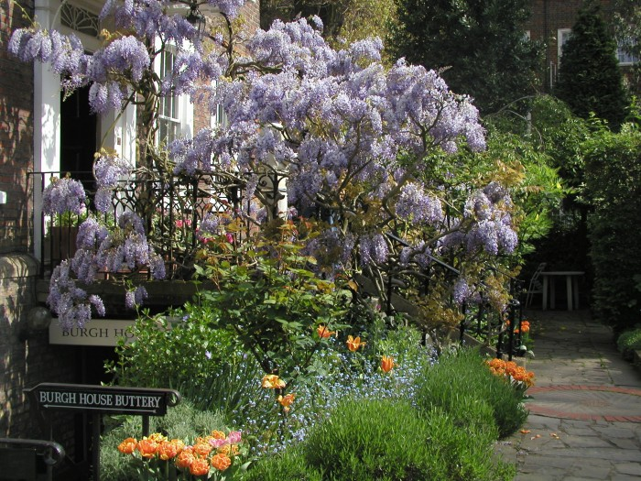

**c1990 Burgh House front steps with wisteria**

**Use by local community**

**\*\*\***

**Special Policy Area:**

Area of Special Character: Hampstead & Highgate Ridge.

**Other LA designation:**

Burgh House is in the Hampstead Conservation Area.

**Supports Local Plan Policies**:

Designation of Burgh House gardens as a Local Green Space would support **Camden's Local Plan Policy A2 'Open Space': c, f, h; A3 'Biodiversity': a, c, e, f and h. Through its provision of a restful and beautiful space with facilities for local people,** it is consistent with Local Plan Policy C1 'Health and well-being': a, and Policy C2 'Community facilities'.

**Hampstead Local Plan:**

Views; biodiversity corridors

**Links to other Green Space in the Hampstead Local Plan area**

Burgh House is within Biodiversity corridor A, a long historic tree line and a key link for wildlife between the Heath and the town. Burgh House gardens are also close to Biodiversity corridor B with its direct links to Biodiversity corridors C, D and F. It is also close to the old village green and open public space in Flask Walk, to the designated village green and open space 'Gainsborough Gardens', and is immediately next door to Local Green Space 'Communal Gardens of Wells House and Gertrude Jekyll’s Garden'.

**Owners of the land**

Camden are the freeholders,

**How will the green space be managed in the future?**

