**Local Green Space: Admiral's Walk to Windmill Hill**

**Description of Space:**

This footpath is a public right of way running south from Admiral's Walk to Windmill Hill by the service entrance of Fenton House.

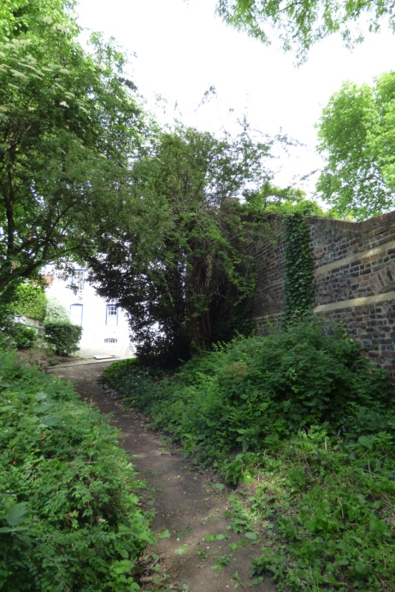 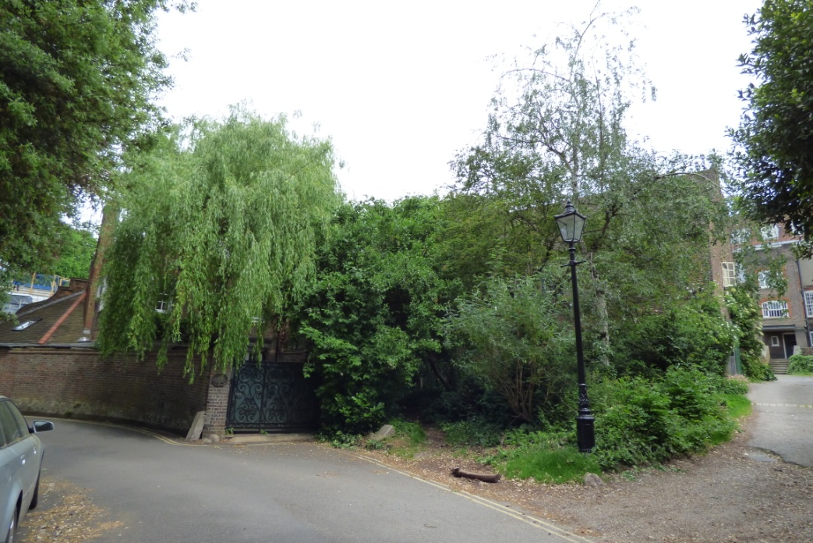

**Northern end of footpath, Southern end of footpath seen emerging between Willow Cottage black**

**opposite Admiral's House gate (to left) and service entrance to Fenton House (to right).**

It runs between the rear, western wall of Fenton House gardens and Fenton House Cottage, and the eastern boundaries of Fleet House in Admiral's Walk and Willow Cottage in Windmill Hill. The footpath has trees and ground cover either side and is maintained by footfall. Clock House pond (also called Crockett's pond) was to its west until the mid-19th century when the pond was filled in. It appears in a painting of Grove Lodge by John Constable c1821-2.

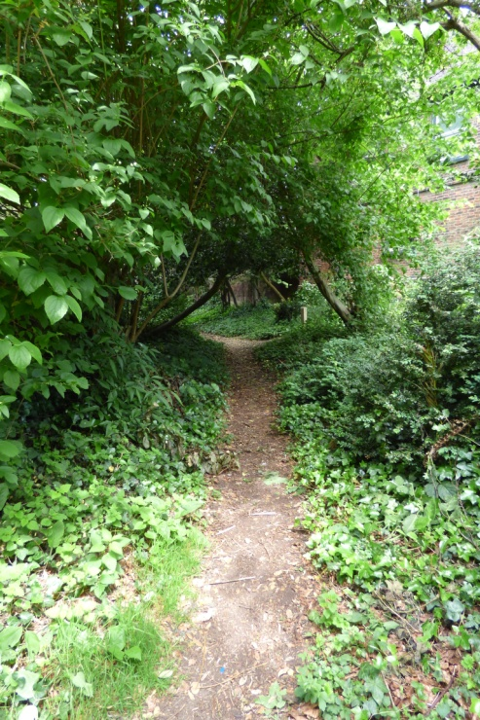 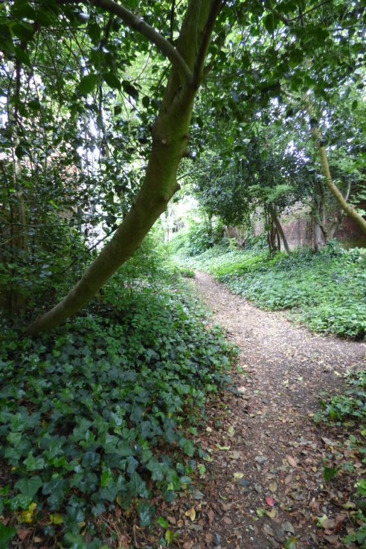 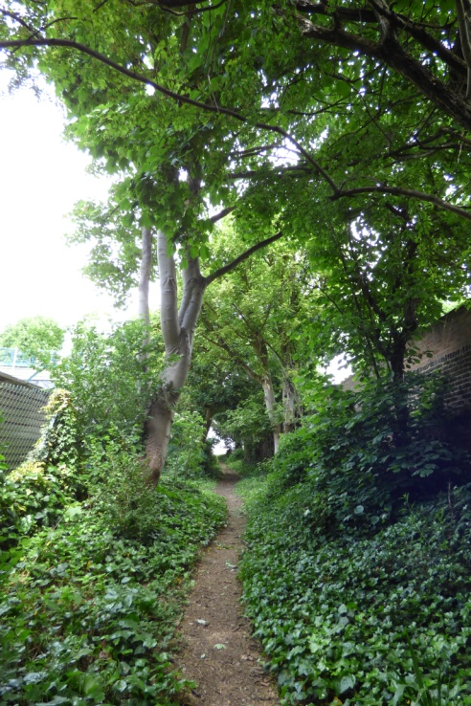

**Local Significance: (Historical and Beauty)**

This footpath is clearly shown on the 1866 Ordnance Survey map as well as possible to make out on Stanford's Library map of 1862 and the Manorial maps of 1762. Attempts by developers to cut down trees or to use the path as an area for parking construction vehicles has been vigorously fought. Camden Tree Officers have refused all attempts to unreasonably fell trees and Camden have refused permission to park on the footpath, particularly within Construction Management Plans.

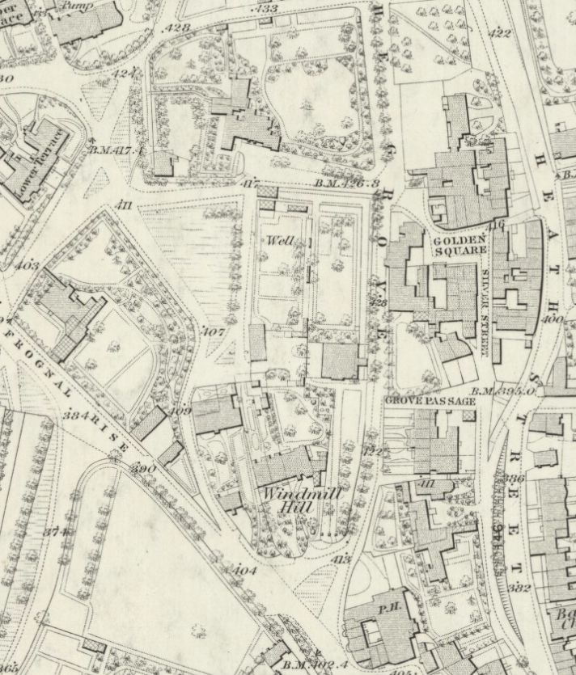

**1866 OS map showing**

**the footpath**

Extent of footpath

Fenton House

Fenton House cottage

'Grove Lodge',

now Admiral's House

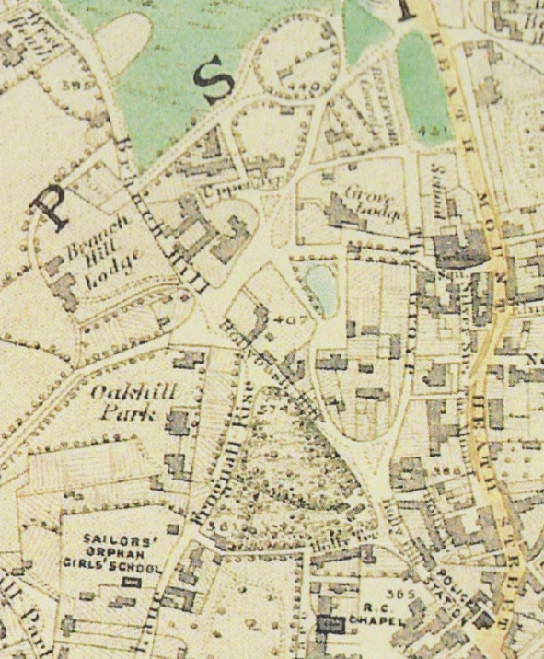 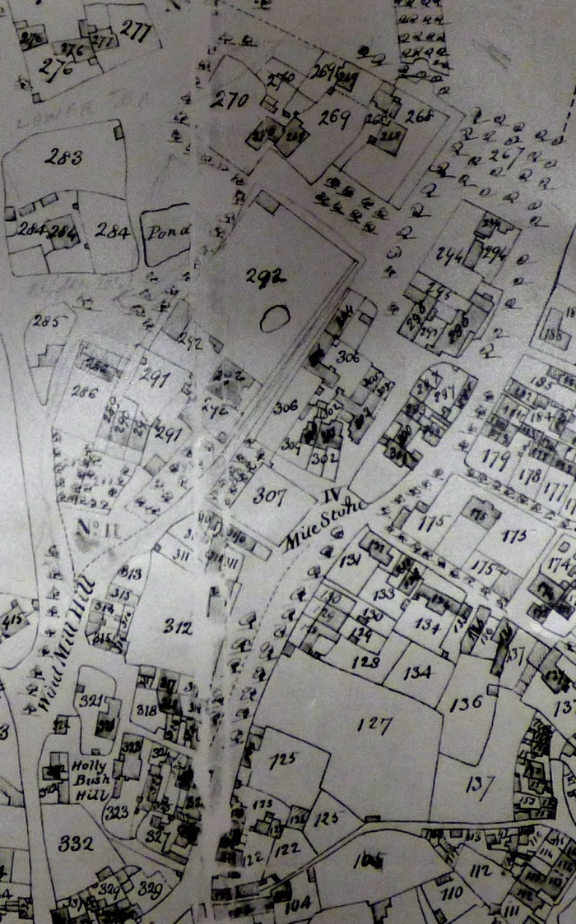

Extent of footpath

Extent of

footpath

**Stanford's Library map 1862 1762 Manorial map**

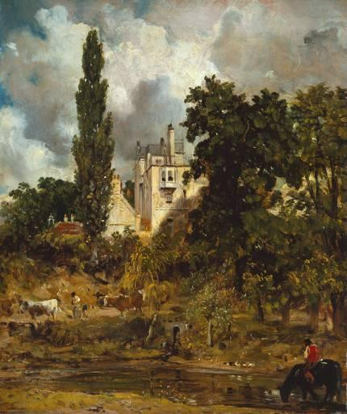

**John Constable's painting c1821-2 of Grove Lodge (now Admiral's House) with Clock House pond (also called Crockett's pond) in the foreground and the footpath seen running behind a row of tall trees on the right**

**Richness of Wildlife**

Trees found along the footpath include hawthorn, elder, yew, sycamore, false acacia, goat willow and Norway maple. Pipistrelle bats fly along this footpath during warm evenings and the extensive ground cover - mainly ivy - provides good habitat and cover for mammals and invertebrates. This is one of the last remaining areas of true 'scrub' land within Hampstead village.

**Use by the Local Community**:

The footpath is a public right of way and its use is evident from the maintenance of the path by this footfall.

**Special Policy Area:** Within the Area of Special Character: Hampstead & Highgate Ridge.

**Other LA designation:** Within the Hampstead Conservation Area.

**Hampstead Local Plan:** Biodiversity Corridor H that runs from the Upper Terrace Reservoir, through the Lower Terrace and Admiral's Walk area, and along Hampstead Grove.

**How will the green space be managed in the future?**

The lack of management and maintenance is the footpath's main attribute. Local people and Fenton House are keen that the footpath is retained as a wild area and a soft treed background to the Fenton House walled garden. The area is unlit and the path maintained purely by footfall, ensuring good conditions for the wildlife that use the cover to nest, feed or to travel through. Since the underlying soil is mainly Bagshot sands it is well drained. Local people plan to work with Camden on retaining its

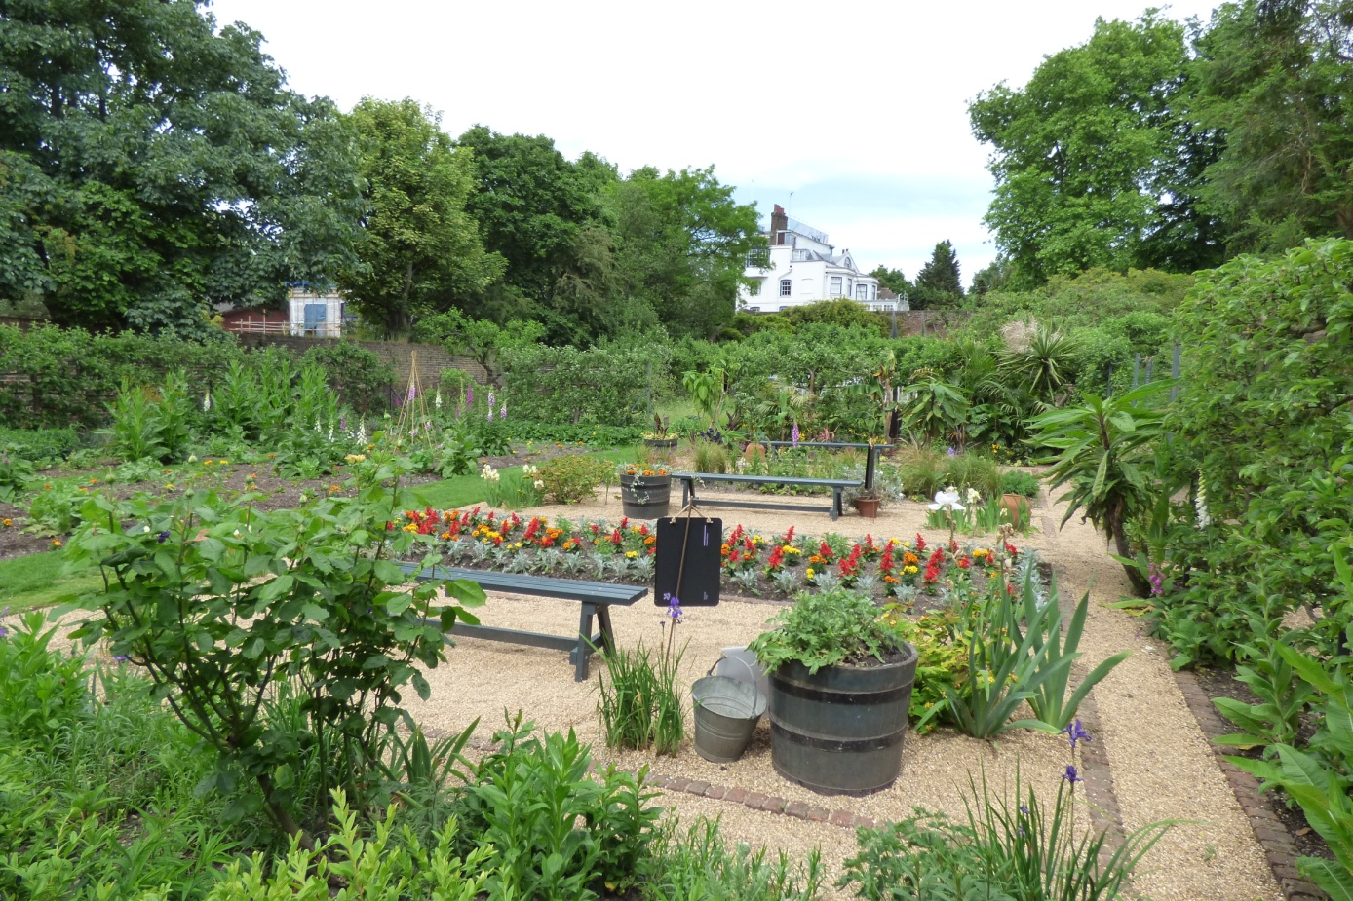

**The line of trees along the footpath behind Fenton House garden western wall**

wildness, and continuing to prevent unnecessary tree felling or pruning, wildlife disturbance, or access by vehicles.

**Have the landowners been consulted?**

It is understood that the footpath is owned by the Maryon Wilson family, past Lords of the manor. Efforts to track them down are on-going.