|  |  |  |
| --- | --- | --- |
| **Branch Hill House Gardens and Wood** | **Description of Space:** Branch Hill consists of several individual blocks of woodland, interposed with small areas of open grassland, a wooded bank south of Firecrest Drive as well as the private wooded grounds of Coombe Edge, Oak Hill House and Heysham House. Largely secondary woodland, it includes native and exotic trees, and is important for wildlife. The area of Oak Hill Wood is particularly known for its bluebells. The Oak Hill Park development was built in 1961-65 by Michael Lyell Associates, with landscaped grounds.  **Use by Local Community:**  **Evidence for Particular Importance**  **Richness of Wildlife:**  **Local Significance: (Beauty and historical)**  Branch Hill Woodland was originally part of Hampstead Heath, from which it was cut off when Branch Hill House was built in its own grounds in the 1860s. Branch Hill Allotments are now on part of its former garden. The sloping site also has areas of woodland, open grass and wooded grounds of private houses. One area is particularly known for its bluebells.  Below Branch Hill House is an interesting low-rise tiered housing scheme unobtrusively built in the midst of the woods on a site purchased in 1965 by LB Camden. The estate was designed in 1974-78 by Gordon Benson and Alan Forsyth. The houses have gardens that also form the roof of the house below, thus blending into the surrounding green space. | **Special Policy Area:** Area of Special Character: Hampstead & Highgate Ridge.  Grade 1 Borough SINC  **Other LA designation:** Public Open Space (Small Local),  Hampstead Conservation Area.  Supports Local Plan Policies: SP13 (open space and biodiversity) ‘protect and enhance and when and where possible extend the existing boundaries of the borough’s green belt, designated open land, designated open spaces, green chains, allotments, river corridors and other open spaces from inappropriate development’ ’protect and improve sites of biodiversity and nature conservation’ ‘protection, management and enhancement of existing trees’ |
| **Oak Hill Wood** | The largest individual block of woodland is Oak Hill Wood. This is secondary woodland which includes sweet chestnut (Castanea sativa), horse-chestnut (Aesculus hippocastanum), sycamore (Acer pseudoplatanus), oak (Quercus sp.), white poplar (Populus alba), common lime (Tilia x europaea) and holly (Ilex aquilifolium). Other species have colonised, including silver birch (Betula pendula), downy birch (B. pubescens), elm (Ulmus sp.), ash (Fraxinus excelsior) and elder (Sambucus nigra).  Housing development in the woodland includes Oak Hill Park built with landscaped grounds and below Branch Hill House is a low-rise tiered housing scheme built unobtrusively in the midst of the woods.  This contains numerous mature trees including hornbeam (*Carpinus betulus*), horse chestnut (*Aesculus hippocastanum*), yew (*Taxus* baccata), beech (*Fagus sylvatica*), sweet chestnut (*Castanea sativa*), oak (Quercus sp.) and ash (*Fraxinus excelsior*). Amongst the understorey species are holly (*Ilex aquifolium*), elder (*Sambucus nigra*) and cherry laurel (*Prunus laurocerasus*). | As above |
| **Branch Hill Allotments** | Adjacent to Frognal Rise and Oak Hill Way are the well-used Branch Hill Allotments that were formed from the gardens of Branch Hill House, probably including a kitchen garden for which part of a wall remains. In the 1980s the neglected gardens were taken on by enterprising gardeners who informally maintained them by growing vegetables here. Their endeavours had the support of local residents and The Heath & Hampstead Society, and resulted in Camden Council earmarking the land for community use as allotments. The Branch Hill Allotments Association is currently taking over management of the area from LB Camden. There are 32 plots here, although a number are divided in two, and some 40 allotment-holders belong to the Association. Probably half as many again (friends of holders) garden there and visiting schoolchildren are pleased to assist.  It is a regular and active part of the annual Open Garden Squares weekend.  The Association aims to allow wildness while developing cultivation in this area once frequented by poets such as John Keats and Gerard Manley Hopkins, and artists such as John Constable and George Romney. It has a wide nature strip along its Oak Hill Way boundary, is surrounded by trees along and just inside all boundaries, and supports several bee hives and ponds.  There is de facto access to most of the site and it is an extremely popular recreational resource for many local people.  A good number of birds regularly visit the site including jay, great spotted woodpecker, tawny owl, nuthatch, goldcrest, long-tailed tit, kestrel, heron, stone chat. Bats; stag beetles and their larvae.  Importance as a green corridor into the village, particularly for bats and for the link between the veteran hedgerow trees on Hampstead Heath and the veteran hedgerow trees in the Redington Frognal area that still exist in some gardens. | As above plus food growing |

Do I have the blessing of the BHAA?  Perhaps you and/or the committee could let me know.

If you have any revisions/suggestions they would be most welcome.  Do let me know if you need any further details about Local GreenSpaces and the Hampstead Local Plan.

**Branch Hill and Spedan Close** Branch Hill Allotments are tucked away on Branch Hill, NW3 close to Hampstead village and have 26 plots and a communal shed. There is currently a waiting time of 10 years for a plot at this site. Spedan Close play area is set in a wooded enclosure and provides a valuable play facility for the local community. It caters for children from 4-12 years old.

 

Proposed boundaries of Branch Hill Local Green Space

a) Branch Hill House Gardens; b) Branch Hill Wood; c) Oak Hill Wood and; d) Branch Hill Allotments. [Al Smith getting back to me with boundaries]

This will be overlaid by the SINC CaB102 in hatching, and also the Branch Hill Woodland TPO (within Branch Hill House gardens, the triangle between Branch Hill - the road - and Branch Hill House).

The added area of woodland garden to the west of Birchwood Drive [photo] will join Branch Hill SINC to the Green Biodiversity Corridor within Redington Frognal NF running from Hampstead Heath towards Finchley Road. The area of trees and garden along the east of Firecrest Drive will provide more continuity with Hampstead Heath and the Branch Hill SINC, assisting the physical connections between veteran trees on the Heath, within Branch Hill SINC and both Hampstead and Redington Frognal NFs' green corridors in the area.

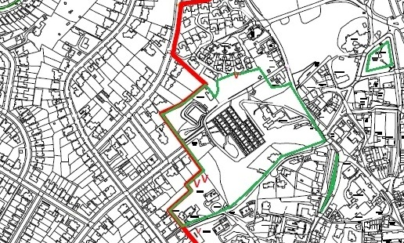

Oak Hill Wood and Play Area are in Hampstead NF area and the closest to the region of Redington Frognal NF area that

Frognal and Fitzjohns ward have 0 square metres of public park and only

Hampstead ward has 1.1 hectares of Total Public Open Space Area per 1,000 population, but Frognal and Fitzjohns has 0.6 and the map of ‘Locations deficient in natural greenspace’ in the Camden draft Local Plan show the importance of Oak Hill Wood and the public Play area to our neighbouring ward.

Camden’s Joint Strategic Needs Assessment

**Camden Local Plan Map 3: Locations deficient in natural greenspace**

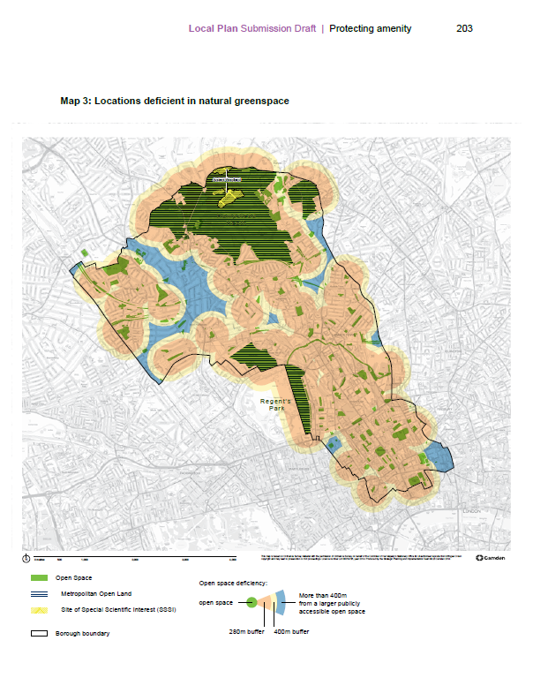

UDP (2006)

Branch Hill SINC CaB102 (Supplementary Planning Document, Sept 2006): A large part of this site is owned by Camden Council. It consists of several individual blocks of woodland interposed with small areas of grassland. It also incorporates the private grounds of three large houses: Combe Lodge, Oak Hill House and Heysham House. Branch Hill Allotments are also included. The largest individual block of woodland is Oak Hill Wood, this is secondary woodland which includes sweet chestnut (*Castanea sativa*), horse-chestnut (*Aesculus hippocastanum*), sycamore (*Acer pseudoplananus*), oak (*Quercus robur*), white poplar (*Populus alba*), common lime (*Tilia* x *europaea*) and holly (*Ilex aquilifolium*). Other, possibly more invasive, species have made an appearance for example silver birch (*Betula pendula*), downy birch (*B.pubescens*), elm (*Ulmus* sp.), ash (*Fraxinus excelsior*) and elder (*Sambucus nigra*). In the north-west corner of the site and connected to Oak Hill Wood by wide wooded avenues of common lime, poplar (*Populus* sp.) and yew (*Taxus baccata*) is a smaller area of woodland and scrub. To the south is the wooded ground of Oak Hill House (mostly composed of sycamore and oak). To the north-east is another large house and wooded grounds and a high density of mature trees. This connects with the private wooded area (chiefly composed of sycamore, oak, yew and lime) aside Firecrest Drive.

Adjacent to Frognal Rise and Oak Hill Way are the well-used Branch Hill Allotments.

A good number of birds visit the site including jay, great spotted woodpecker, tawny owl, nuthatch, goldcrest, blue tit, great tit, long-tailed tit, robin, wren and kestrel.

There is no official (but *de facto*) access to most of the site.

Nevertheless it is an extremely popular recreational resource for many local people.