OPEN SPACE APPENDIX:
Detailed Maps of Key Open Spaces

This section illustrates the key open spaces referred to in the Natural Environment section of the Neighbourhood Plan. These maps should be read in conjunction with Table XXX at the end of this section and highlight the following types of spaces:

- Hampstead Heath
- Local Green Spaces (proposed)
- Spaces with London Squares Preservation Act 1931 designation (existing)
- Spaces with Camden UDP Private / Public Open Space designation (existing)
- Sites of Importance for Nature Conservation (all such spaces are also proposed to be Local Green Spaces)

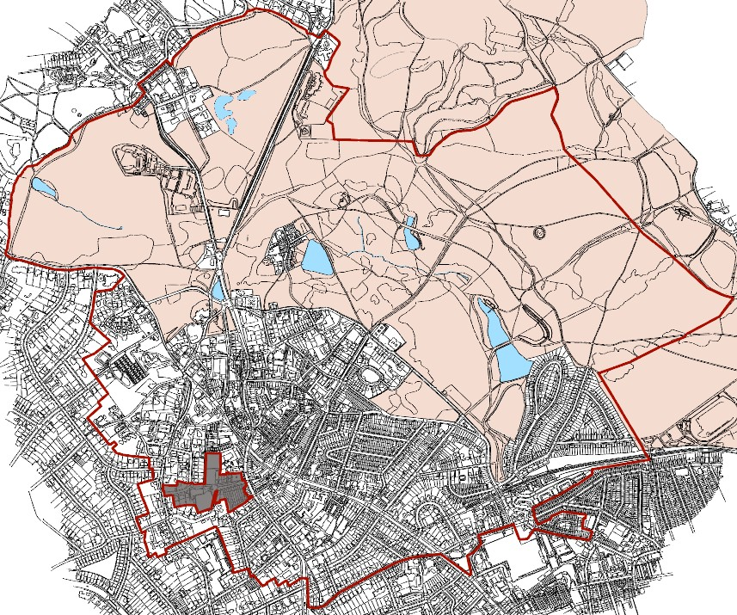

  - Hampstead Heath

Open Spaces and Biodiversity Corridors Map

1

17

9
10 7 H
3 8 11

18
15 16

25
E

2 G 26

20 23

24

4 I
19
29
12 13
A B
28
C

27

D 21 5

6

F 22

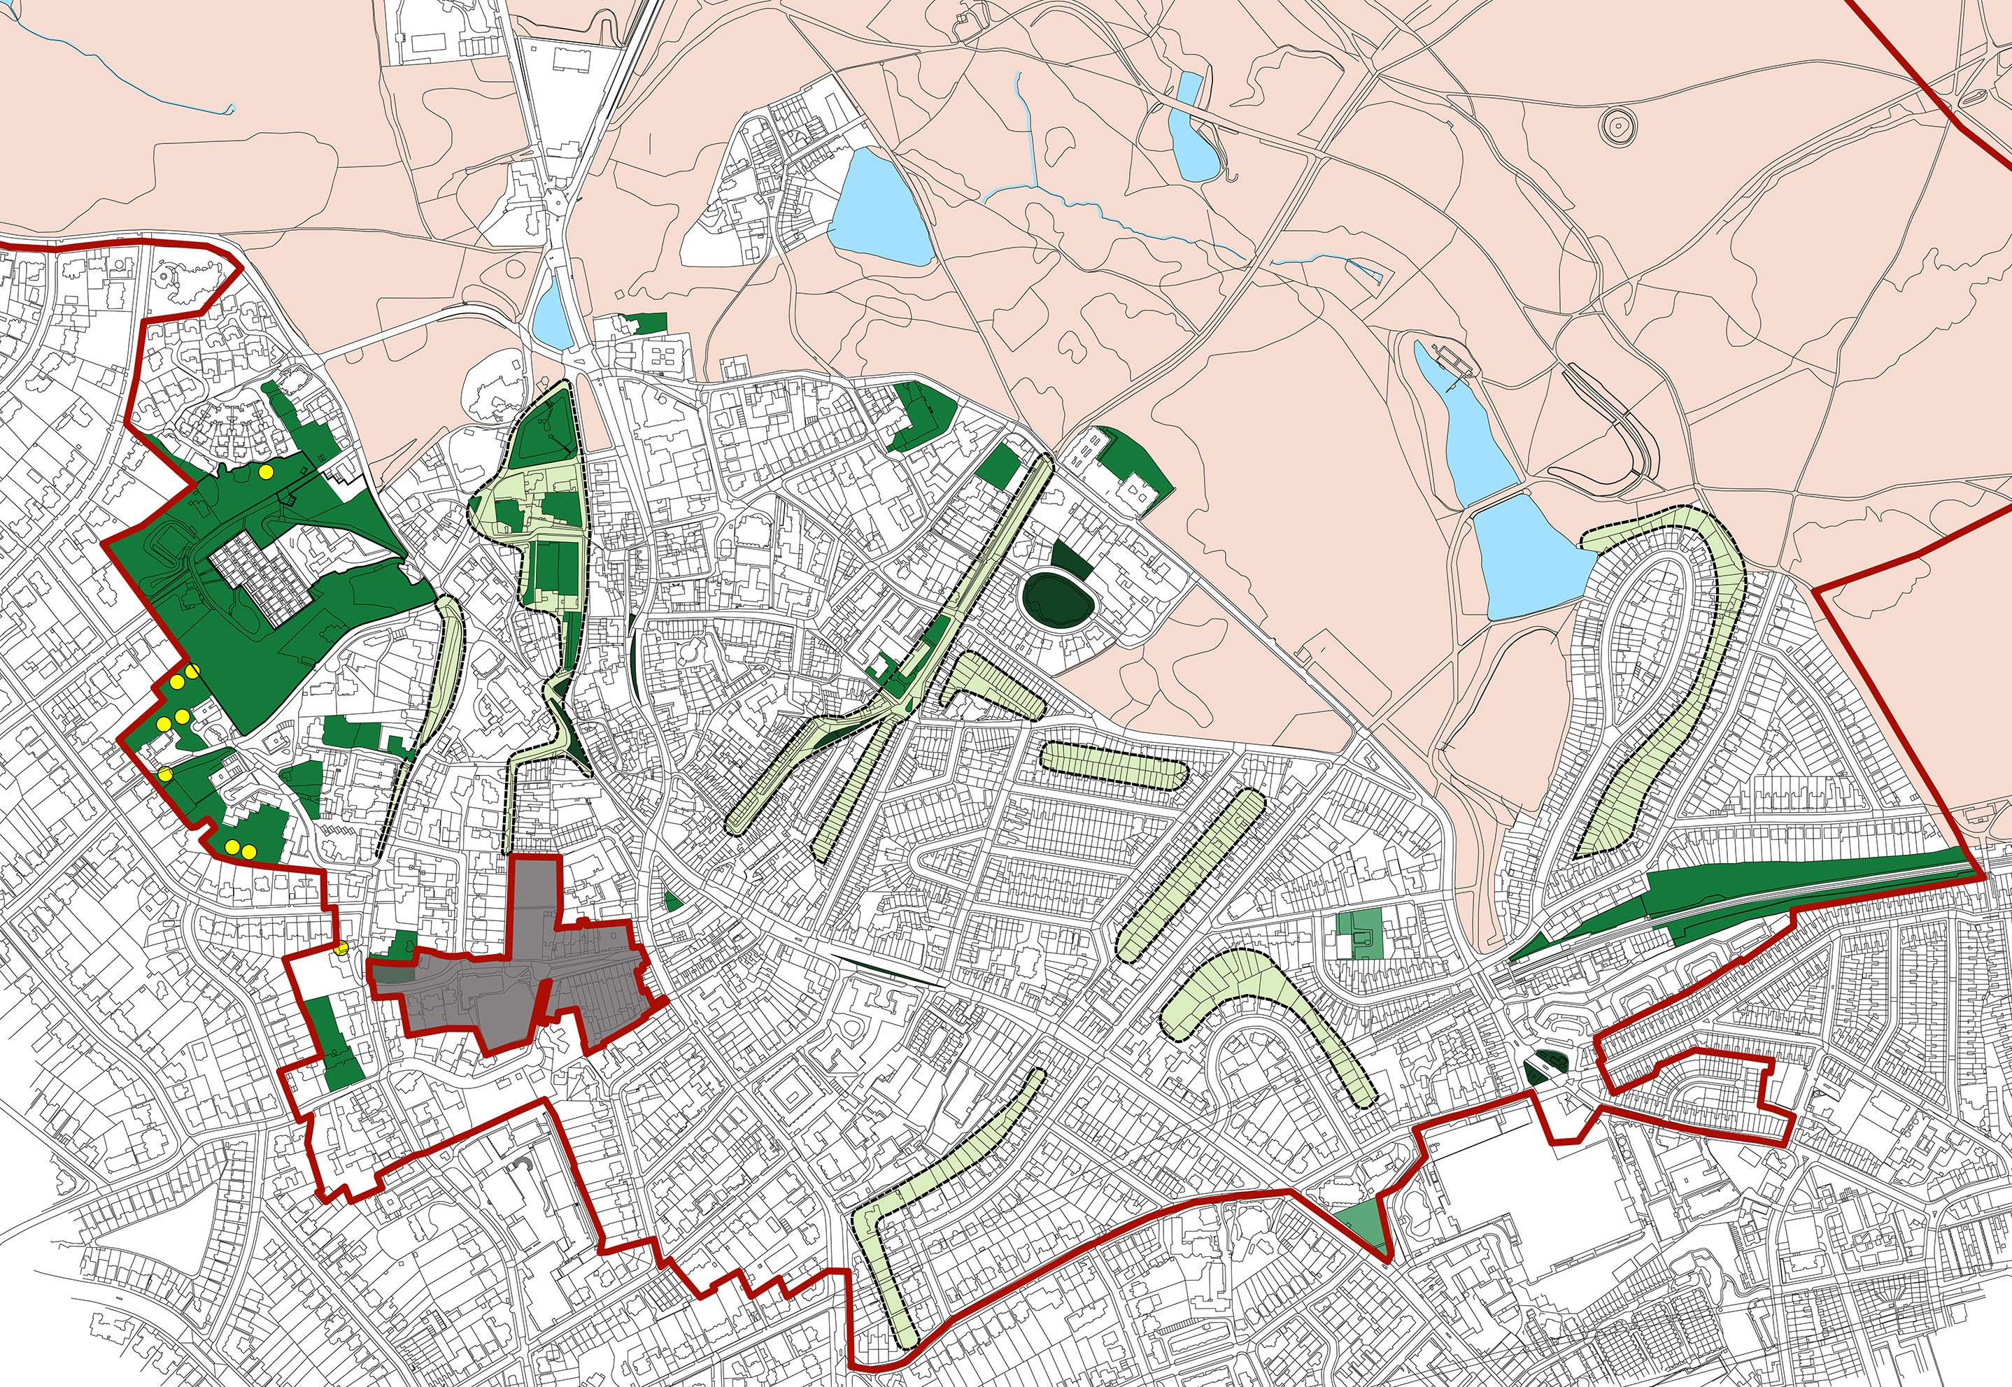21
J
30

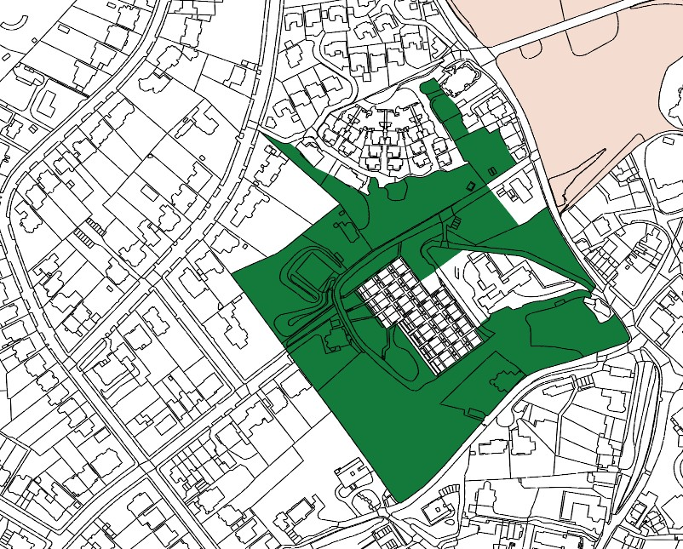

2. a) Branch Hill House Gardens; b) Branch Hill Wood; c) Oak Hill
Wood and; d) Branch Hill Allotments (CHECK NAMES)

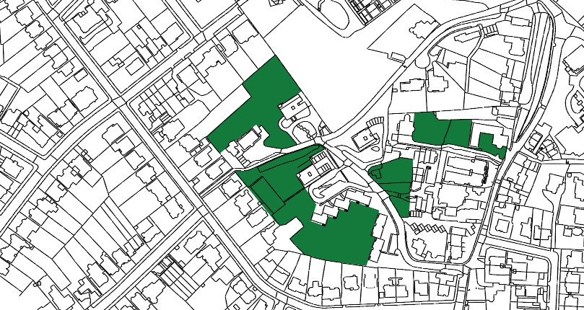
4. Oak Hill Park

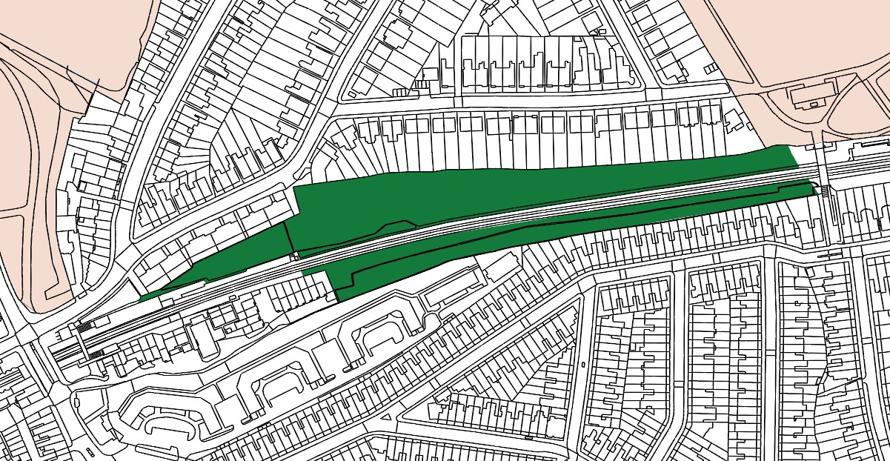

- Gospel Oak Rail Sides

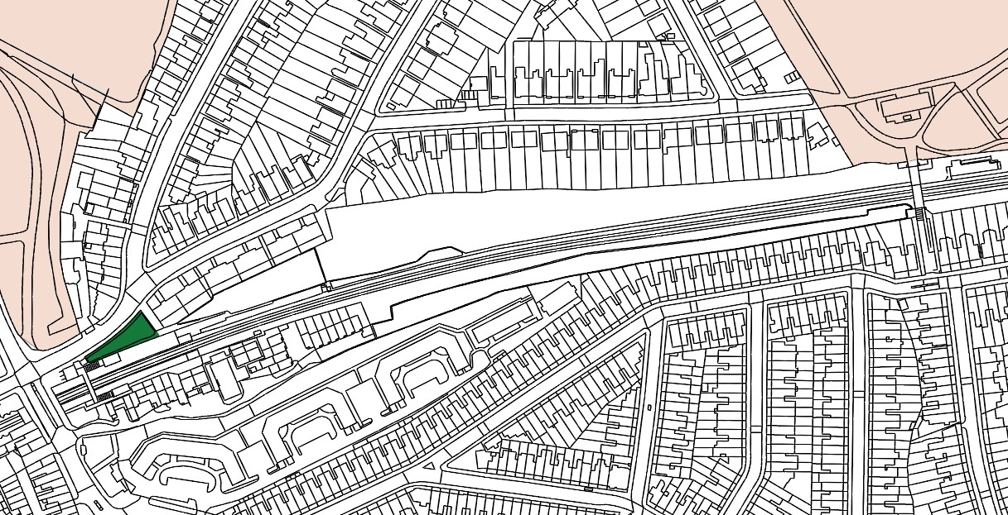
- World Peace Garden, South Hill Park

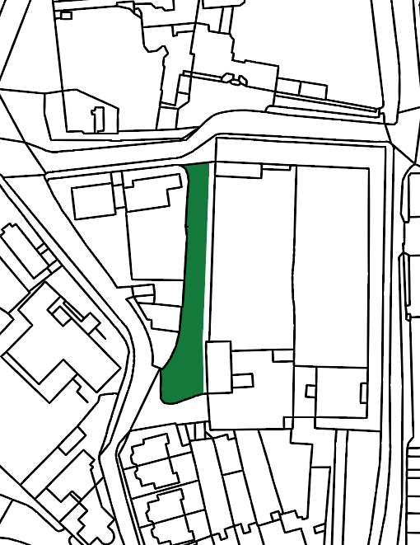

- Pedestrian Walk – Admirals Walk to Windmill Hill

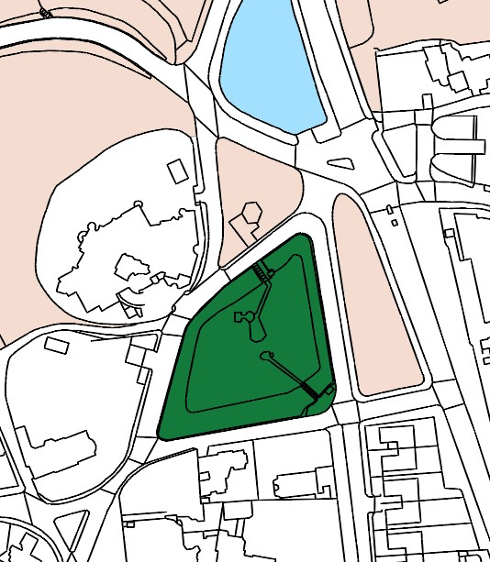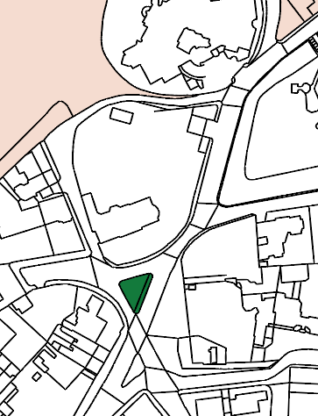

- Upper Terrace Reservoir 10. Green Triangle, Upper Terrace

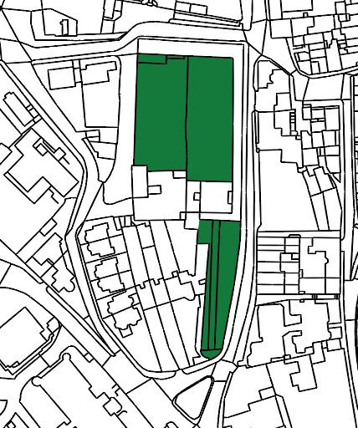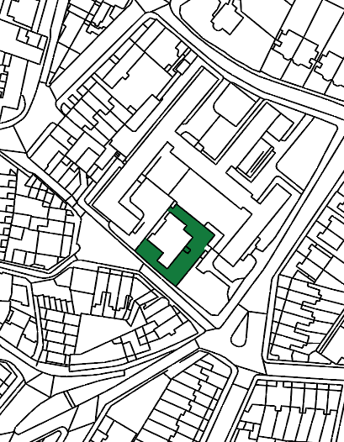

11. Fenton House Gardens 12. Burgh House Gardens

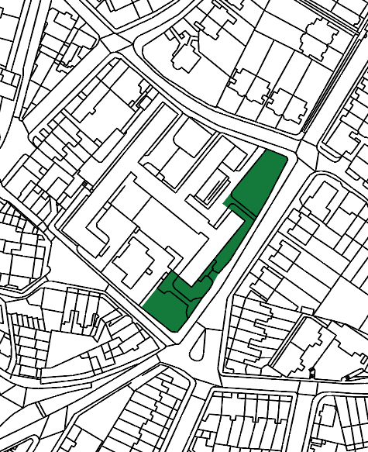

- Communal Gardens of Wells House and Gertrude Jekyll’s Garden

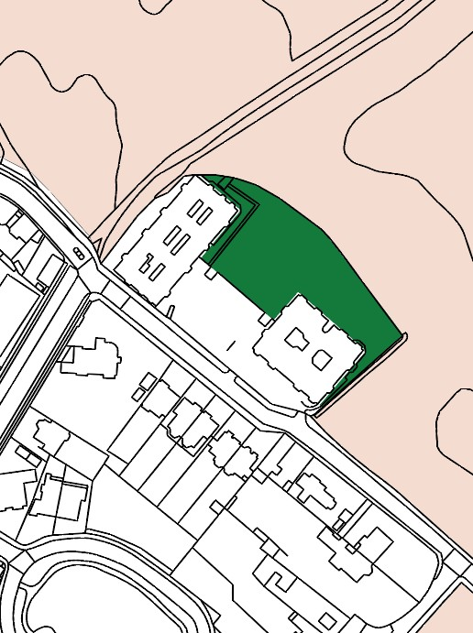

- Garden of The Pryors

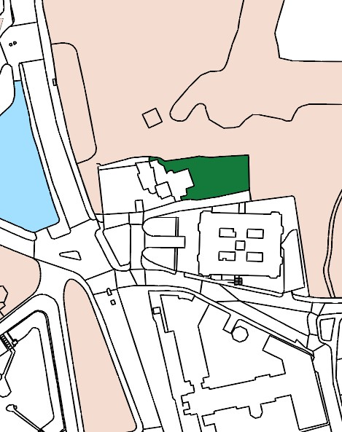

- Whitestone House Gardens

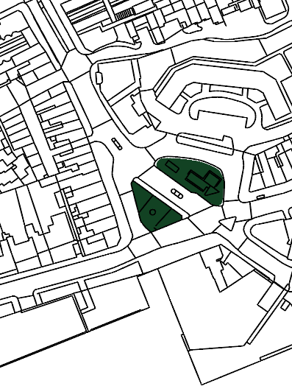
22. South End Green

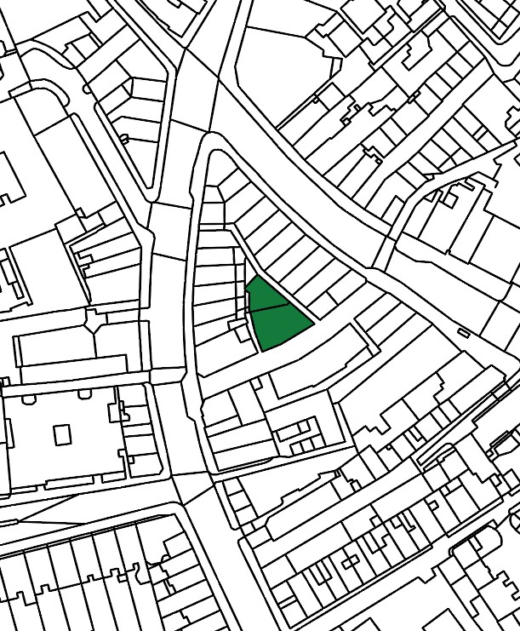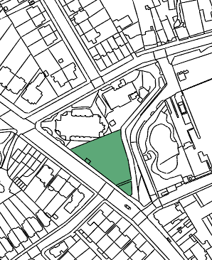

- Oriel Place Garden 30. Hampstead Green

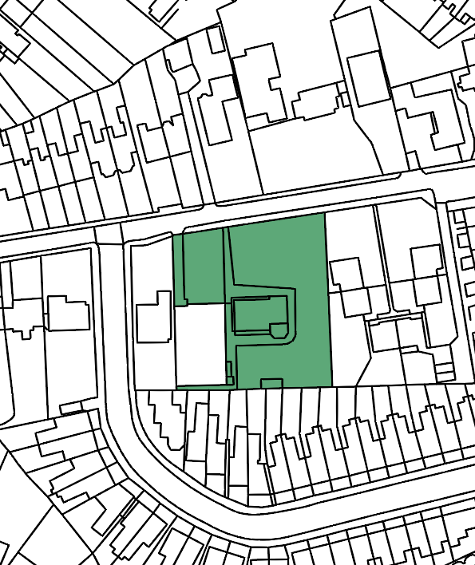

31. Keats House and Garden

