**Green Corridor D**

Site of Historic Hedgerow between Downshire Hill and Pilgrim's Lane

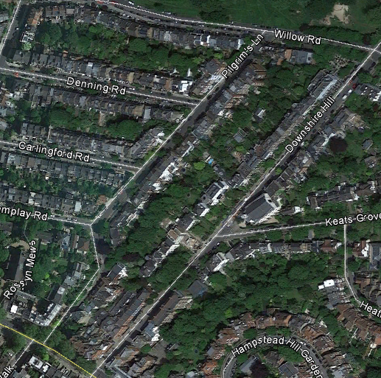 Google Earth 2016

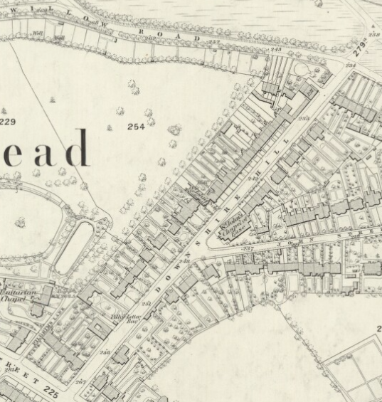 1866 OS map

Green Corridor D: Historic hedgerow line

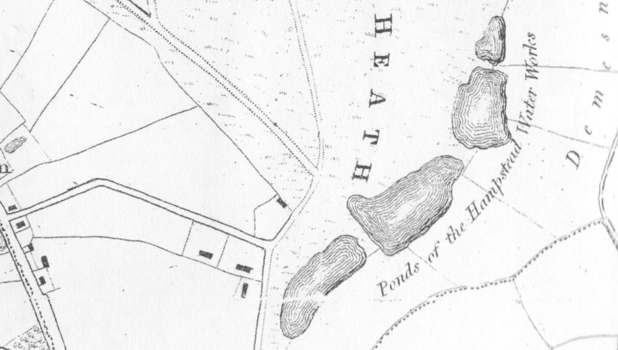 1814 Newton's map

While the trees on the 1866 OS map no longer exist, there is still a continuous line of tall canopied mature and over-mature trees along this boundary line between Downshire Hill and Pilgrim's Lane rear gardens. It is still fiercely protected by local people against over pruning or undermining by sub-garden basement applications. This gives a continuous tall tree canopy line from the Heath running towards the town that can still be used by its attendant invertebrates, birds, small mammals and bats.