**Green Corridor C**

Rear garden boundary between Willow Road and Denning Road

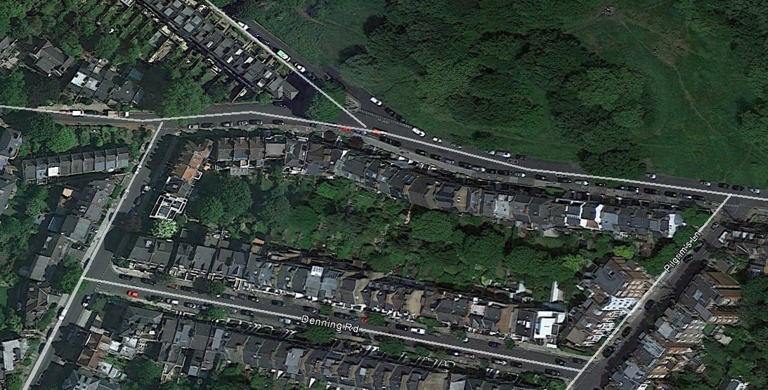

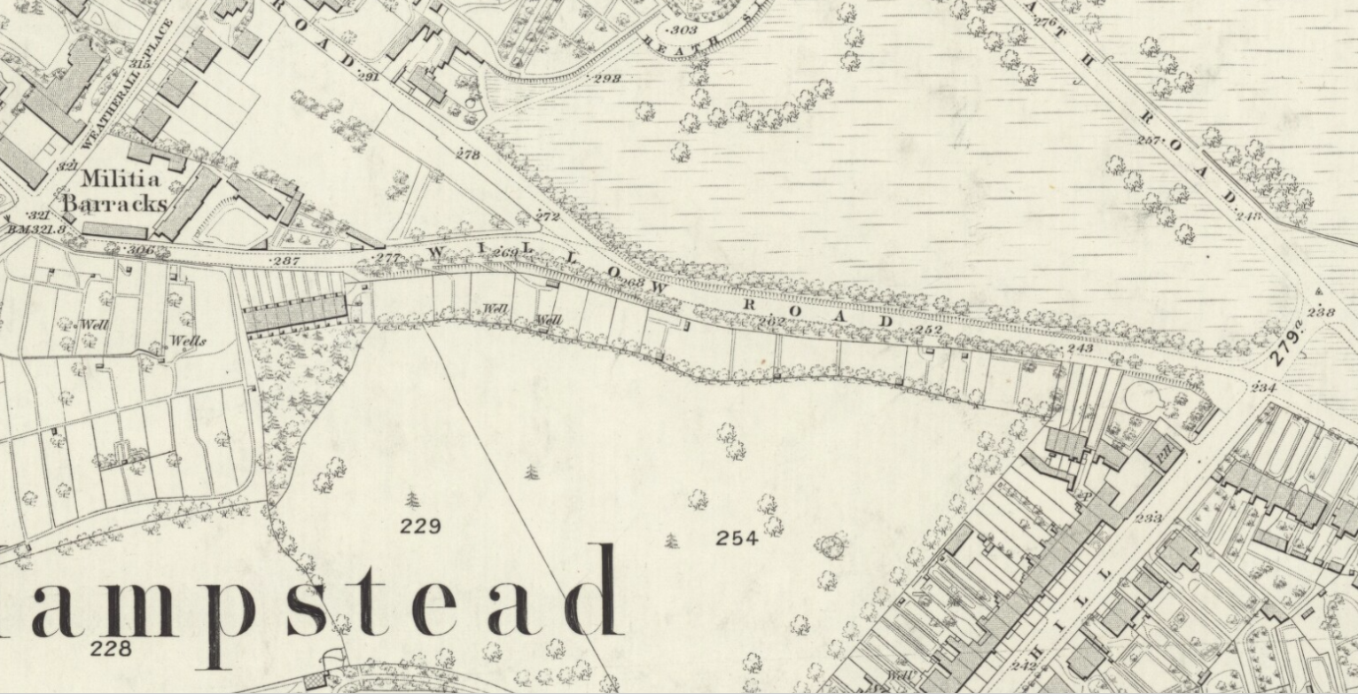 1866 OS map

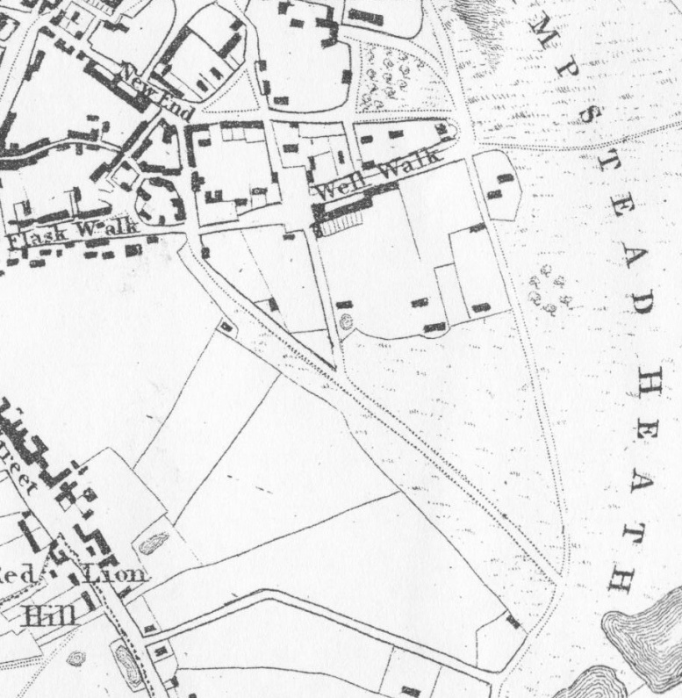 Newton's 1814 map

East Heath Road

Field boundary line later to be boundary line of rear gardens of Willow Road and Denning Road

Willow Road

This is an historic hedgerow and field boundary; an important linking green corridor between green corridors B (Rear gardens SW Christchurch Hill) and D (Rear gardens Downshire Hill and Pilgrims Lane), and the Heath.