Green Corridor B
37-11 Christchurch Hill
Green corridor B
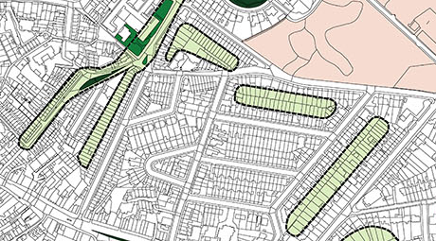
The rear gardens and broad footpath behind form a tranquil green area, thought by locals to have been an orchard in the past. A few old fruit trees remain, many have been removed and some replaced, in recent years. This an important link between Well Walk Green Corridor and that between Willow Road and Denning Road, itself an historic hedgerow and field boundary, and the Heath.

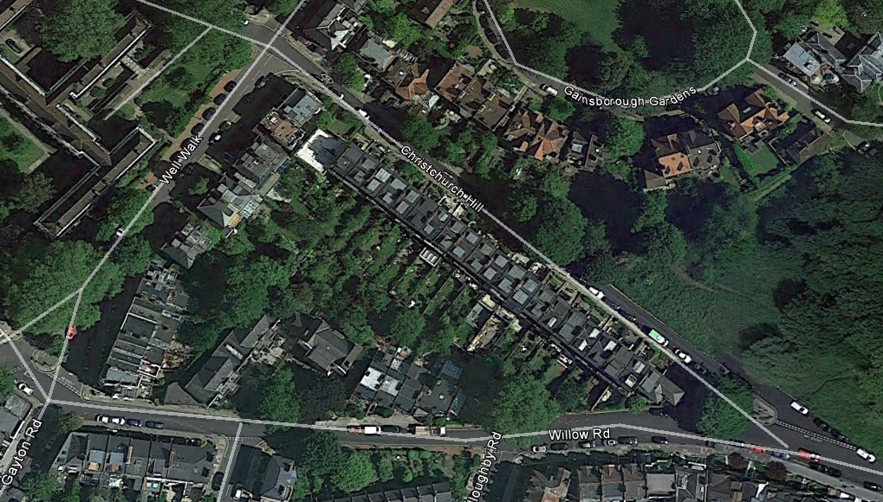

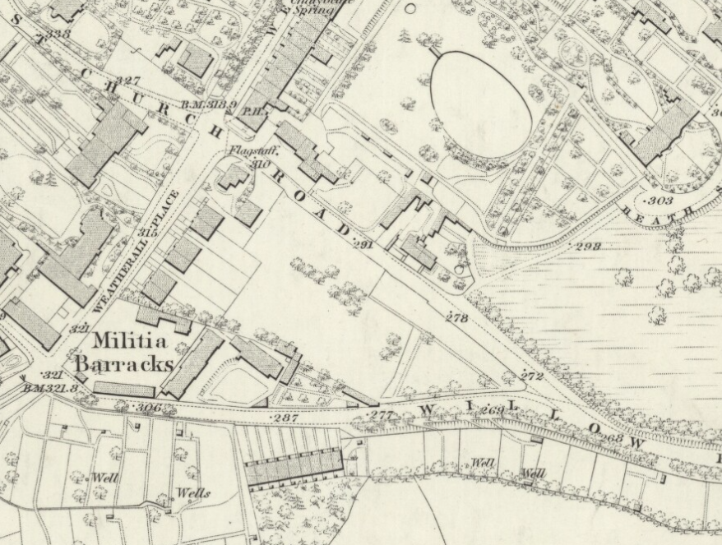
1866 OS map showing the right of way behind the rear gardens of Christchurch Hill, (previously Christchurch Road) to number 43 from where the builder Mr Bickles built what are now numbers 41-1 Christchurch Hill. On completion the area became an orchard.
43 Christchurch Hill

Panoramic winter photograph from roof of 43 Christchurch Hill looking southwards
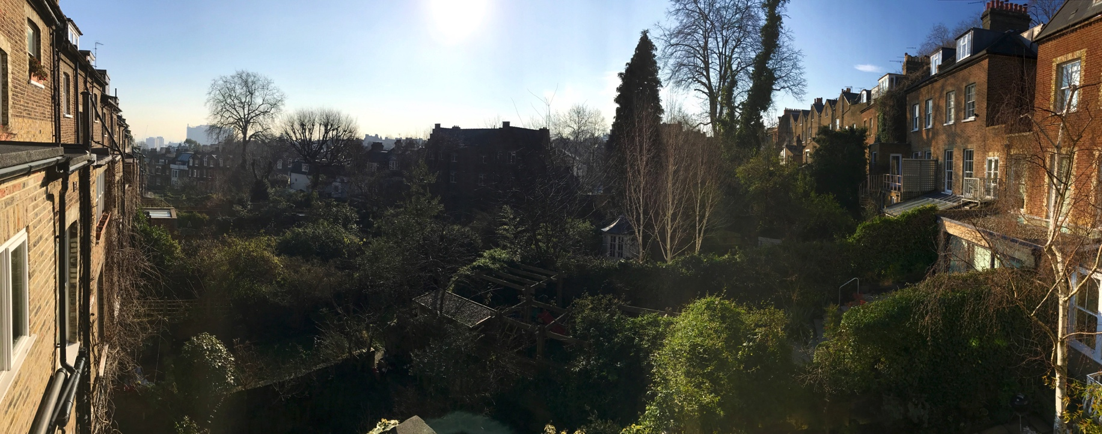
Rear of 41 Christchurch Hill Rear of 26 Well Walk

