Policy BA1: Basement Development

**4. For rear boundaries where there are visually important, mature or veteran trees, historic tree lines or a green corridor, a minimum boundary of 15 metres should be provided.**

In the section 'Trees' [page 31], paragraphs 8-11 demonstrate the particular importance of tall canopied trees in gardens of the Plan area, in several ways different from other southern parts of the borough. A minimum boundary of 15 metres should be provided between basements and rear boundaries where there are visually important, mature or veteran trees, historic tree lines or a green corridor. This will secure a healthy rooting area as well as canopy space for the main tree species that define the Plan area, & **for existing & future veteran trees.**

**Evidence for 15 metre buffer zones for veteran trees and historic tree lines**

**National Guidance**

From: https://www.gov.uk/guidance/ancient-woodland-and-veteran-trees-protection-surveys-licences

**Ancient woodland and veteran trees: protecting them from development**

From: [Forestry Commission](https://www.gov.uk/government/organisations/forestry-commission) and [Natural England](https://www.gov.uk/government/organisations/natural-england)

Part of: [Protected sites and species](https://www.gov.uk/topic/planning-development/protected-sites-species)

Published: 13 October 2014

Last updated: 29 October 2015,

Applies to: England

**Avoid, reduce or compensate for the impacts**

Planning authorities and developers should start by looking for ways to avoid the development affecting ancient woodland or veteran trees e.g. by redesigning the scheme.

As ancient woodland and veteran trees are irreplaceable, discussions on compensation should not form part of the assessment of the merits of the development proposal.

Mitigation measures will depend on the development but could include:

* leaving an appropriate buffer zone of semi-­natural habitat between the development and the ancient woodland or tree (depending on the size of development, a minimum buffer should be at least 15 metres)

**National Ancient Woodland and Veteran Tree Standing Advice covering England issued by Natural England and the Forestry Commission in April 2014** [this contains much detail - including see below - but the main thrust has been superseded by Oct 2015 see above] Nevertheless it states:

In a planning case in West Sussex the Secretary of State supported the arguments for a 15m buffer around the affected ancient woodland,10 but larger buffers may be required.

10 In a planning case concerning an ancient woodland in West Sussex, Four Acre Wood, a minimum 15m buffer was recommended by the Inspector and endorsed by the Secretary of State. Asquith, P. J. (2007) Report on Appeals by Crest Nicholson (South) Limited Relating to Bolnore Village Phases 4 And 5, Haywards Heath, West Sussex. The Planning Inspectorate, Bristol. Appeal refs: APP/D3830/A/05/1195897-98 & APP/D3830/A/06/1198282-83.

[I have emailed Richard Barnes of the Woodland Trust asking him for evidence of the 15 metre gap for veterans and future veterans. He was involved with the Standing Advice and mentions Local Plans in his PowerPoint presentation about the Standing Advice on the internet. Unfortunately I haven't heard back yet.]

**BS 5837: 2012 Trees in relation to design, demolition and construction – Recommendations**

This document makes the following statements about veteran trees and Root Protection Areas:

**4.5.11** The tree survey might identify the presence of veteran trees on the site.

The implications of their presence on the use of the surrounding land should be assessed at the earliest possible stage of the design process. Where such trees are to be retained, particular care should be taken in the design to accommodate them in a setting that aids their long-term retention.

*NOTE Whilst veteran trees typically provide a range of niche habitats, they are especially valuable if ancient, due to their scarcity and high habitat values for associated species of fungi, lichens and saproxylic invertebrates, including some which are rare or endangered and occur only where such trees have been continuously present for centuries. These trees will therefore almost always be included in the A3 category.*

**4.6 Root protection area (RPA)**

**4.6.1** For single stem trees, the RPA (see **3.7**) should be calculated as an area equivalent to a circle with a radius 12 times the stem diameter.

**5.2.4** Particular care is needed regarding the retention of large, mature, over-mature or veteran trees which become enclosed within the new development (see **4.5.11**). Where such trees are retained, adequate space should be allowed for their long-term physical retention and future maintenance.

*NOTE The presence of large species trees is increasingly being seen as advantageous, since it contributes to climate change resilience, amongst other benefits. Achieving successful integration of large species trees requires careful consideration at the conceptual and design stages.*

While this does not specify 15 metres for veteran trees - this is in the 'National Ancient Woodland and Veteran Tree Standing Advice' see above - it helps us make an argument for historic tree lines. For example, many of the trees typically found in the Plan area are tall forest-type trees: London Plane, lime, poplar - black poplar and lombardy - oak and ash trees. These are the trees that originally populated the historic tree lines. In order to comply with BS 5837: 2012 root protection zones of 12 times the diameter of the trunk at breast height should be retained, so if trees with diameters up to 1.25 metres (quite within the trunk sizes found within the Plan area) are to be retained in the future, a distance of 15 metres from basement edge to boundary edge should be retained. Historic tree lines are also where our veterans of the future are likely to be found.

**London Tree Officers Association**

From open letter to Mr Richard Nicholson, Chair of Revision Panel BS5837:

c) Since the standard was published we now have better understanding of the vulnerability of ‘veteran’ trees. Should not the new standard address the special requirements of veteran trees?

This acknowledges that BS: 5837-2012 does not give sufficiently specific advice for veteran trees, though clause 7.4 'Permanent hard surfacing within the RPA' does state:

*NOTE This subclause does not apply to veteran trees, where it is recommended that no construction, including the installation of new hard surfacing, occurs within the RPA.*

**Other Local Authorities**

**Shropshire Council Natural & Historic Environment Development Guidance Note 7 Trees and Development**

https://new.shropshire.gov.uk/media/2504/2016-trees-development-guidance-note.pdf

4.5.3 The chief below ground constraint is represented by the Root Protection Area (RPA). BS 5837: 2012 defines the RPA as a layout design tool indicating the minimum area around a tree deemed to contain sufficient roots and rooting volume to maintain the tree’s viability, and where the protection of the roots and soil structure is treated as a priority.

4.5.4 For single stem trees the RPA should be calculated as an area equivalent to a circle with a radius 12 times the stem diameter. Other calculations are used for multistemmed trees, based on an average of their stem sizes. For all trees, the RPA is capped at a maximum size of 707m2 , with a nominal circular radius of 15m, for stems of 1,250mm diameter or above (see section 4.6 of BS 5837: 2012).

4.5.5 Note, however, that there may be occasions when an RPA other than as recommended under the British Standard is appropriate; for example, ancient and veteran trees are heavily reliant on intimate associations between their fine roots and soil microflora and thus particularly susceptible to disturbance of the root zone. A growing body of expert opinion suggests that the RPA for such trees should be increased beyond the 15m radius recommended in the British Standard.

**Memo: Melinda Barham, Trees and Landscape Epping District Council** http://planpub.eppingforestdc.gov.uk/NorthgatePublicDocs/00435965.pdf

The ecology report submitted by the applicant produced by GS Ecology (but not provided as part of the pre application papers) concludes that, “Epping Forest is therefore of significant conservation value at both a national and an international level and it will be important to ensure that the proposed development is designed from the outset to minimise any impacts upon it. The following may help to mitigate any adverse impact of the development on the forest:

- In line with Natural England’s standing advice to planning officers on Ancient Woodland a buffer of at least 15m width would need to be maintained between Epping Forest and the development boundary

- A native and wildlife friendly landscaping scheme should be provided to include native hedgerows or shrubs to act as a buffer between the development site and the forest.”

The ecology reports is commented on by Natural England who state in their comments dated 26th June in that they would raise no objection to an application if the above mitigation is implemented – ie the provision of a 15m buffer zone and appropriate native planting.

**Camden**

**Policy A5 in Camden's Draft Local Plan** states:

The siting, location, scale and design of basements must have minimal impact on, and be subordinate to, the host building and property. Basement development should:

**m**. avoid the loss of garden space or trees of townscape or amenity value. and

The Council will require applicants to demonstrate that proposals for basements:

**v**. do not prejudice the ability of the garden to support trees where they are part of the character of the area.

See also

**6.124** In addition to protecting against flooding, ground instability and damage to neighbouring buildings as set out above, the Council will also seek to control the overall size of basement development to protect the character and amenity of the area, the quality of gardens and vegetation and to minimise the impacts of construction on neighbouring properties. Larger excavations cause greater construction impacts and can have greater risks and complexity in construction.

**6.125** A basement development that does not extend beyond the footprint of the

original building and is no deeper than one full storey below ground level is often

the most appropriate way to extend a building below ground.

While veteran trees are mentioned in 6.75,

**6.75** The Council will seek the retention of trees and vegetation of significant amenity, historic, cultural or ecological value. This includes trees within the public highway which can potentially be affected by a development. Trees and vegetation are important to the contribution a site and its setting make to townscape character and amenity and have a sense of maturity which may often be lacking from replacement planting. Ancient woodland and ancient or veteran trees found outside ancient woodland are particularly valuable as once lost they can never be replaced. The ancient woodland in Camden forms part of the Hampstead Woods Site of Special Scientific Interest (SSSI).

nowhere in the Camden Local Plan is there mention of specific requirements for veteran trees. Since a large proportion of veteran trees are found in the Hampstead area, this requires the Hampstead Local Plan to address this.

**Evidence in the Literature**

**Helen Read (2000) 'Veteran Trees - A Guide to Good Management' pub English Nature.**

At 6.4 (p 67) a box includes the words:  
  
"The urban habitat can be a hostile environment for veteran trees, which can suffer from:...  ...   Severing of roots caused by the digging of trenches for cables etc. Excavation work should not be carried out within a separation distance, extending away from the tree for 15 times the diameter of the trunk at breast height (ie 30m for a tree of 2m). This should be regarded as  minimum..."



**David Lonsdale 'Ancient and other veteran trees: further guidance on management' pub Tree Council 2013.**

page 46

Protect young and mature trees where they are the potential successors of the current generations of ancient and other veteran trees.

**Root Protection Areas (RPAs) for veteran trees: comparison with other guidance**

Guidance for establishing and enforcing RPAs for trees on construction sites, as opposed to agricultural land, is given in British Standard 5837:2012). This represents a compromise, as construction would generally not be practicable if the entire rooting area of every tree were to be protected. Some degree of compromise is often unavoidable also in areas where veteran trees co-exist with economic use of land, such as commercial farming. There is, however, often scope for providing a larger RPA than would normally be provided under BS 5837. A radius of 15 times the stem diameter at breast height, or five metres beyond the edge of the tree's canopy, whichever is the greater, is recommended in the present book (in relation to ploughing and grazing). On the other hand, it can sometimes be sufficient for the RPA to be a zone of very low-intensity use, rather than one of total exclusion of farming or other activities.

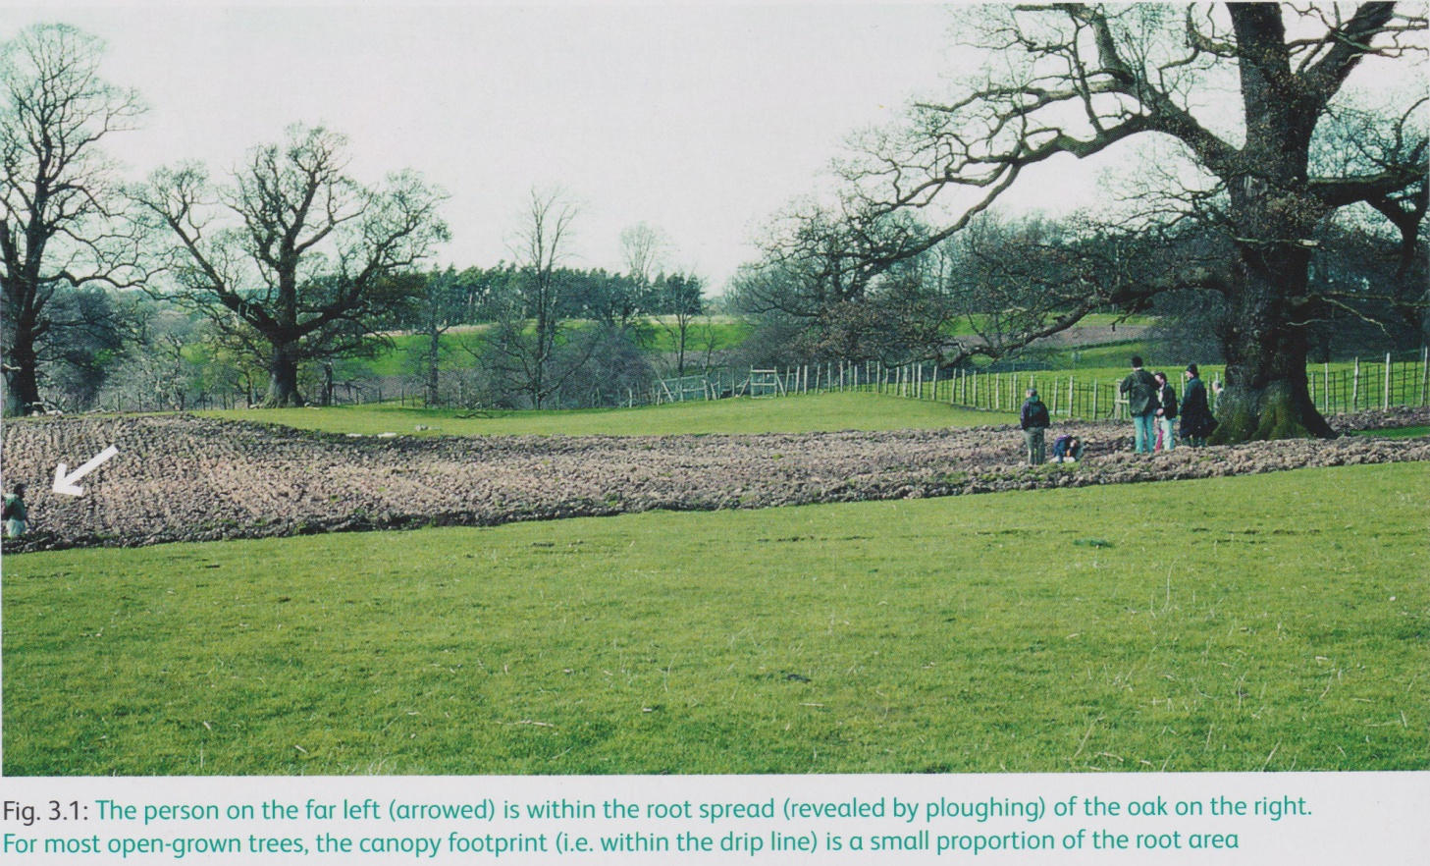

Fig. 3.1: The person on the far left (arrowed) is within the root spread (revealed by ploughing) of the oak on the right. For most open-grown trees, the canopy footprint (i.e. within the drip line) is a small proportion of the root area

- and page 63

**3.6 CONSTRUCTION SITES**

Every effort should be made (in the planning process) to avoid the situation described in 3.5.2.1 in relation to the risk that is created by bringing new buildings, and hence people, closer to veteran trees, since all the values associated with the trees can thus be compromised or lost entirely (Ancient Tree Forum (2007) Ancient Tree Guide No. 3: Trees and development pp7). Also, at every stage of the planning and construction process, full account should be taken of the full range of the potential effects of development on woodlands or wood pasture (Corney et al, 2008).

The boundaries of an RPA for one or more veteran trees on a construction site should be decided according to the principle of erring on the side of caution. The rationale is that veteran trees have special value and are particularly vulnerable to the disturbance that inevitably results from a fundamental change of land use, such as construction.

Thus, the minimum extent of the RPA should be formulated as stated in Section 3.1, subject to modification, if appropriate, on the basis of a thorough and expert investigation of the extent of the root system and of the soil conditions (BSI, 2012).

David Lonsdale thus does not give a specific minimum figure for veteran tree RPAs but indicates that it should be generous for veteran trees compared to BS 5837 and allow for 15 times the trunk diameter rather than 12 times. Since this means that veteran trees with only 1 metre diameter trunks would require an RPA of 15 metres, this lends further support to our policy.