**Biodiversity Corridor K**

**Western Frognal rear gardens from south Redington Road to HNF boundary.**

This biodiversity corridor runs south from the rear gardens of 1-19 Redington Road, 67-61 Frognal and 23 Frognal Lane, across the front gardens of 21 and 19 Frognal Lane, crosses Frognal Lane then runs along the western gardens of Frognal and the east side of Langland Gardens to the edge of Hampstead Neighbourhood Forum boundary. Here it links with Redington Frognal Neighbourhood Forum's biodiversity corridor.

This biodiversity corridor has good historical credentials as it contained the Hampstead Estate manor-house where the Courts Lees were held. The section north of Frognal Lane was ancient demesne land (land that the lord of a manor, in feudal times, kept for himself rather than letting out): part of Manor Farm. Later it became the eastern side of Frognal Park, an area between Old Frognal Court (now 23 Frognal Lane) and the house called Frognal Park. The old manor-house which stood at the north-east corner of West End Lane (now called Frognal Lane) was a long, low farmhouse building. This was demolished and a brick house built on the site (Old Frognal Court now 23 Frognal Lane), another further west (Maryon Hall), later split into two houses: Maryon Hall (no. 19) and Maryon House (no. 21) Frognal Lane.

In the 1800s Frognal Park had grounds of 23 acres, and Manor Cottage (south of Frognal Lane and now number 40) had grounds of 5 acres, with the grounds of Frognal Priory continuing south. A grand veteran oak tree now in the garden of 65 Frognal 'Old Oak Place' would have been a mature tree then. With the development of Frognal down to Frognal Lane during the 1880s, most but not all signs of farm life disappeared. The gardens of these houses now form a section of the proposed biodiversity corridor with fine tall trees including holm oaks where tawny owls and woodpeckers were previously seen to roost and still fly to.

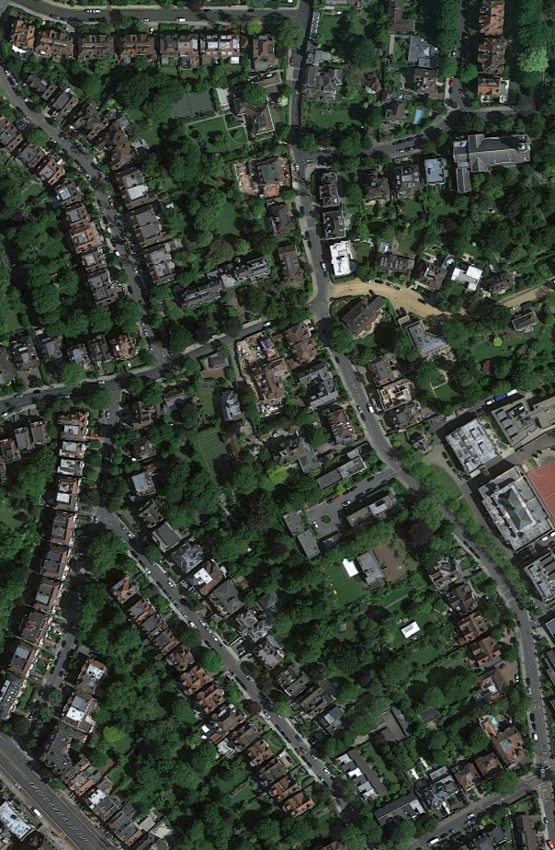

Veteran oak tree Lindfield Gardens

Maryon House

Old Frognal Court

Site of old Manor House

65 Frognal 'Old Oak Place'

Veteran oak tree

Maryon Hall

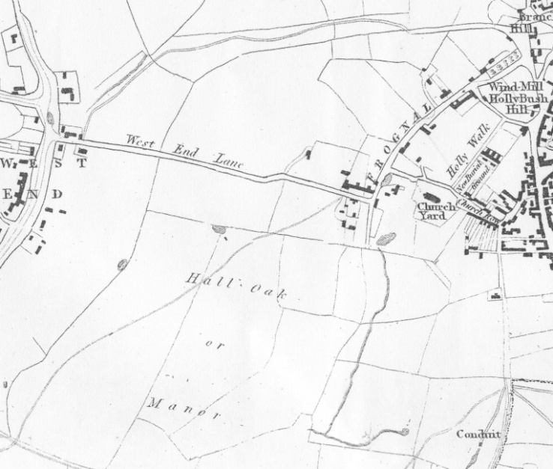 from Newton's 1814 map

Frognal Park

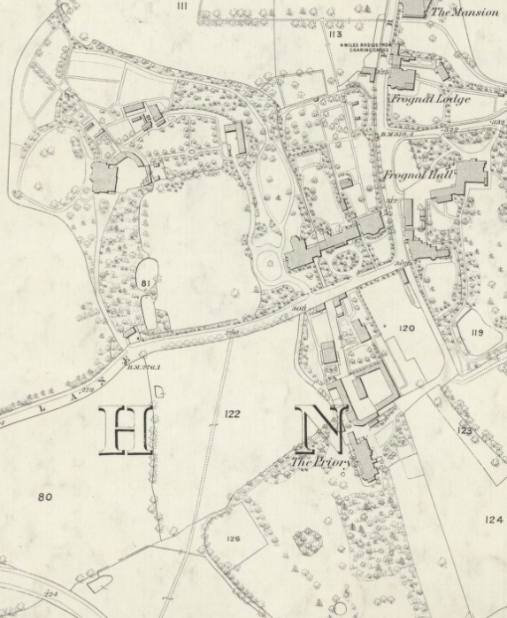

Manor Cottage

Old Frognal Court

Site of old Manor House

Maryon House

Maryon Hall

Existing veteran oak tree

Existing veteran oak tree

This biodiversity corridor is an important link for another veteran tree associated with 27 Lindfield Gardens and a large area of rear gardens with tall trees and springs: part of Redington Frognal Neighbourhood Forum which will be proposed as a Biodiversity Corridor itself.