**Biodiversity Corridor J**

**Shepherds Walk, Spring Walk and Spring Path**

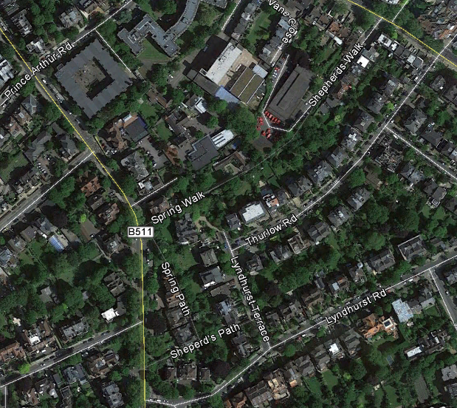 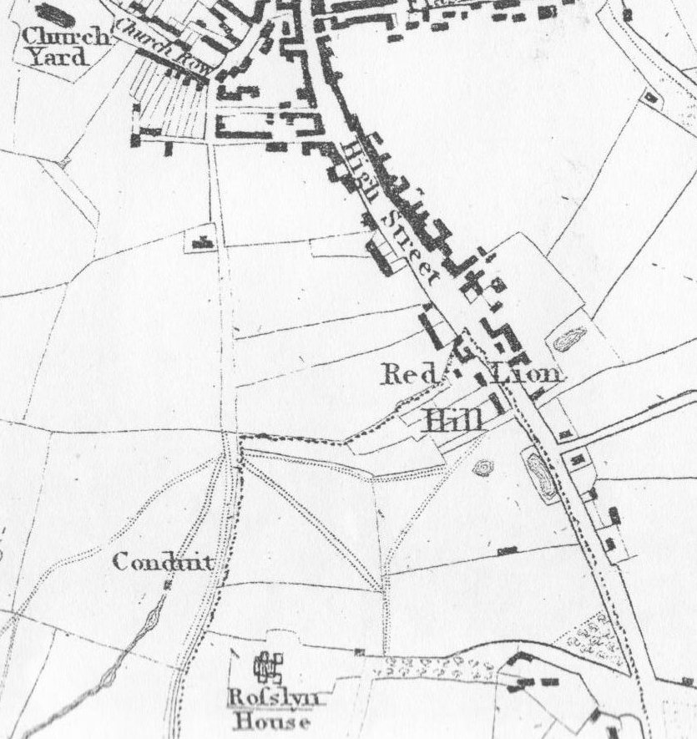

Shepherds Walk

Google Earth 1814 Newton's map

This biodiversity corridor BC J is a long established line of trees and gardens that runs south west along the rear gardens of the length of north west Thurlow Road, just south of Shepherd Walk which later becomes Spring Walk. It then continues south down the western gardens of Lyndhurst Terrace and part of the course of the Shepherd stream, then between the rear gardens of Daleham Gardens and Fitzjohns Avenue to the edge of the HNF boundary.

BC J includes the garden of Elm Bank: a large mid-Victorian detached villa built in the 1860s with a large garden on three sides.

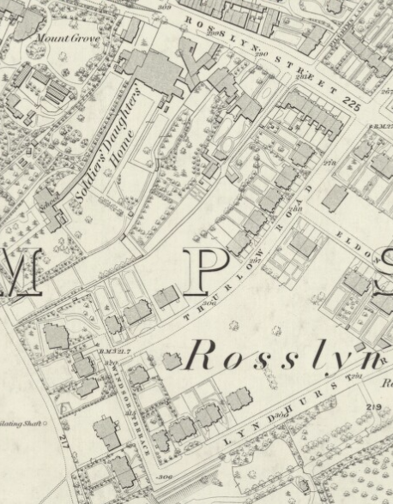 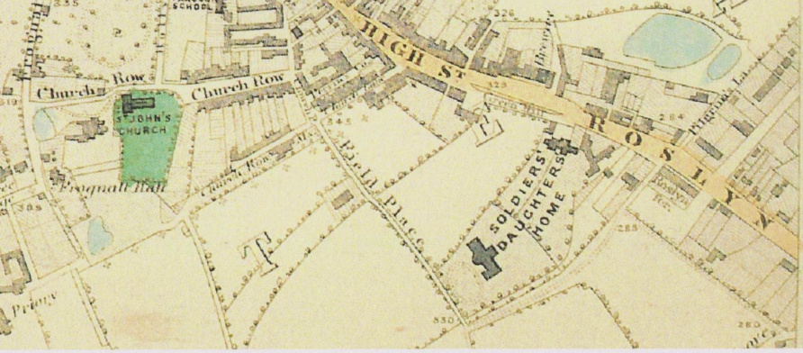

Shepherd's Walk

Elm Bank 1866 OS map Stanford's Library map 1862

As it follows the original course of the Shepherd stream between the rear gardens of Fitzjohns Avenue and Daleham Gardens, the garden boundary here contains several black poplars, water-loving trees that were planted to help keep the gardens less waterlogged. These are not always being replaced with black poplars now they are coming towards the ends of their lives or are removed for development, so many gardens are now much wetter. Nevertheless bats have been reported in these gardens.