Biodiversity Corridor H

Hampstead Grove, Admirals Walk, Upper and Lower Terrace

This biodiversity corridor includes the Upper Terrace Reservoir, the gardens of Upper Terrace House, Admiral's House, Grove Lodge, Netley Cottage, Fenton House, and Grove End, as well as the three small public open spaces of Windmill Hill Enclosures in Upper Terrace, with the late-mature sweet chestnut with veteran features on the green triangle on Upper Terrace near to Judges Walk.

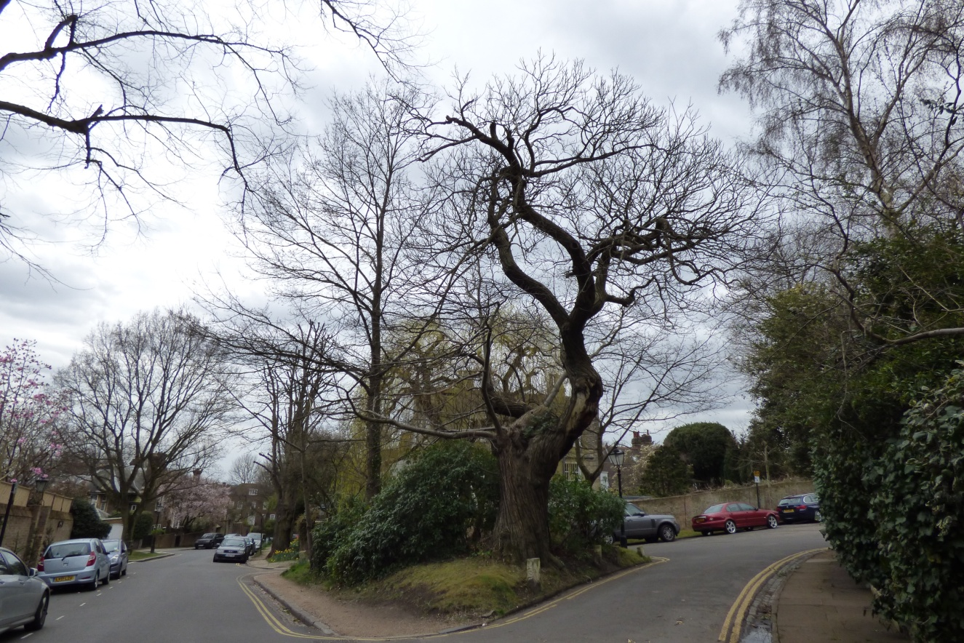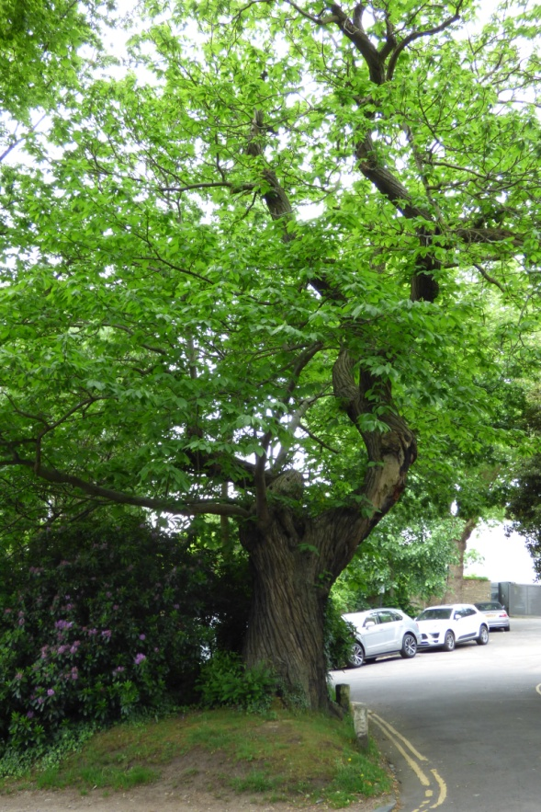
Sweet chestnut on Green Triangle of the 'Windmill Enclosures': winter and summer

The tall lime trees of this biodiversity corridor are an important feature of this area of Hampstead. The 'Victoria County History' states that Hampstead has a history of planting lines or groves of trees. The area in and around this biodiversity corridor particularly does: it could easily be re-named 'Groveland'. Hampstead Grove - the road previously named 'The Grove' but changed to distinguish it from the road with the same name in Highgate - has several buildings with the name Grove close by, including: 'Grove Lodge', 'Grove End', 'Old Grove House' and 'The Grove' (the previous name for Admiral's House) while 'Frognal Grove' (an 18th century house famous for its impressive avenue of lime trees leading up to the entrance of the house and later named 'Montagu Grove' was converted into 105-111 Frognal) and the more modern 'Highgrove Point' are just south of here within Biodiversity Corridor G 'Frognal', and the road Grove Place is to the east.

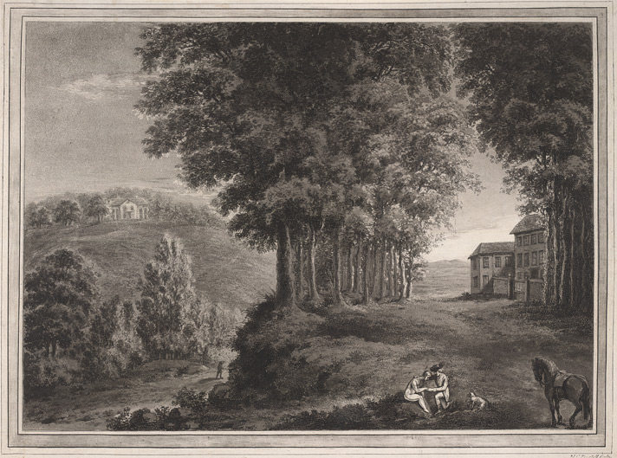
Frognal Grove, engraving by Maria Catherine Prestel (1747-94)
The lime walk planted up to Frognal Grove has featured in many old Hampstead pictures, notably in 'As Happy as a King' (1836) by William Collins at the Tate Gallery:
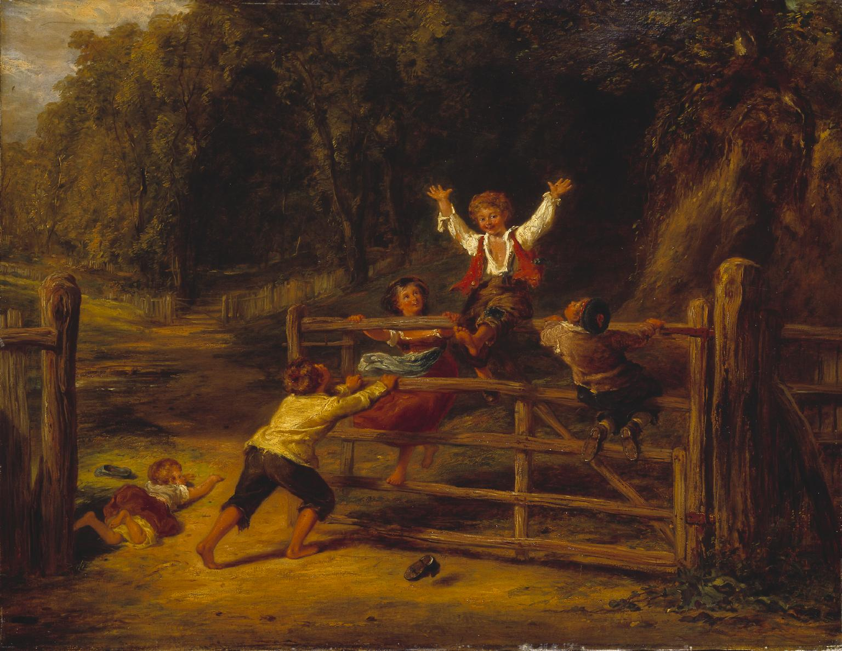

Indeed William Hone in his Table Book of 1827 called Hampstead 'the place of groves'. There are still enough fine old lime trees along Hampstead Grove, Admirals Walk and Upper Terrace to justify its name.
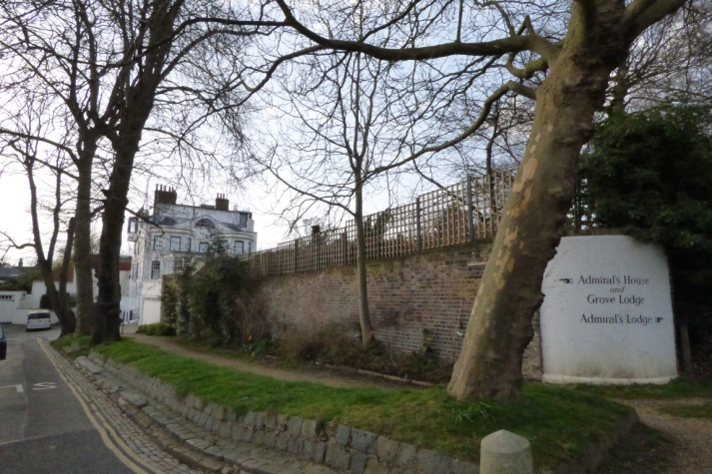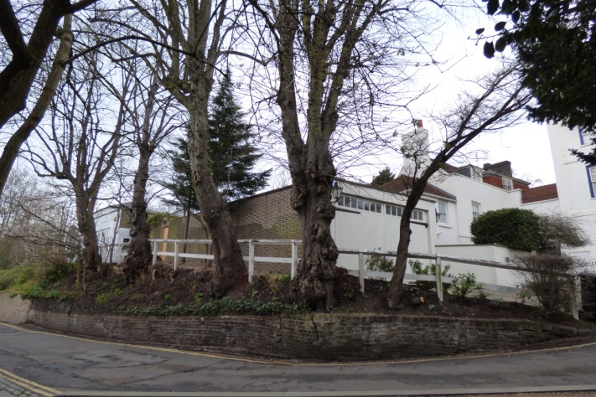
Row of Admiral's Walk lime trees (on left), winter Row of lime trees by Grove House, Admiral's Walk, winter
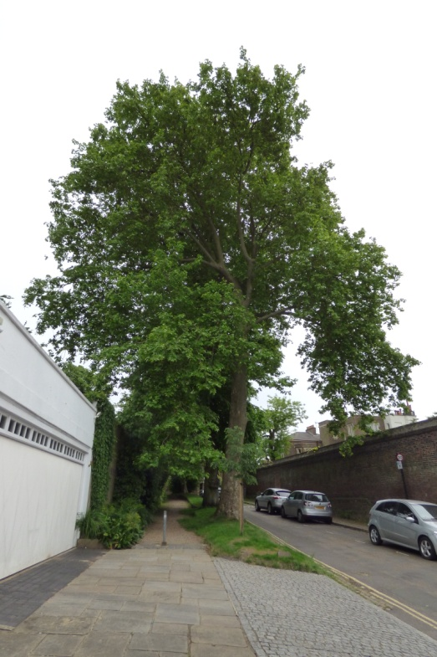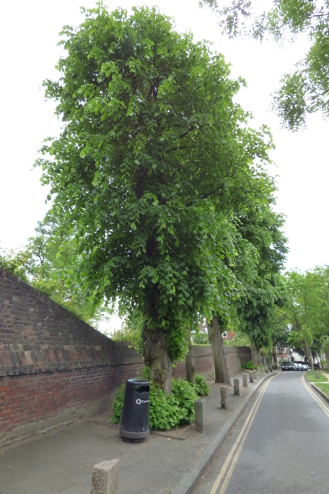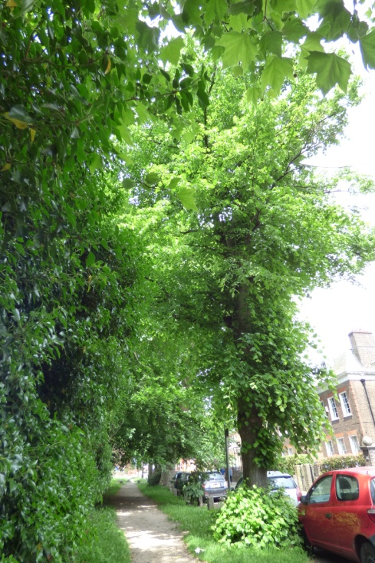
Lines of lime trees in Admiral's Walk - and along Hampstead Grove in summer
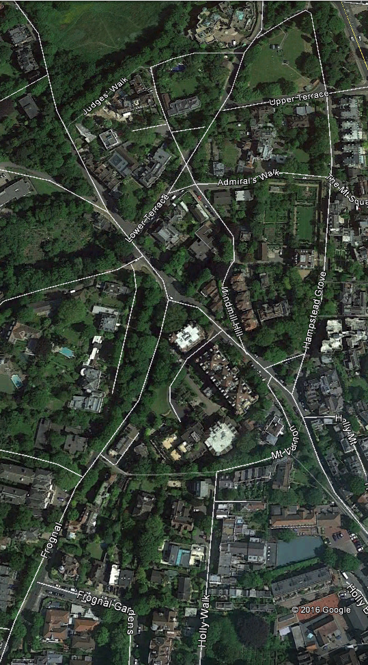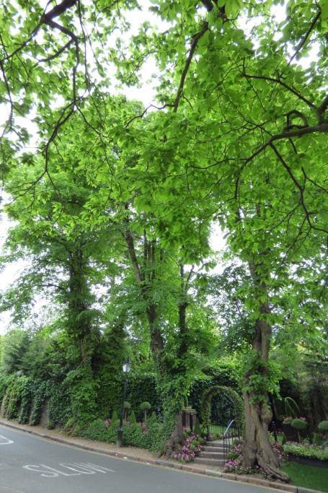
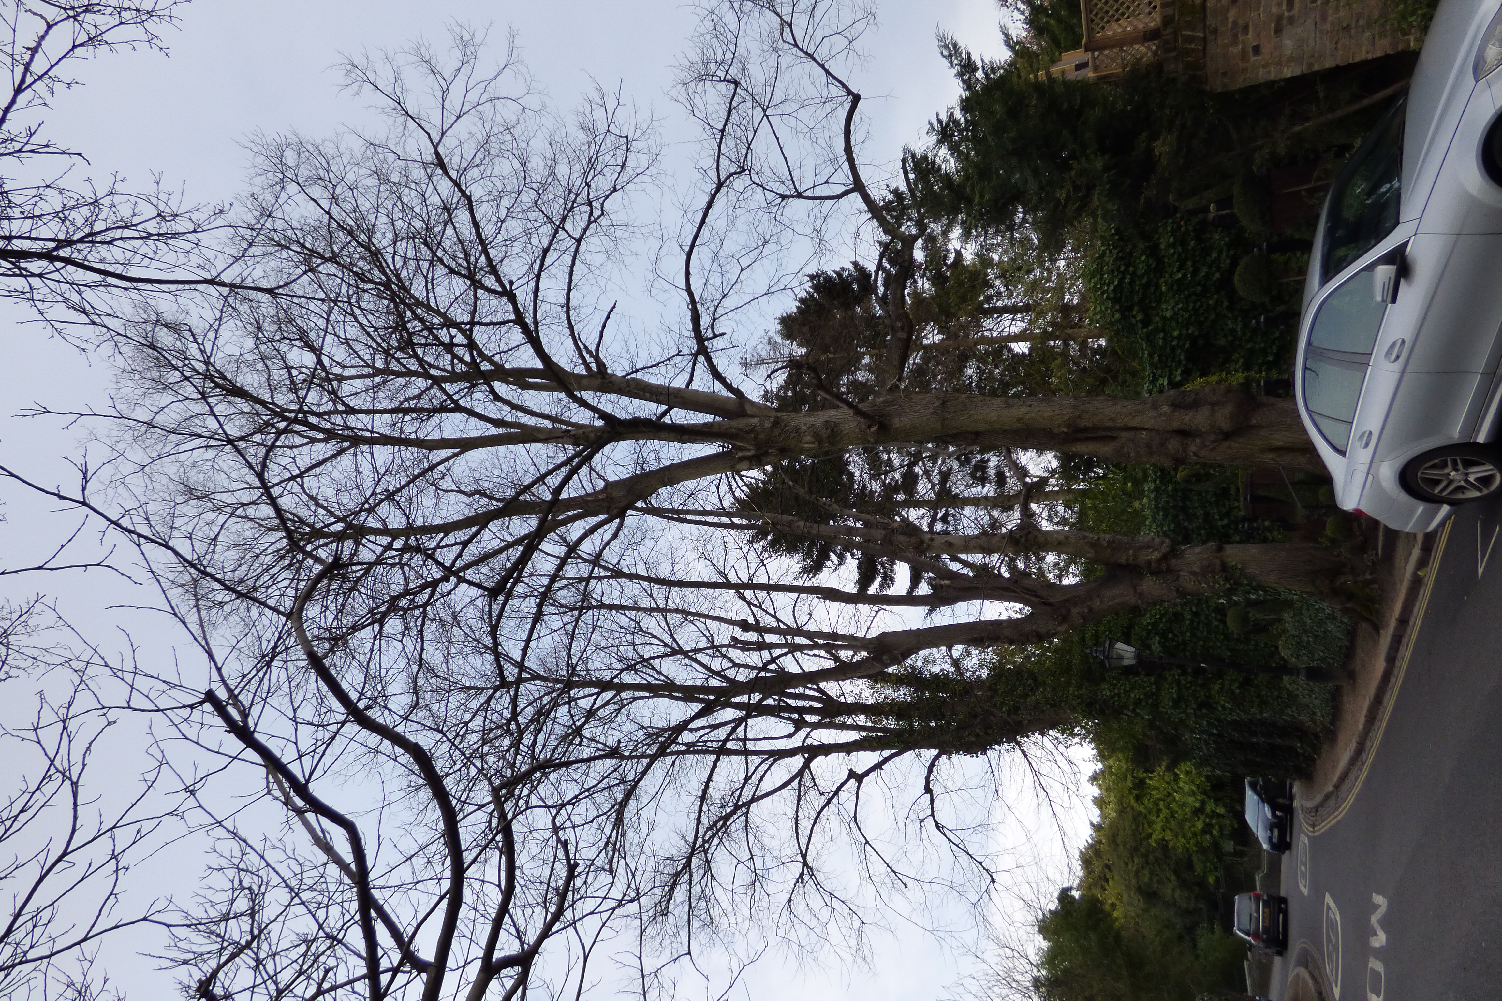
Historic lime trees by Netley Cottage,
Lower Terrace in winter
Historic lime trees in summer

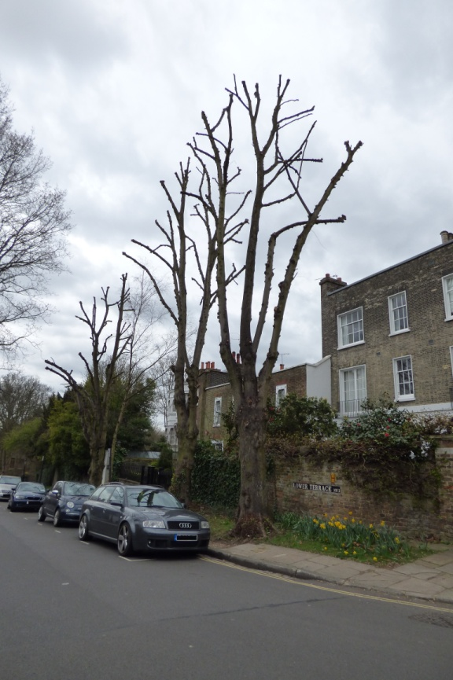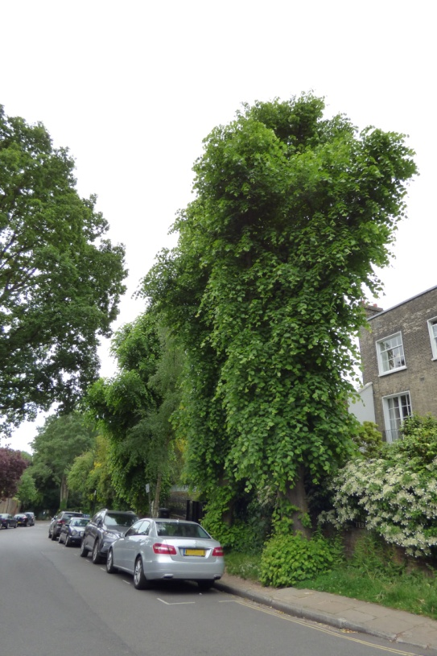
Recently pollarded lime trees along south west section Lower Terrace in winter and in summer

The presence of these tall water-loving forest trees reflect the many springs and tributaries of the Westbourne river that flow through this area and can be seen at the bottom of the many wells present here e.g. one within Admiral's House and three alone within the grounds of Fenton House.

There was previously a pond known as Clock House Pond or Crockett's Pond just below Admiral's House painted by John Constable during the time that he rented 2 Lower Terrace nearby in the summers of 1821 and 1822:
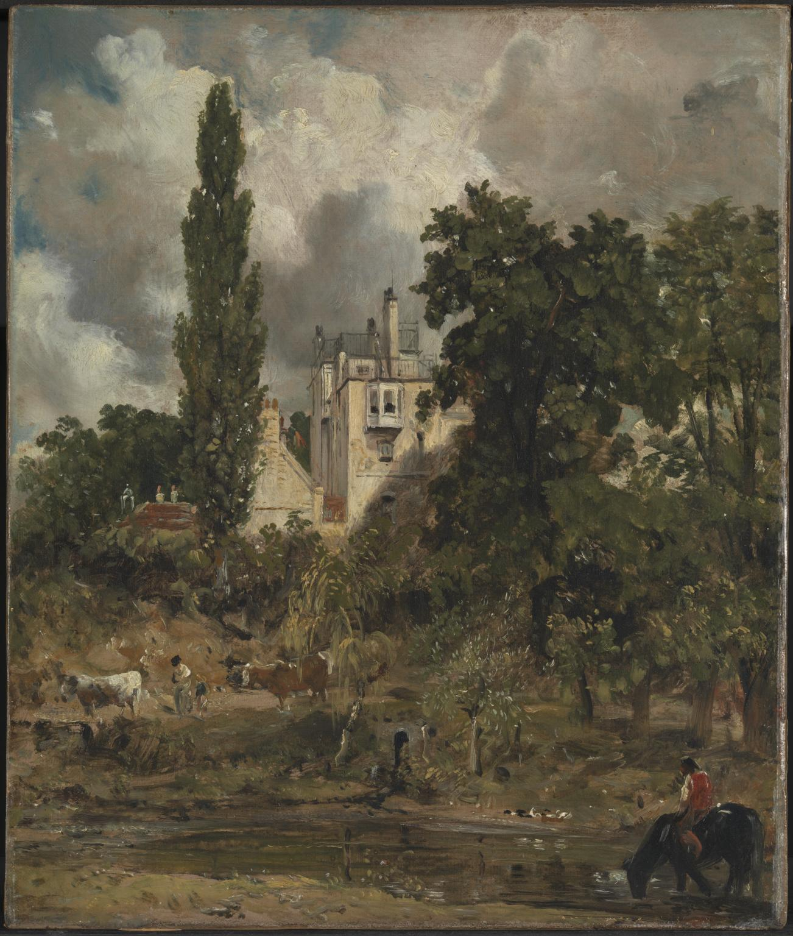

The many 18th and 19th century paintings of this area including lime, poplar and oak trees (large water-loving trees for keeping gardens, roadways and paths drier) are thus both an important historic feature of this area and have practical value in this area of wells and ponds with groundwater that to this day erodes silt from the soil and is a local cause of building subsidence.

