**Biodiversity Corridor G**

**North-Western Frognal**

This biodiversity corridor runs along the private 'shrubbery' on the western side of Frognal Nos 115- 99, and continues down the western side of Frognal to join to Oak Hill Park Local Green Space.

**History**

A large oak wood 'Northwood' grew on the Bagshot bed in the Frognal-Childs Hill area in the 15th century and probably for centuries before (from David Sullivan's *The Westminster Corridor*, 1994):

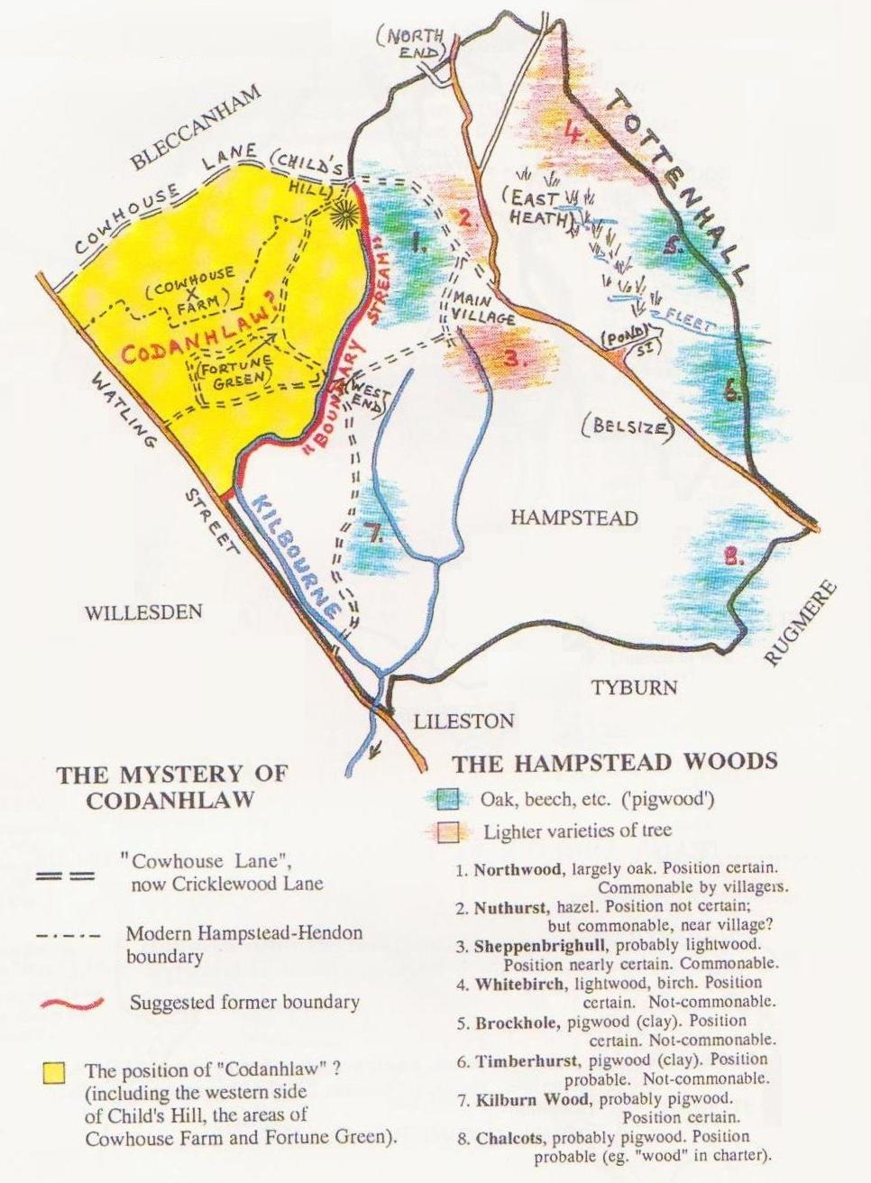

Frognal was mentioned in the early 15th century as a customary tenement, the "house called Frognal", which lay on the west side of the road, probably on the site later occupied by Frognal House, now 99 Frognal.

By the 17th century there were several cottages and houses at Frognal; the name probably indicating the road leading from the church and manor farm northward to the heath. On the west side of Frognal only the estate associated with Frognal House was ancient copyhold. The rest was either ancient demesne to the south or waste (heath) to the north.  In 1740 Frognal field was the eastern abutment of Northfield, part of the demesne.

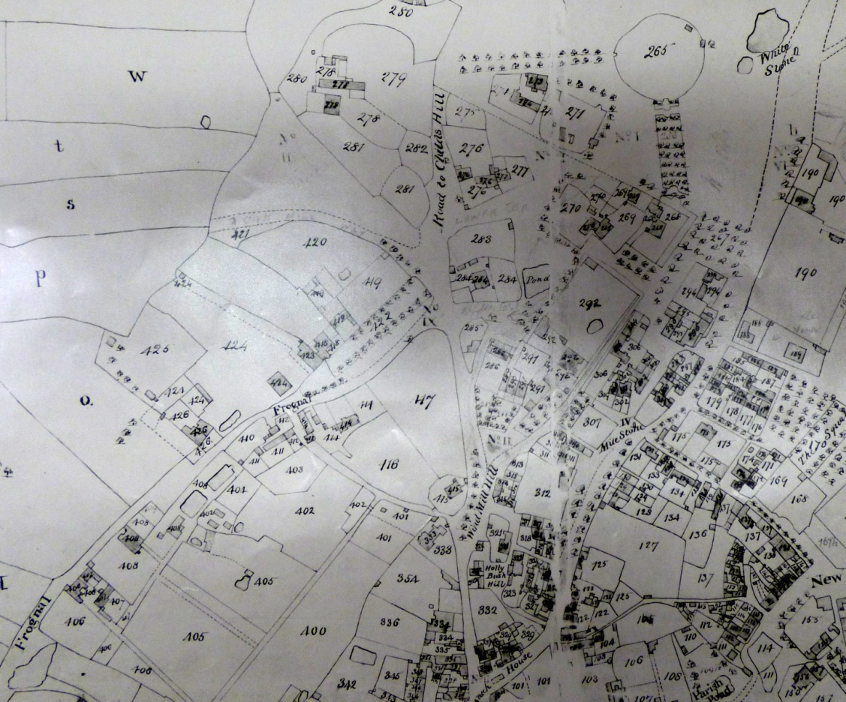

'Frognal House'

'Frognal Grove'

and stables

Lime avenue to Frognal Grove

Hampstead Manorial map 1762

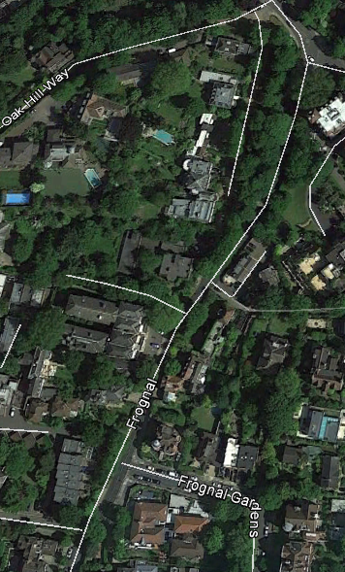

105-11 Frognal, originally 'Frognal Grove' and its stabling

The Shrubbery

99 Frognal, 'Frognal House'

In 1741 the architect Henry Flitcroft (1697-1769) acquired from Thomas Watson-Wentworth, earl of Malton, a house dating from 1700 or earlier on what was then heath, a coach house and stable and another cottage, and himself obtained further grants of adjoining waste, including the lime walk illustrated by William Collins in his painting 'As happy as a King' (1836) - see Biodiversity Corridor J.  He probably built Frognal (later Montagu) Grove on the site (now nos. 105 and 107 Frognal; no. 109 and 111 Frognal were formed from the stabling).

In 1811 Frognal was a 'hamlet of handsome residences', surrounded by groves and gardens 'of an extent begrudged by builders in these modern days'. (Abraham, quoted in Images of Hampstead S Jenkins & J Ditchburn, 56.)

Nowadays, the 'Shrubbery' opposite 103 to 115 Frognal is owned in sections by each house, ensuring that this area of green that shields these houses from the road and its traffic can never be built over. The biodiversity corridor also includes the large gardens of 90, 99 & 99a (Sisters of St Dorothy Convent) Frognal.

**Green Links**

This corridor is an important link to Biodiversity Corridor K and to Oak Hill Park Local Green Space, both of which contain veteran oak trees. While these trees are probably not old enough to be remnants of the old Northwood, nevertheless the continuity of oak trees and other tall forest-type trees such as limes and their links to each other are important for them and for the wildlife associated with them. This corridor is an eastern link between the SINCs of Branch Hill and St John's churchyard and the Local Green Space of Oak Hill Park.