**Biodiversity Corridor F**

**Rear gardens Hampstead Hill Gardens**

This corridor is an historic tree line following ancient hedgerow and boundary lines, its distinctive shape and lines of trees easily recognisable on the 1866 OS map and John Roque's map of 1746. It is closely related to Biodiversity Corridor D ' Rear gardens between Downshire Hill and Pilgrims Lane', and to Biodiversity Corridor J ' Spring Walk/Thurlow Road to Fitzjohns/Daleham via Lyndhurst Terrace'. Through its close association with proposed Local Green Spaces 'Hampstead Green', 'Heath Hurst Gardens', and 'Keats' House Gardens', and with Open Spaces 'Keats & Downshire Gardens', and hence to 'South End Triangle', it is a wildlife corridor with important links to the Heath.

There are a number of mature lime trees along its length, particularly at its High Street end, which may help to explain the reported presence of bats in the rear gardens here, so close to the High Street.

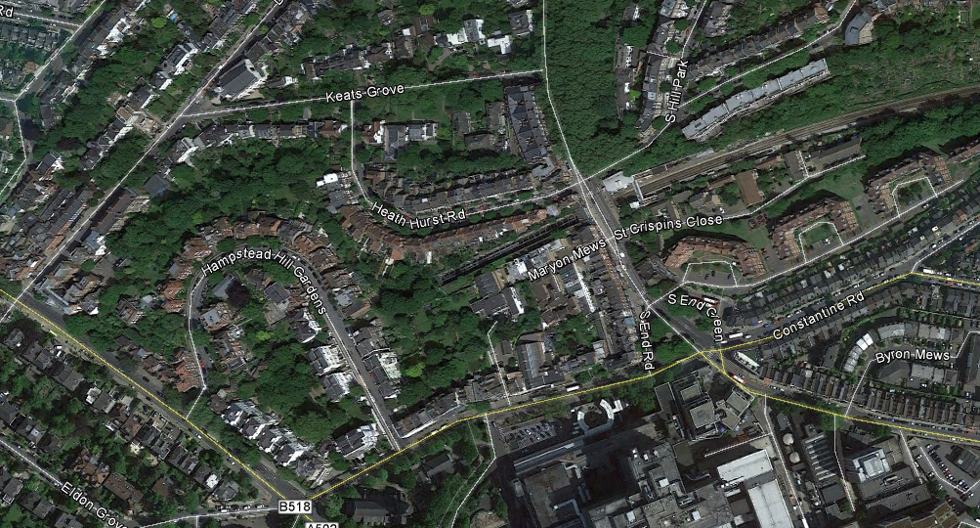

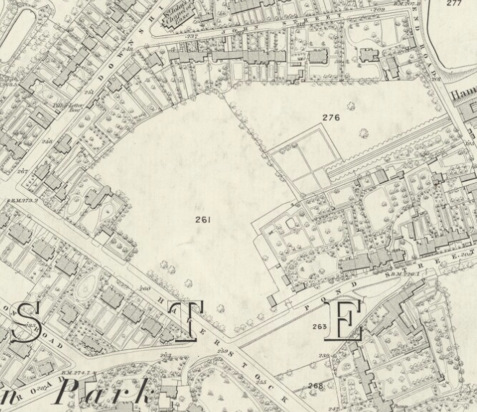 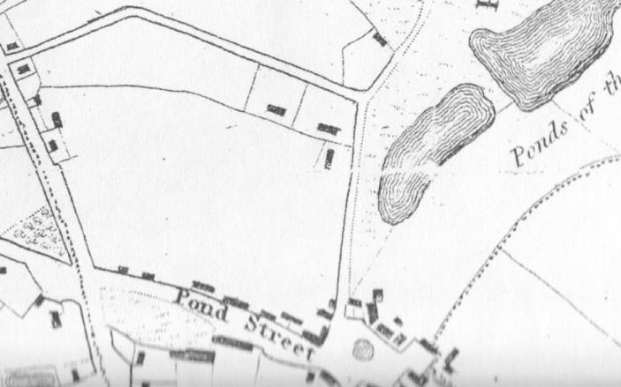

1866 OS map (Keats Grove was then called John Street) Newton's 1814 map showing the northern extent of

the fields marked 261 & 276 on the 1866 OS map.

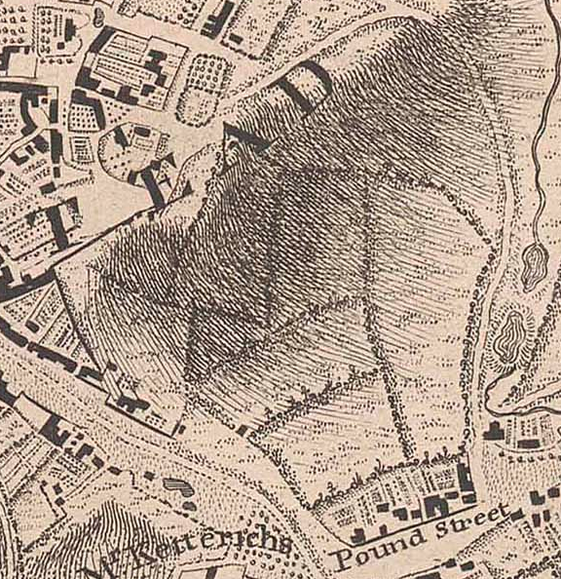

John Rocque's map of 1746 showing the familiar outline of this

historic hedgerow corner above 'Pound' (now Pond) Street.