**Biodiversity Corridor E**

South Hill Park and South Hill Park Gardens including Heath Edge Gardens and Parliament Hill (207 in Camden's schedule of Open Spaces).

This corridor follows ancient hedgerow and boundary lines, its distinctive shape and lines of trees easily recognisable on old maps. At the top of South Hill Park it still contains two veteran trees and the whole corridor is a continuous line of tall forest-type tree canopies. These link the wild life associated with mature and veteran trees to the western end of the SINC CaB104 and on towards Biodiversity Corridor F via Open Spaces South End Green and Keats and Downshire Gardens, and Local Green Spaces Heath Hurst Gardens and Keat's House Gardens. Its close proximity on one edge to the Hampstead ponds is important for transferring wild life associated with these ponds to other smaller ponds within Hampstead's gardens and Open Spaces.

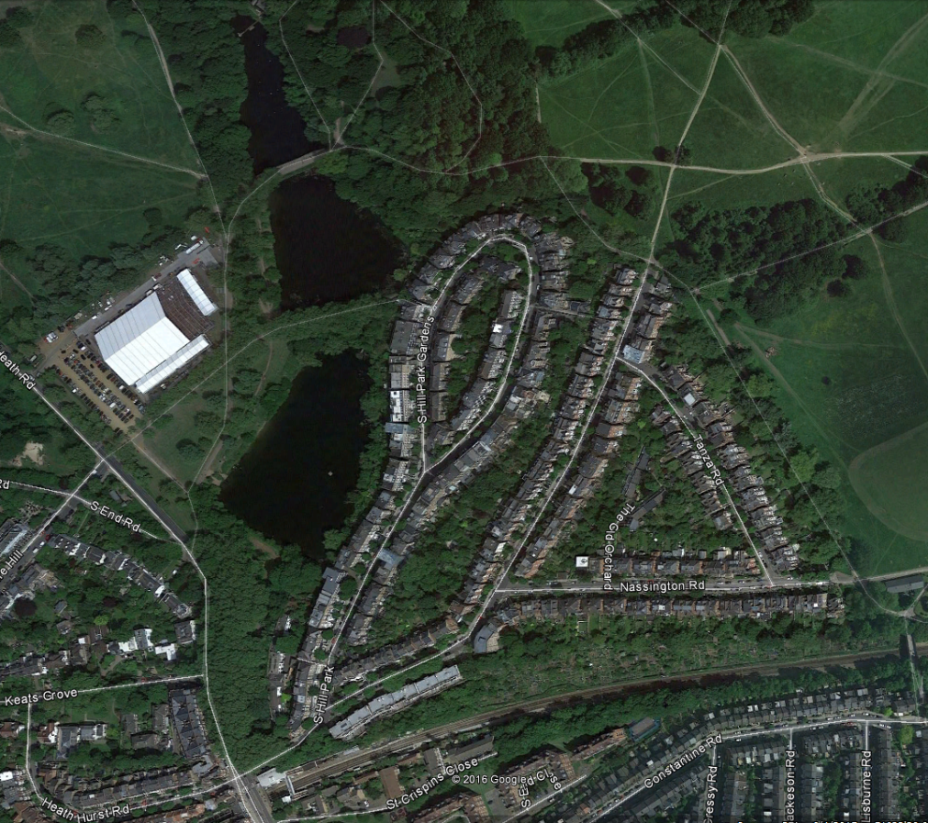 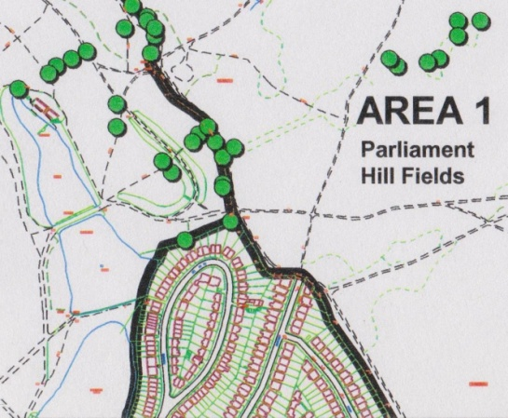

 Oak with veteran features

2 veteran trees associated with Biodiversity Corridor E; linked to other veterans on the Heath

from: 'Hampstead Heath Veteran

Tree Survey'

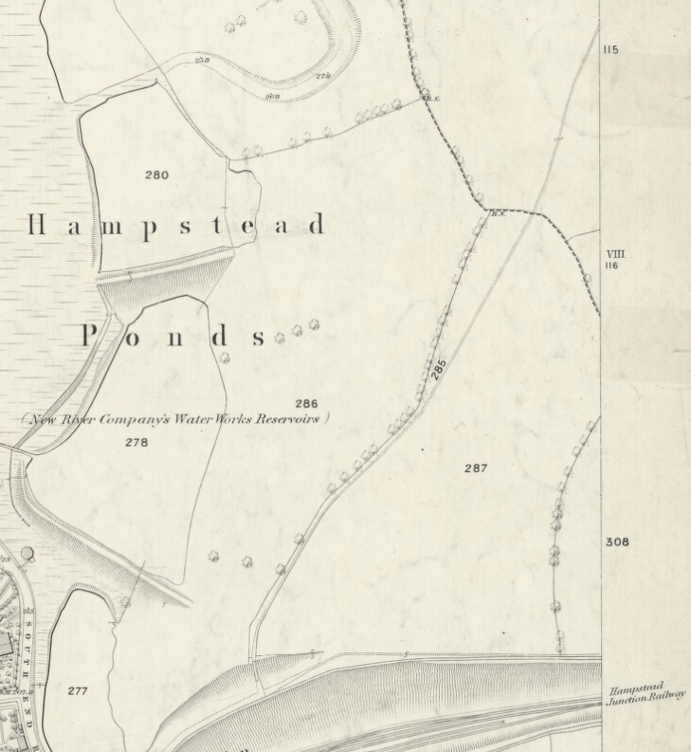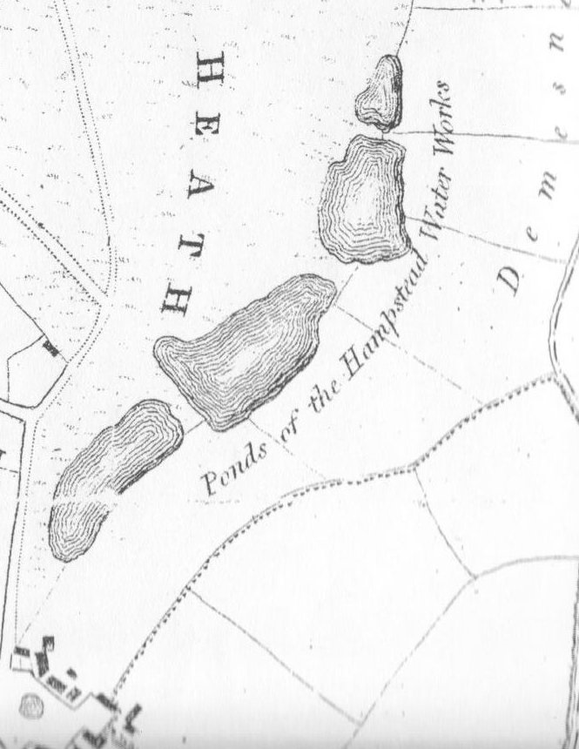

1866 OS map Newton's 1814 map

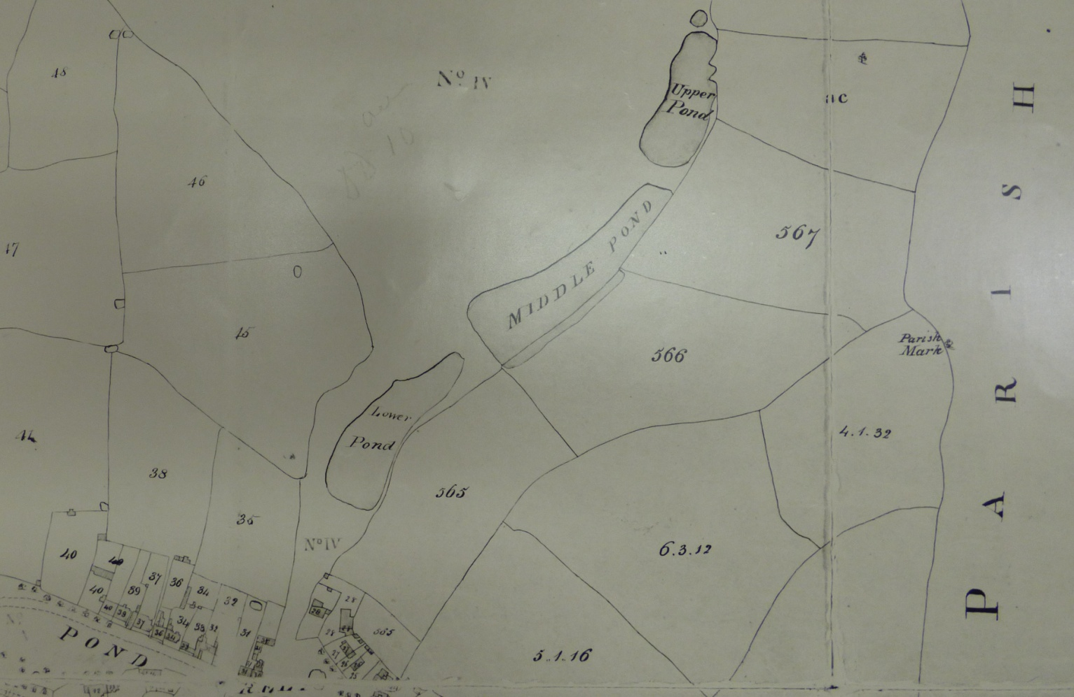

Manorial map 1762

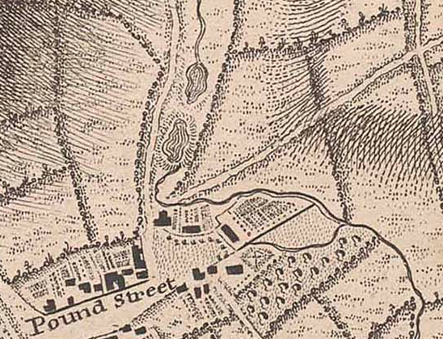

1746 John Rocques map