**Biodiversity Corridor C**

**Rear gardens between Willow Road and Denning Road: Historic tree line.**

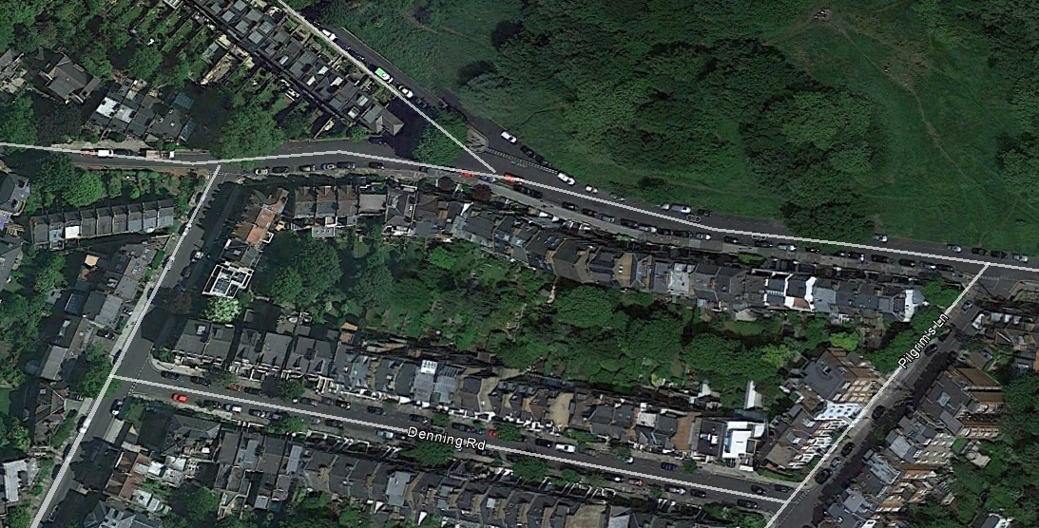

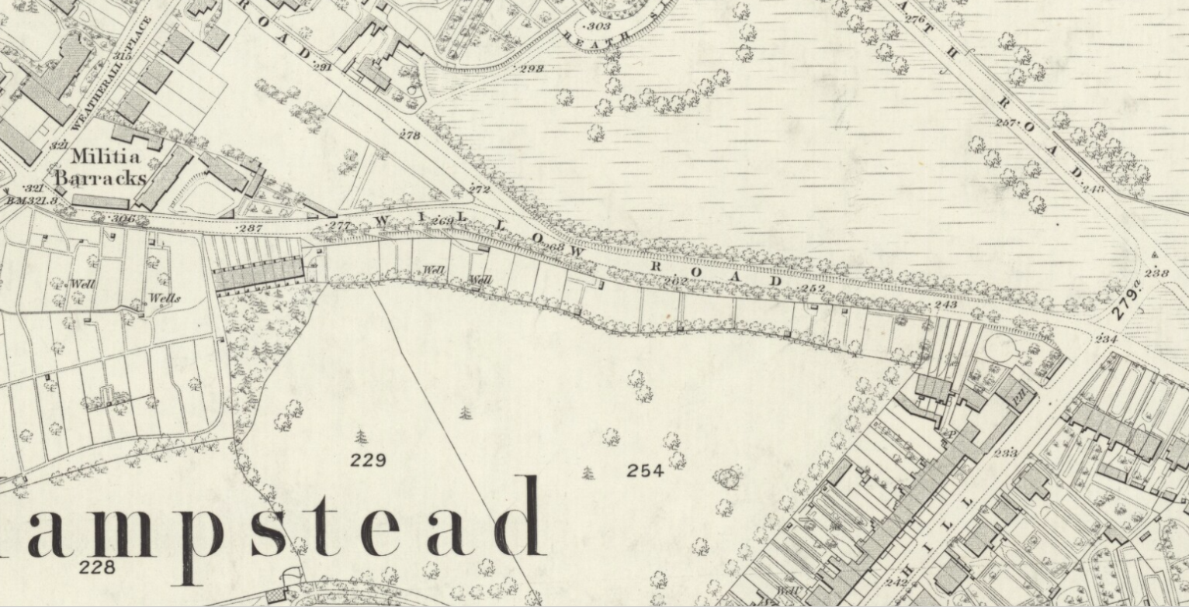 1866 OS map

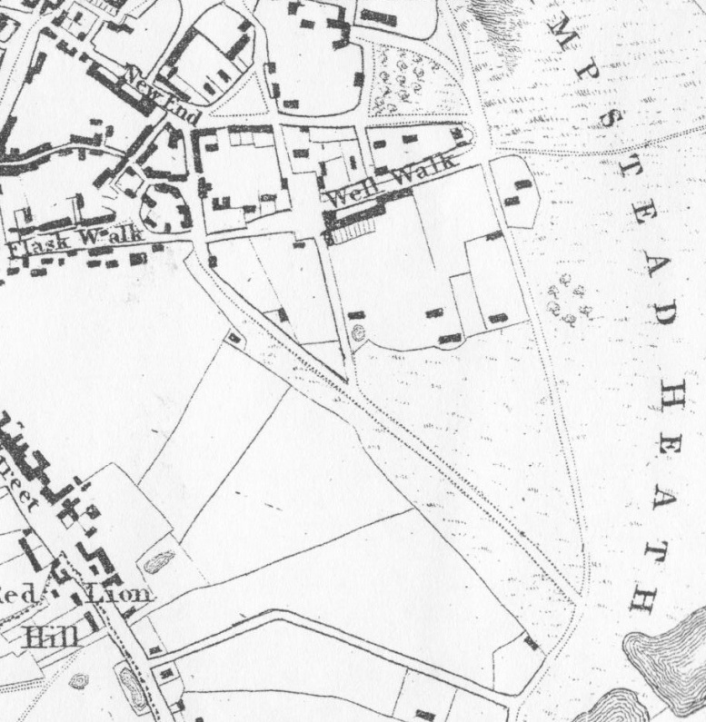 Newton's 1814 map

East Heath Road

Field boundary line later to be boundary line of rear gardens of Willow Road and Denning Road

Willow Road

This is an historic hedgerow and field boundary; an important linking biodiversity corridor between biodiversity corridors B (Rear gardens SW Christchurch Hill) and D (Rear gardens Downshire Hill and Pilgrims Lane), and the Heath.