Biodiversity Corridor A

Well Walk, Flask Walk and Gayton Road

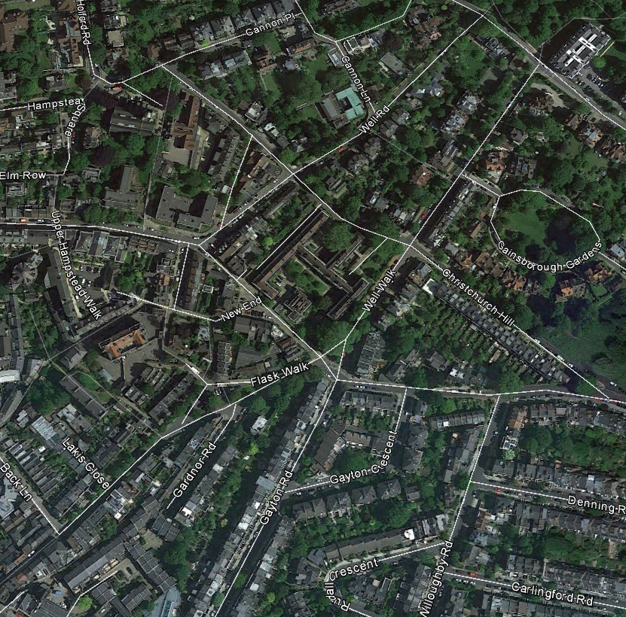

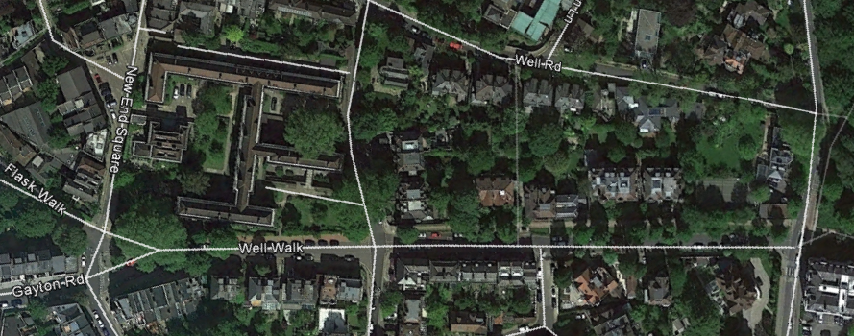

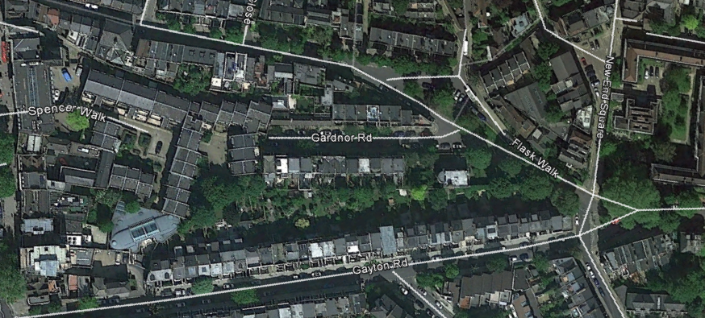

A contemporary manuscript reports that in 1700 "A hundred fine young trees" were planted either side of Well Walk. The present day line of lime trees running from the East Heath Road end of Well Walk along the grass verge and distinct raised and broad pavement on the north-west side to Christchurch Hill, continues with a line of London Plane trees towards Flask Walk and along the frontage of Gertrude Jekyll's garden below Burgh House and now part of Wells Court. This line of tall trees makes this an airy and verdant street leading from Hampstead Heath through the Heath fringes to the town, contributing to the important views towards and from the Heath, and increasing the rural effect.

Well Walk is just south of the spring line between the Bagshot Sands and the Claygate Beds, indicated by its name. An important function of the trees along this street therefore is to help reduce the impact of emerging groundwater, and it is clear they were originally planted to fulfil this function. Limes are tall forest-type high water demand trees and hence frequently planted in Hampstead by the Victorians and Edwardians as they are here along the northern side of Well Walk. Along the southern side of Well Walk there are also three lombardy poplars; tall extremely thirsty trees that make an important contribution to the corridor, keeping the gardens here less boggy, and somewhat reducing erosion of silt from the Claygate Beds by groundwater action.
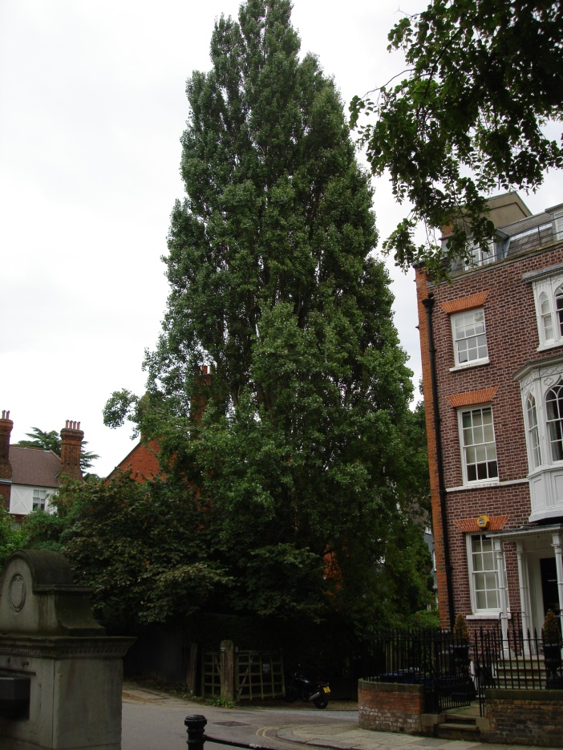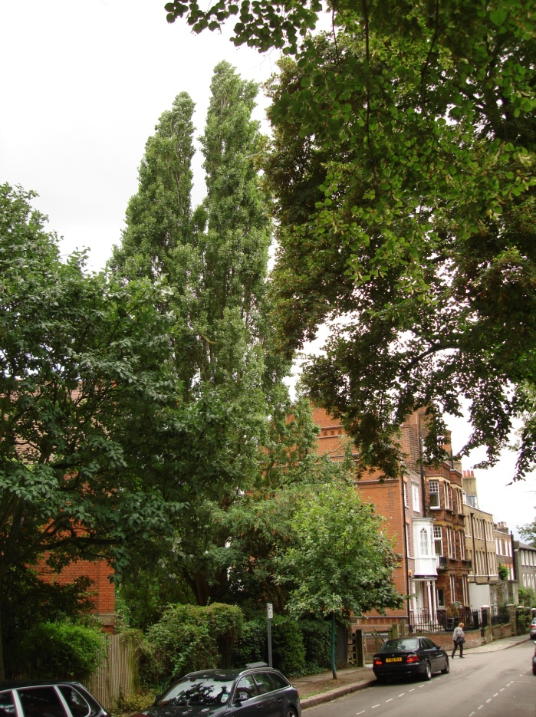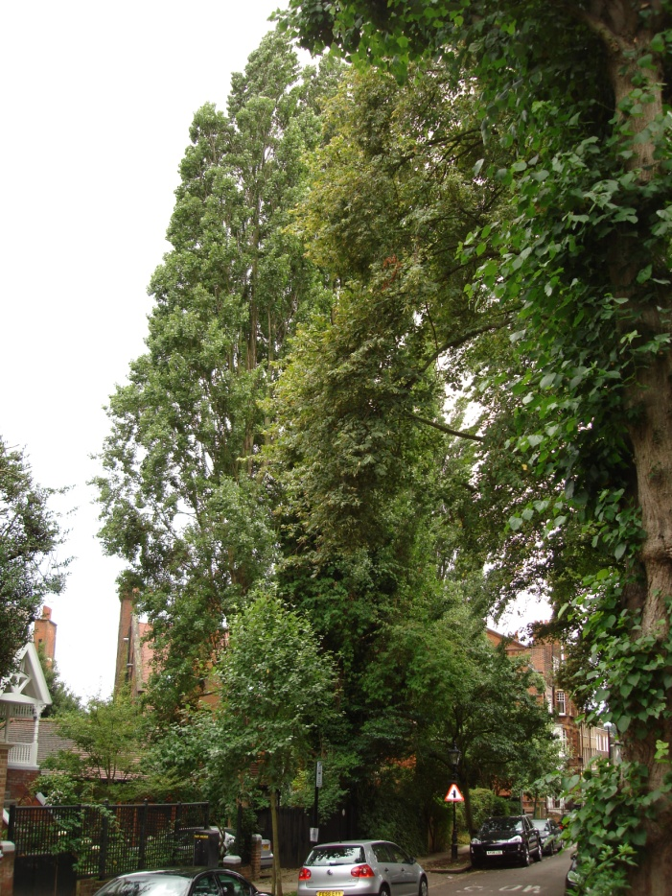

This line of trees is historic, and is clearly present on the 1866 Ordnance Survey map too:
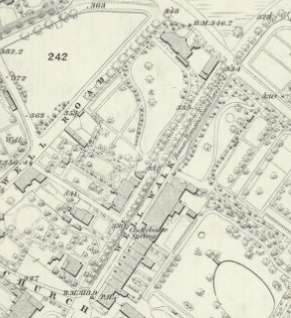
It can also be seen along Flask Walk and the first few trees along what is now Well Walk on the Manorial map of 1762.

High Street Back Lane Old Village Green New End Square

Trees along Flask Walk Trees beginning the line along Well Walk

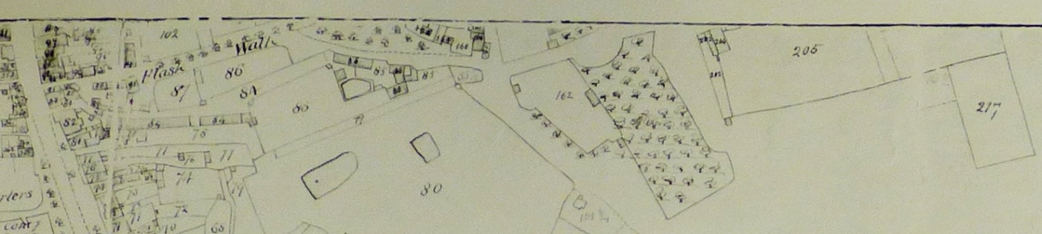

At New End Square the biodiversity corridor continues along Hampstead's former Village Green, now much reduced to a small grassy area with a few trees along it. The corridor then divides: a line of lime trees continues along Flask Walk as far as Back Lane, and the rear gardens of Gardnor Road and Gayton Road form the other fork.
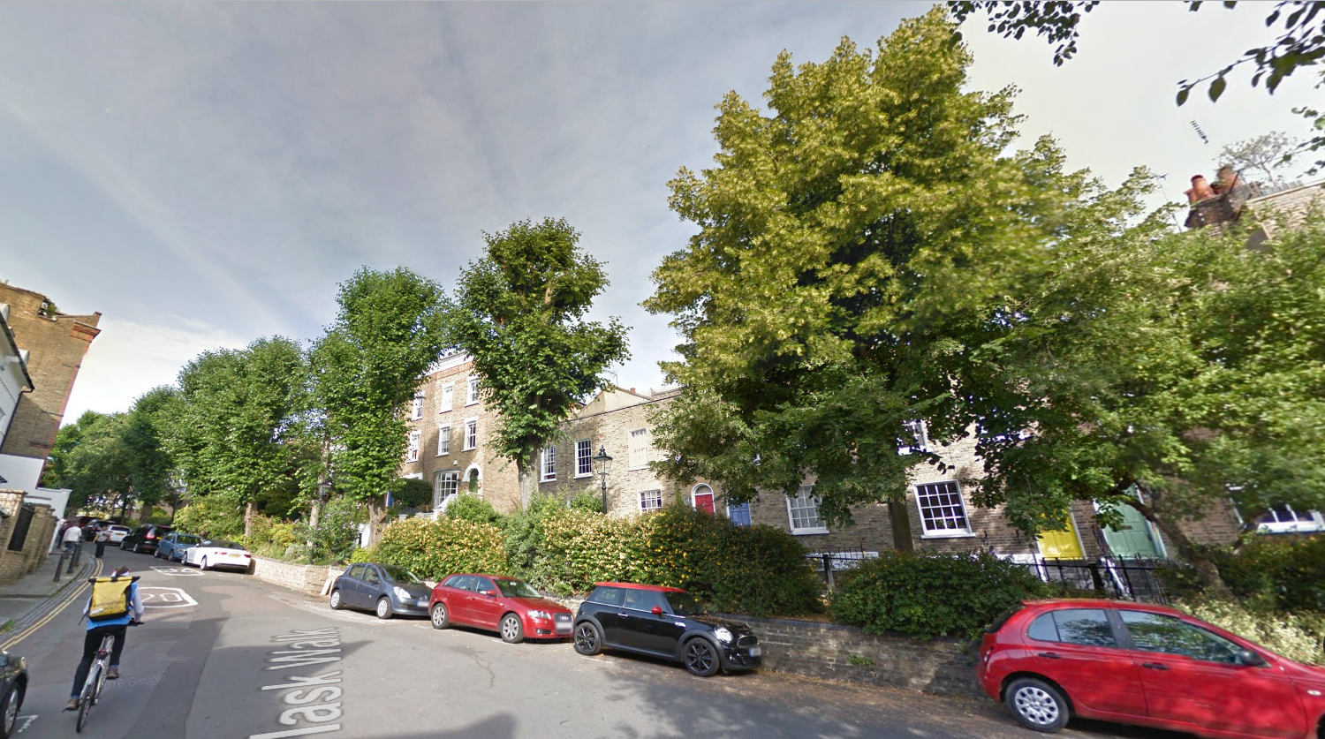
Lime trees along the north side of Flask Walk

The verdant quality of the trees here is much due to the fact that the Spring line between the Bagshot Sands and the Claygate Beds runs just north of this biodiversity corridor.

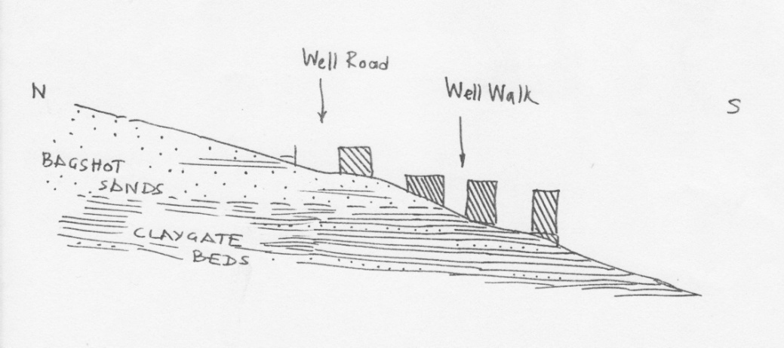
Section through the underlying geology of Well Walk by Dr Eric Robinson, geologist University College London
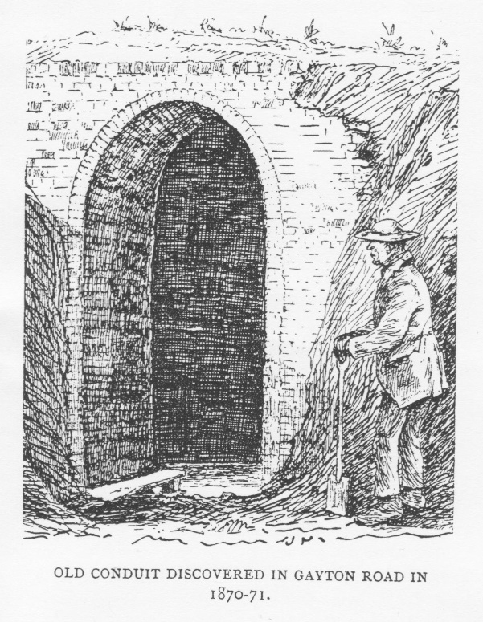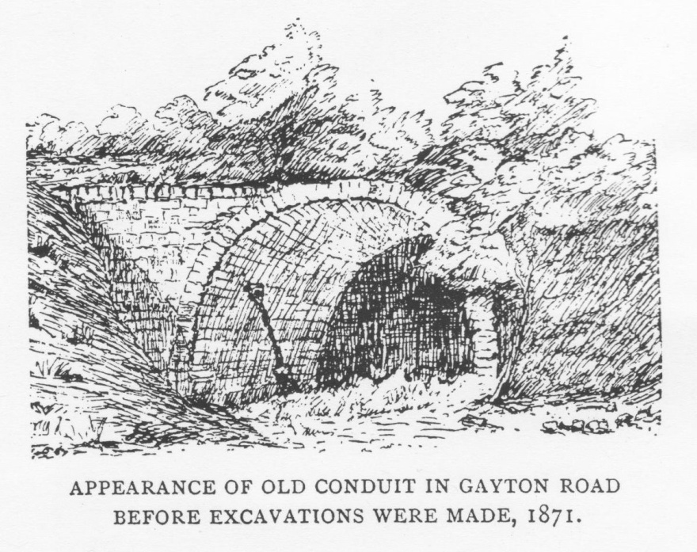
Several underground streams run downhill across the area; many were contained within old conduits and are now in the Victorian sewer pipes.
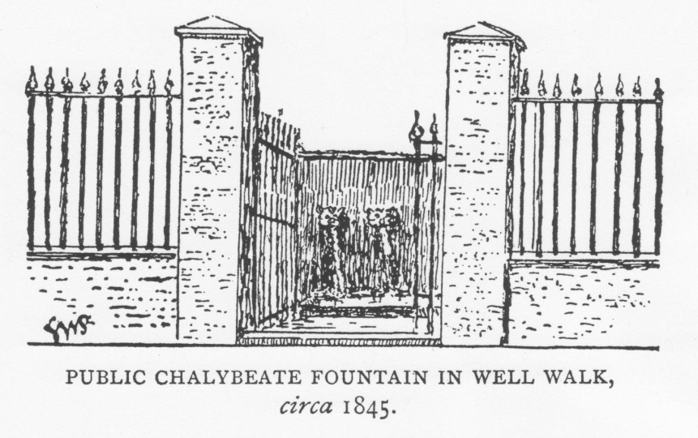
This fountain mentioned in George Potter's book 'Hampstead Wells' published in 1904, was fed by the stream originally running along, later in a conduit under, the path between Well Road and Well Walk. It emerged from the head spring and pond ('Parish pond' on the Manorial map of 1762, that Thomas Barratt in his 'The Annals of Hampstead' (1912) reports was later named the 'Bath pond') 100 yards higher on the hill. George Potter as a young boy in 1840 recalled the fountain as being outside the house now replaced by 22-24 Well Walk. "The water issued from two bronze lions' heads in two fairly strong jets, and was received into a shallow square stone basin." It was replaced years later by the current public well on the other side of the road, here seen in an early postcard, as well as the row of lime trees on the north bank of Well Walk going towards the Heath
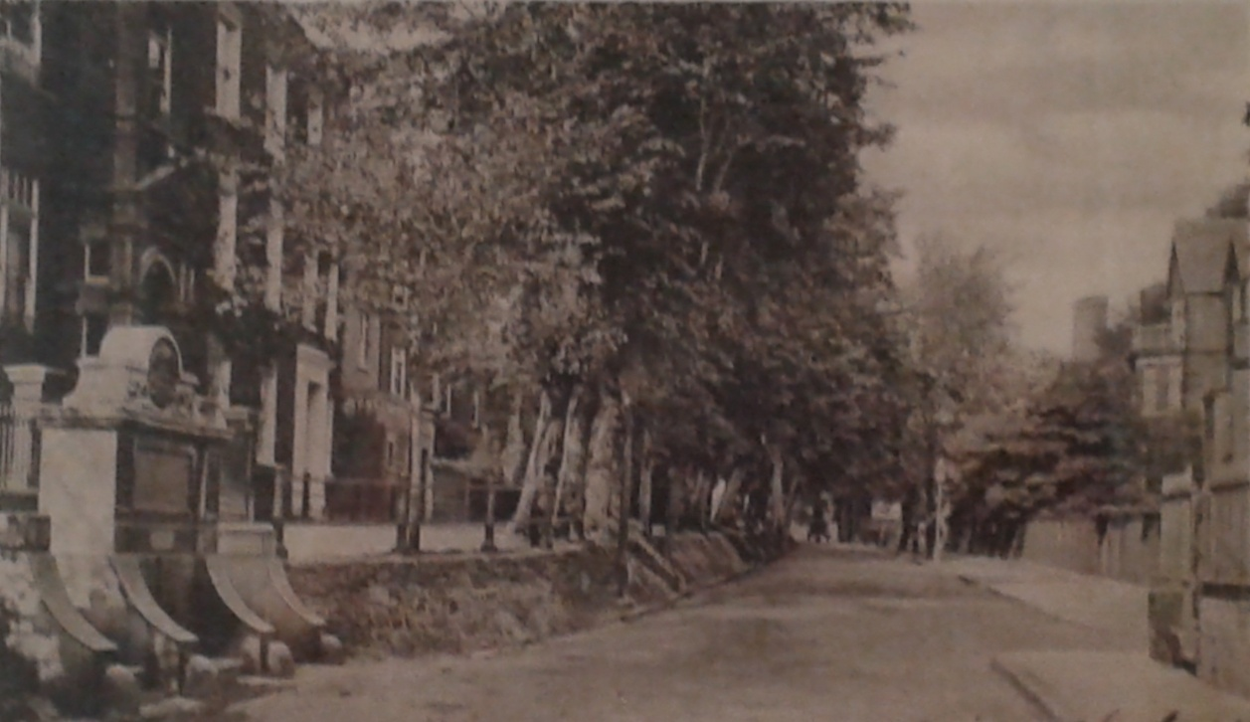

The importance of this line of trees to local people is demonstrated by their determination to retain it: funding to plant 8 new lime trees within gaps in this line was amongst the first CIL projects to be voted for in 2016. The Biodiversity Corridor is also the subject of many paintings and woodcuts by local artists:

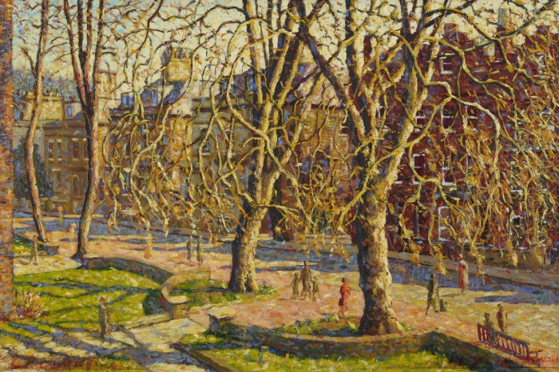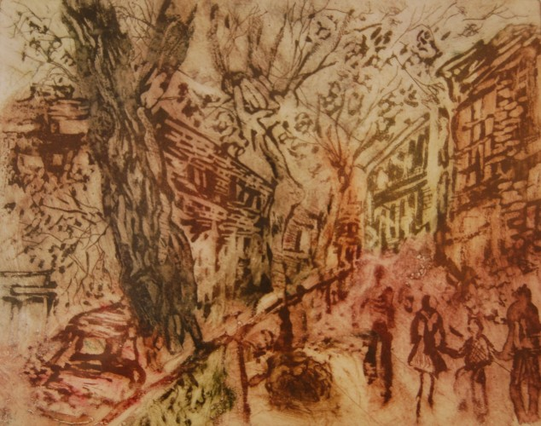
Well Walk from New End Square 1930 by George Charlton Lime trees up Flask Walk by Bette Greenhalf 1986

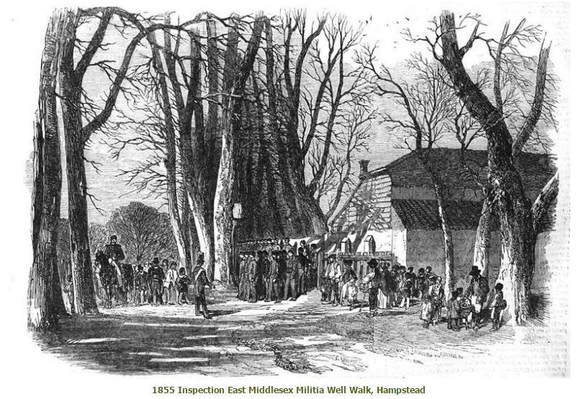

TJ Barratt 'The Annals of Hampstead' vol i: p181

