**For Janine: "**The location and distance of the property to areas identified as at flood risk in the URS report."

This is not in either **URS: 'Camden Infrastructure Study Update', July 2012** or

**URS: 'LB Camden — Infrastructure Study Update', 2015**  but this one does have:

**Flood Risk page 9:** "In total 12,700 properties in the borough are considered to be at risk from surface water flooding at a depth of above 0.3 m, based upon a 1 in 200 year rainfall event (Greater London Authority (2012); *London Strategic Flood Framework*).

The Camden’s Flood Risk Management Strategy identifies that the most likely flooding event to occur within the Camden north area is surface water flooding, of which Gospel Oak, Hampstead Town and Highgate would be most at risk. There are currently no viable schemes recognised for Gospel Oak or Highgate. However, within Hampstead Town the use of SUDs retrofits, embankments and methods to improve the control of water into the sewerage system have been proposed." [N.B. I cannot find this; suspect either removed or not completed]

In: 'London Borough of Camden — Strategic Flood Risk Assessment July 2014' Appendix B, Figure 3 iii page 78

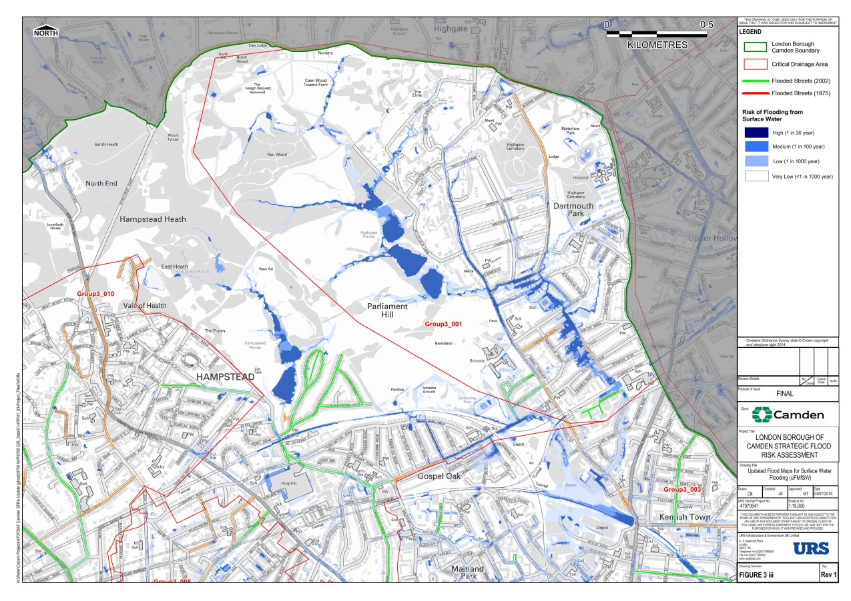

and Figure 3 iv page 79

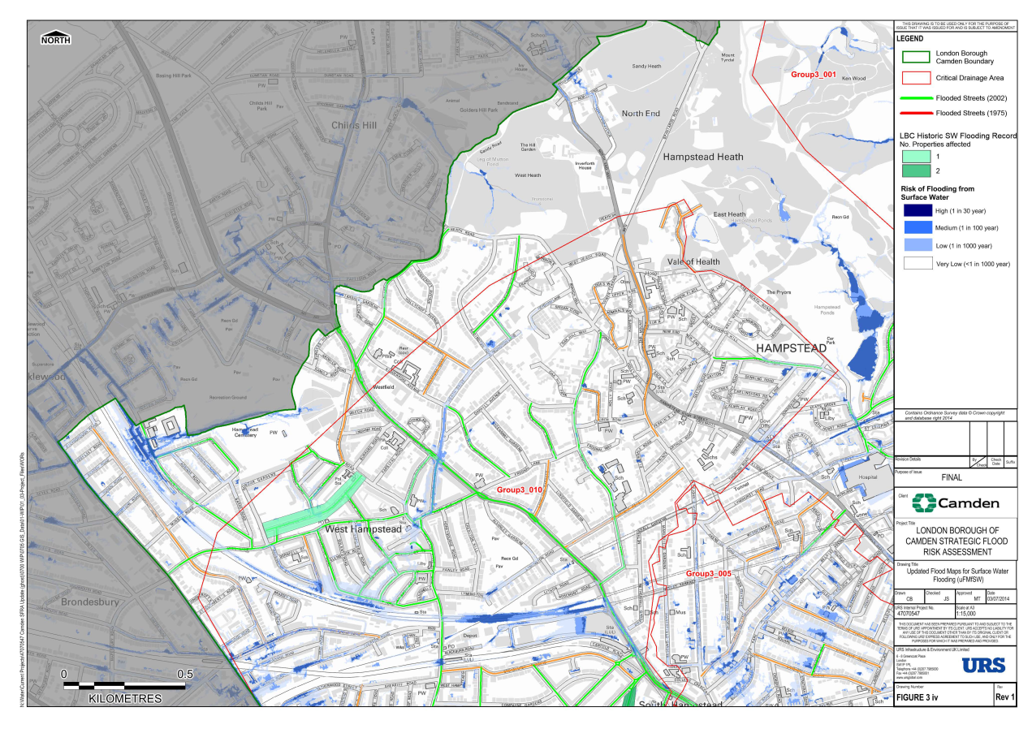

and Figure 3 v page 80

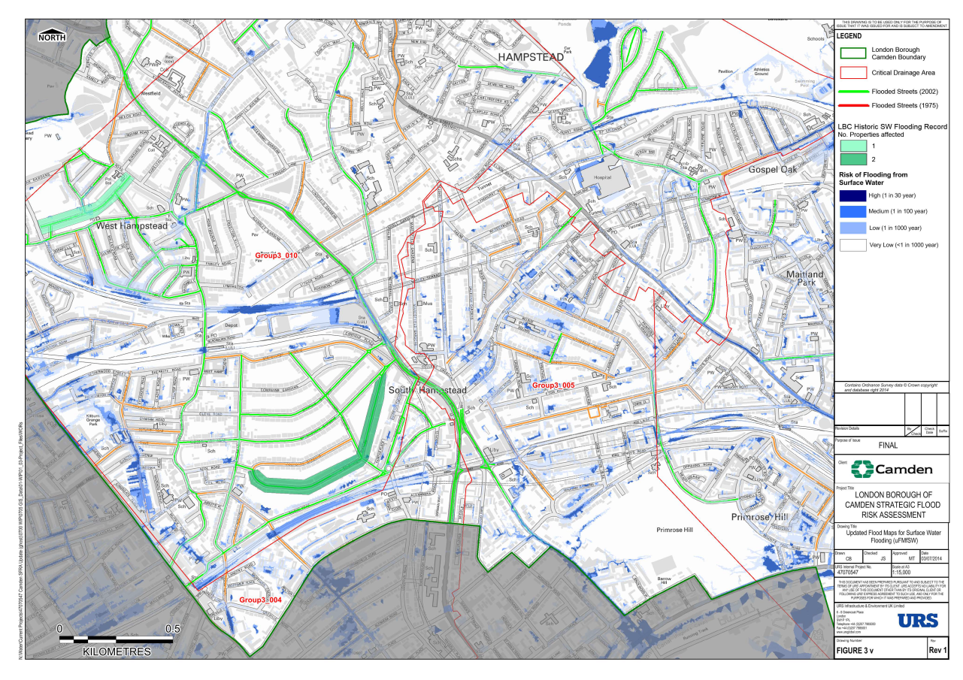

In: 'Managing flood risk in Camden: The London Borough of Camden flood risk management strategy'

**Fig. 5.1 - Map of flooded roads in 1975 and 2002 floods**



**Table 6.1 Key locations at risk of flooding in Camden North**



**"6.3 Flood Alleviation schemes in Camden North**

This area is at risk of surface water runoff in an extreme rainfall event, and to a lesser extent, of the Hampstead Heath ponds overtopping or breaching. The Royal Free Hospital is a piece of critical infrastructure which has been recognised as being at risk from flooding.

The more likely event to take place in the north of the borough is surface water flooding. Because of the steep hills, there is a risk that, in an extreme rainfall event, water will rush down the slope causing significant flooding at the bottom. There are nine key locations in the north of the borough where flood water is likely to gather should there be an extreme rainfall event. These have been grouped into three areas for potential flood alleviation schemes: Gospel Oak, Hampstead Town and Highgate.

**6.3.2 Hampstead Town**

This area covers a range of different locations to the west and south of Hampstead Heath.

Enhanced modelling estimates large numbers of properties may be within the Very Significant and Significant risk bands. Flooding is generally caused by direct rainfall on impermeable surfaces generating relatively high surface runoff velocities over roads and water collecting at low points.

Five different locations have been identified as having flood risk and they were investigated for the Project Appraisal Report which was completed in spring 2013. This report looked at schemes involving embankments, Sustainable Drainage Systems (SuDS) retrofits and increasing the number of gullies to let more water into the sewer while controlling it with a hydrobrake.

**6.3.5 Royal Free Hospital**

The Royal Free Hospital has been identified by Drain London as one of the London hospitals which needs to manage its surface water flood risk. It will be part of a detailed investigation by Drain London 2013-14 which will be used as a test approach to assess risks to other strategic infrastructure."

What I think is missing is a list of roads so that developers can't ignore or miss this issue, and would suggest that from 'London Borough of Camden (2003) Floods in Camden – Report of the Floods Scrutiny Panel' **Appendix 4: Flooded Roads in Camden,** 1975 and 2002' - we extract -

**'Hampstead Neighbourhood Forum Area Roads flooded in 1975 and 2002' [**which I think are]:

**1975 2002**

Arkwright Road NW3 Arkwight Road NW3

Fleet Road NW3

Frognal Gardens NW3

Heath Street NW3

Lyndhurst Gardens NW3

Mansfield Road NW3

Nassington Road NW3

Parliament Hill NW3

South End Road NW3

South Hill Park NW3

South Hill Park Gardens NW3

Tanza Road NW3

Willow Road NW3 Willow Road NW3

Windmill Hill NW3