Hampstead & Highgate Report
Geological and Hydrological Study

July 2012
First Steps Ltd
Lindsey Connelly

Contents
Executive Summary 3
Chapter 1 Introduction 4
Chapter 2 Geology 7
2.1 Basic Geology of the Hampstead & Highgate area 7
2.2 Hydrogeological Maps 8
Chapter 3 Hydrology 9
3.1 Hydrology of Hampstead & Highgate 9
Chapter 4 Basement Planning and Construction Implications 13
4.1 Basement Planning System 13
4.2 Basement Implications 13
References 15
Figures 15
Tables 16
Appendices 17

Executive Summary
- Basement developments are becoming an increasingly fashionable way to extend properties in the Hampstead and Highgate area of North London. However as a result, the area is currently under a lot of pressure to accommodate the influx of basement development proposals which threaten to cause long term problems for the residents.

- This report therefore intends to provide understandable geological and hydrological information for the residents of the Hampstead and Highgate area whom are currently affected by basement developments in any way. The report includes a number of geological and hydrogeological maps which, together with background knowledge of the area and important concepts explained, will allow the reader to understand fully the site in mind. The report also looks at the different types of basement construction, outlining the processes involved and professionals responsible at each stage of planning and construction.

Chapter 1 Introduction
- Currently a number of residents in the Hampstead and Highgate area are choosing to construct basements since it is viewed as a good way of gaining additional space in homes without having to relocate to larger premises in a different area [7]. Common uses for residential basements include swimming pools, home gyms, studies and bedrooms. However, whilst excavating a basement below a property solves the problem of land space, it has the potential to cause a negative impact on the property and neighbouring properties. Basements can cause structural stability problems of the property and surrounding properties, result in land instability and/ or create problems with local groundwater flow.

- The aims of this report are to investigate from open sources the geology and hydrogeology of the area and the methods of design and construction used for dimensioning and excavating basements in the over consolidated strata of North Camden. Also the report aims to obtain factual data on the rainfall and evaporation for the area and from this derive a first approximation of the quantity of recharge to groundwater through a typical year. Following this, the report should include maps detailing the topography, streets, rivers and springs (identifying areas of source and sink) and likely groundwater flow for the area. For these purposes the “area” is that bounded by the Grid Lines Eastings ⁵25 to ⁵29 and Northings ¹85 to ¹88.

- In order to gain an understanding of the hydrology of the area, the hydrological cycle must be considered. The cycle is one which water takes above and below the surface of the earth, where it changes state depending on the temperature and pressure at that point. Figure 1 shows the order of the cycle, including the evaporation, precipitation and infiltration processes involved. The rate at which water is transported varies during different seasons, for example evaporation rates will be higher during the warmer months. This report will use rainfall and evaporation data to quantify volumes of water at different stages in the cycle, including the maximum volume of rainfall in a catchment and infiltration values. The retaining walls used in basement construction can adversely affect the hydrological cycle by forming a dam against groundwater flow, forcing the groundwater to take a different path.

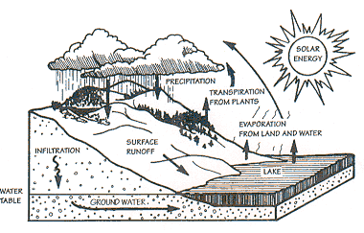

Figure 1 Diagram of the hydrological cycle [7]

- Basements can be constructed under current properties, in open spaces on property land (gardens) or constructed underneath newly developed houses. Any basement construction project begins by driving four retaining walls into the ground surrounding the perimeter of the basement plan. The ground material inside the walls is excavated. Following this, there are then a number of methods employed to carrying out the construction of a basement, including the ‘Top/Down’ and ‘Bottom/Up’ method for large basements and the ‘Hit and Miss’ method for smaller projects [1].

- After positioning the retaining walls in place, the ‘Top/ Down’ method then requires piles to be drilled in for further reinforcement. Next, a ground floor level slab is cast, making sure to provide access for workers, excavation machinery and removal of spoil during construction. The ground beneath is then excavated and disposed of as directed, again leaving an access hole for the construction of additional storeys. This process can be repeated for the following second and third level. This method of basement construction allows for the building above to be constructed at the same time as the basement works saving a lot of construction time and money and more importantly limiting ground movement under neighbouring properties.

- The ‘Bottom/Up’ method involves excavating the basement to its full depth and constructing from the base upwards. Struts (braces) are used to during excavation and basement construction for temporary support. Depending on the depth of the excavation, one or more different layers of struts will be required to ensure sufficient resistance against groundwater and soil pressures on the retaining walls. The concrete floor slabs are cast in place, which begin to help support the sidewalls of the basement alongside the struts. The strutting system in place can subsequently be used for structural beams or floors for each storey, or indeed can be removed once the basement floor has been incorporated (now taking all groundwater and soil pressures).

- The ‘Hit and Miss’ method of basement construction process involves a series of small excavated sections underneath a property, typically 1.0 – 1.5m in length. This produces a series of spaced gaps under the property (‘hit and miss’ pattern), which are filled in by casting concrete under the existing foundation. By filling in the excavations, the overlying structure is thus underpinned. Once the perimeter of the basement has been underpinned to the required depth, the full excavation can hence be carried out. Following this, the concrete floor slab is installed and the rest of the basement interior is constructed.

- For any basement proposal a system is in place involving a number of different roles with individual responsibilities, each important for ensuring the project is carried out effectively and safely. These positions include Chartered Geologists, Chartered Civil Engineers, Structural Engineers, Contractors and Technical Advisors. See Appendix A for flow diagram of these positions and how the basement planning process is carried out.

- This report will draw upon a number of case histories throughout the Hampstead and Highgate area, demonstrating further the impact of basement construction projects.

Chapter 2 Geology
- The geology of any site can be analysed using a number of different sources. In this report, geological data has been taken from Ordnance Survey maps, borehole & trial pit data logs and visual geology i.e. what can be seen on site.

2.1 Basic Geology of the Hampstead & Highgate area
- The geology of the Highgate area consists of Bagshot Beds capping the higher ground, overlaying the Claygate member of the London Clay Formation, which covers the London Clay. The British Geological Survey describes Bagshot Beds as “fine, white, buff and sometimes crimson sands, grey when unweathered, with sporadic seams of pale pipe-clay and local beds of flint-pebble gravel”. The BGS defines the sediments of the Claygate member as “interbedded fine-grained sand, silt and clay” and the London Clay Formation at this location as “fine, sandy, silty clay”.

- Due to glacial effects, the Bagshot and the Clay materials outcropping on the slopes have merged over time to form a sludge material; this has now dried and hardened covering the layers present. As a result, digging or excavating into this layer of material can generate slope instability.

- The ponds in Highgate appear to be fed by surface water and groundwater, which is collected in pipes and fed through to the ponds. The surrounding fields provide the source, whilst the ponds act as sinks in the groundwater flow system. In the event of heavy rainfall, the excess surface water can be channelled into an overflow or “stock pond” located next to the Highgate ponds.

- There are a number of springs situated in Fitzroy Park, pushing up water through cracks in the road. Strata springs follow a natural course of weaknesses in the underlying bedrock. It has been reported that smaller ponds situated on residential land nearby have never dried up, suggesting they feed from both surface water and additional springs located around the sink itself.

- The geology in Hampstead is very similar to that of Highgate, with Bagshot overlying layers of the Claygate member and London Clay Formation. Again, the result of glacial effects subsequently resulted in the mixture of Bagshot and clays to form a sludge material.

- Parliament Hill is ~100m high and mainly consists of Bagshot Beds (gravely material) overlying clays. The hill itself is covered in vegetation and trees.

- A number of houses situated on the clays in these areas record past periods of differential settlement. Some housing showed signs of structural instabilities, including asymmetrical window frames, doors and beams etc.

- A number of ponds are situated to the west of South Hill Park, with some houses backing right on to the ponds edge.

2.2 Hydrogeological Maps
- The topography of the Hampstead and Highgate area largely falls from the North to South of the site covered. Appendices B & C show maps of the topography of the area, at a Scale of 1:10,000 and 1:5000. Areas of greatest height include the Hampstead Heath area which measures ~130m AOD and the North of Highgate measuring ~125m AOD.

- Appendix D is a map showing the geological boundaries in the area, taken from Ordnance Survey Maps at a scale of 1:10,000. The map clearly indicates where the boundaries between the Bagshot Beds and Claygate Member ground lie. Therefore, when compared to the streets and railways map in Appendix E, it is clear which properties fall on the geological boundaries.

- Appendix F is a map showing rivers and streams in the area at a scale of 1:5,000. The map details a number of water courses running through Hampstead and Highgate area, identifying various sinks, spring lines and drains present.

- The groundwater flow has been assumed to follow the same path as surface water in this case (using the topography as a guide). Therefore, Appendix G shows a map of scale 1:10,000, with flow lines indicating the direction the groundwater through the area. The map along with hydrological data obtained can be used to calculate the size of the catchment areas and subsequent volume of rainfall expected in each area. The following chapter shows how exactly the catchments can be determined and gives sample calculations for quantifying the amount of rainfall in those catchments.

Chapter 3 Hydrology
The hydrology of the site was analysed in order to determine maximum volumes of rainfall and infiltration values. As previously mentioned, by quantifying the hydrological processes involved in the water cycle, a better understanding of the impact of a basement development can be obtained before construction. This chapter explains how groundwater maps are constructed and how the catchment areas are hence determined. Sample calculations were also included for the maximum volume of rainfall and infiltration values.

3.1 Hydrology of Hampstead & Highgate
- Annual rainfall data and catchment area calculations can be used to determine the maximum volume of groundwater expected; this can be expressed in terms of daily use per person and have the number of people it can support over a given period. Appendix H shows monthly rainfall data for Hampstead from 2002 – 2010, including average monthly rainfall values and totals for each year [4].

- The maps shown in Appendices C & G both show the topography of the Hampstead and Highgate area at a scale of 1:5000 and 1:10,000 respectively. The centre lines for valleys and fluvial divides were constructed based on the topography of the area. Figure 2 demonstrates how the valleys and fluvial divides were constructed using the topography.
100m
90m
80m

Valley
Fluvial Divide

Figure 2 Diagram of groundwater flow construction (valley centres & fluvial divides)

- Once the valleys and fluvial divides were added to the topographic maps, directions of flow can be assumed to travel between them. Figure 3 details the expected direction of flow as a result of the rainfall reacting to the topography of the area.
100m
90m
80m

Catchment Area

Figure 3 Diagram of expected flow paths on a map
- The catchment areas can be determined by measuring the area between fluvial divides on the groundwater flow maps, see Appendices C & G. In order to quantify the maximum volume of rainfall available for groundwater to be expected in a month for the area, an average rainfall amount must be multiplied by the catchment area. This volume can subsequently be divided by the average amount of water consumed daily per person to determine how many people could be supported by such a volume.

Example Calculations

Groundwater Flow Map (Appendix C) catchment area = 462,500m²
In 2010, average monthly rainfall = 58.1mm

  - Average monthly rainfall volume = rainfall x catchment area
= 26,900 m³ (~27,000m³)
= 5,939,167 gallons

Check
Groundwater Map (Appendix G) catchment area = 500,000m²
In 2010, average monthly rainfall = 58.1mm

  - Average monthly rainfall volume = rainfall x catchment area
= 29,100m³ ⁽~290000 m³)
= 6,379,106 gallons

- Therefore both maps (of different scales) give similar values for the average rainfall volume expected for the catchment area, with an error less than 0.1%. The volume of rainfall expected can then be divided by an average volume of water consumed per person per month. Appendix J gives a breakdown of the daily usage of water, suggesting an average value of ~2240 gallons per person per month. As a result of this, a catchment area of 500,000m² catches a sufficient volume of rainfall to supply 2700 people with water per month.

- There are a number of streams and rivers located throughout the Hampstead and Highgate area. Appendix F details the streams, rivers and various springs in the area. There are a number of underground or “hidden” rivers located in the Hampstead area, including the River Fleet [10]. The river flows from Hampstead Heath down to the Thames at Blackfriars Bridge, but now flows in an underground sewer. The sources of the River Fleet are the springs by Parliament Hill, detailed in Appendix F.

- There a number of springs situated throughout the Hampstead and Highgate area, some of which apparent under roads and in residents’ gardens. Appendix K shows a spring coming through a crack in the road in the Highgate area, which appeared to be a common occurrence around the area. A number of basement developments are currently being carried out in Highgate, one in particular involving neighbours demolishing property and building new house with a large basement beneath. By constructing a deep excavation into the clay strata, the pore water pressure would decrease, causing the effective stress in the clay to increase. As a result, the ground would eventually consolidate, causing indefinite settlements occurring to theirs and surrounding properties. Since the consolidation process could take up to ten years, the construction workers appear to care very little about the neighbours’ concerns with such work.

- Appendix I includes evaporation data from 2002 – 2011 for the Hampstead area which, together with the rainfall data from Appendix J, can be used to find the total infiltration amount expected. See equation (1) below. The levels of infiltration are very important with regards to controlling groundwater flow levels and subsequently preventing flooding.
$Infiltration=Rainfall-Potential Evapotranspiration-Accumulated SMD$ (1)
- The infiltration data calculated in Appendix I highlight the negative infiltration values calculated for 2002 – 2011. A negative infiltration value suggests a Soil Moisture Deficit (SMD) occurred which in effect is where more water leaves the ground than enters it. As a result of SMD, the ground can become very dry and stiff, often requiring an irrigation system to keep flowers, plants and trees watered. The data shows the Hampstead area experienced SMD during the years of 2003, 2005, 2006 and 2011. A number of gardens in the catchment area have subsequently employed an irrigation system in their gardens to keep the infiltration rate suitable throughout the year.

Chapter 4 Basement Planning and Construction Implications
This chapter explains the current basement planning system, including a Basement Impact Assessment (BIA) and other legislation. The impact of excavating a basement is explored further and how exactly these impacts can be reduced before, during and post construction.

4.1 Basement Planning System
- Camden Council only permit basement and underground developments that do not directly or indirectly cause harm to the built and natural environment, result in flooding and/ or lead to ground instability [7]. The planning system currently in place involves a Basement Impact Assessment (BIA) designed to identify potential impacts of basement developments and how these could be mitigated.

- Basement developments can have a number of negative impacts on the built and natural environment, potentially affecting groundwater flow, land stability and surface flow & flooding. Therefore legislation is in place to limit the impact of basement developments. The Party Wall Agreement Act, set up in 1996 [3], can be involved when a proposed excavation is within 3m of neighbouring structure, would extend to a greater depth than the structure itself or is within 6m of neighbouring structure which also lies within a zone defined by a 45 degree line from that structure [7].

4.2 Basement Implications
- Excavated basements could potentially displace groundwater flow depending on the groundwater level under the property. In the event of this, the retaining walls of the basement will form a dam-like barrier against the groundwater, causing it to find a new water course around the area of obstruction. The newly formed flow path could result in the flooding of nearby properties or indeed affect trees which rely on the groundwater.

- All basement development proposals must demonstrate that the structural stability of the property and nearby properties will not be compromised at any point as a result of the excavation. A full assessment of the geology of the site and groundwater flow paths is required to calculate the impact of a basement development and whether any additional measures might be required, such as underpinning. Examples of this problem can be seen in some of the houses in South Hill Park, with a number of historical semi detached houses dating back to Georgian/ Victorian times. One such property has recently excavated a single storey basement under the current dwelling. As a result of the construction work, the adjoining property has undergone a number of structural changes, including the twisting of the party wall and large cracks running throughout the centre and rear walls of the house and requires underpinning at the front (see Appendices L & M).

- Finally, basement developments have the potential to cause increased surface flow and subsequently cause flooding. Whilst the Hampstead and Highgate area are not prone to flooding from rivers and seas [5], they could still encounter localised flooding due to the geology and topography of the area. Currently, developers are trying to obtain planning permission in North Hampstead to construct two eight-storey buildings on a plot of land surrounded by other properties. This area of Hampstead is ~100m AOD (see Appendix B), and with proposed piles of ~20m, the buildings would more than likely have an effect on the neighbouring houses. i.e. affecting water levels and resulting in damping of lower houses or in some cases flooding.

- It is desirable for monitoring systems to be in place before, during and post construction in order to measure any change in the groundwater, land stability and surface water surrounding the property and neighbouring properties. Hydrogeological processes are subject to seasonal and long-term changes and therefore could cause adverse affects a long time after basement developments have been passed [7]. Simple methods for monitoring include piezometers for measuring groundwater levels, third party weather station data for rainfall measurement and borehole sampling.

- There are a number of ways to deal with heavy rainfall and notably high or low infiltration rates. For example, horizontal and vertical drainage installations can be used underneath and around a basement to collect and divert any groundwater. The groundwater level must be monitored before, during and post construction to make sure any changes are recognised. “Sustainable Urban Drainage Systems” or SUDS can also be employed to deal with excess surface water resulting from heavy rainfall. SUDS can be designed to either store water or remediate and release the water back into the environment slowly.

References
[1] Beadman, D.R., Gaba, A.R., Powrie, W. and Simpson, B., (2003), “Embedded retaining walls – guidance for economic design”, CIRIA C580.
[2] Buss, S., (2011), Basement hydrology, Groundwater hydrology for residents and developers in Camden and other London Boroughs, [online], Available at: http://www.esinternational.com, [Accessed on 12th July 2012].
[3] Butler, I.P., (2012), Party Wall Act, Online Planning Aid, [online], Available at: http://www.planning-applications.co.uk/partywallact.htm, [Accessed on 18th July 2012].
[4] Eden, P., (2012), “Weather – UK”, [online], Available at: http://www.weather-uk.com/page2.html, [Accessed on 9th July 2012].
[5] Environment Agency, “What’s in your backyard” maps, [online], Available at: http://maps.environment-agency.gov.uk/wiyby/wiybyController, [Accessed on 12th July 2012].

[6] Famighetti, Robert, ed.The World Almanac Book of Facts1995, p. 192; Gale Book of Averages, pp. 91-94.
[7] GSWA, (2000), [online], Available at: http://www.greatswamp.org/Education/TeachersGuide/WaterCycle.htm, [Accessed on 26th July 2012].
[8] London Borough of Camden, (2011), “Basements and Lightwells”, Camden Planning Guidance.
[9] Ove Arup & Partners Ltd , (2010), “Camden Geological, Hydrogeological and Hydrological Study – Guidance for Subterranean Development”.
[10] Tailling, P., (2011), “London’s Lost Rivers”.

Figures
- Diagram of the hydrological cycle
- Diagram of groundwater flow line construction
- Diagram of expected flow paths
- Flow diagram of roles played in basement planning permission process
- Photograph of a spring coming through the road in Highgate
- Photograph of a property in South Hill Park which required underpinning as a result of its neighbour constructing a basement
- Photograph of a the cracking that occurred on a property in South Hill Park due to their neighbour constructing a basement

Tables
- Rainfall data for Hampstead from 2002 – 2010
- Total Infiltration Data for Hampstead from 2002 – 2011 taken from Environmental Agency records
- Average daily water usage for one person

Appendices
Appendix A

Engineer
Geologist

Geotechnical Engineer
Architect
Structural Engineer
Client

Technical Advisors

Proposal to Planning

Consultation Process
Stake Holders

Local Community

Neighbours

Technical Advisors

Decision for Planning

For
Against

Resubmission

Approval given

Appeal (resubmission failed)

Technical Advisor (against)

Technical Advisor (for)

Figure 4 Flow diagram of roles played in basement planning permission process
Appendix B
Topography Map at a scale of 1:10,000
Appendix C
Groundwater Flow Map at a scale of 1:5,000
Appendix D
Geological Boundaries Map at a scale of 1:10,000
Appendix E
Streets and Railways Map at a scale of 1:10,000
Appendix F
Rivers and Streams Map at a scale of 1:5,000
Appendix G
Groundwater Divides Map at a scale of 1:10,000

Appendix H
Table 1 Rainfall data for Hampstead from 2002 – 2010 [4]
2002 | Rainfall (mm) | 2003 | Rainfall (mm) | 2004 | Rainfall (mm) | 2005 | Rainfall (mm) | 2006 | Rainfall (mm)
January | 72.7 | January | 84.6 | January | 92.2 | January | 28.9 | January | 23.7
February | 92.3 | February | 24.7 | February | 27.8 | February | 30.5 | February | 47.4
March | 55.9 | March | 16.9 | March | 33.7 | March | 43.3 | March | 52.4
April | 48.3 | April | 27.2 | April | 77.1 | April | 45.2 | April | 41.1
May | 74.2 | May | 43.7 | May | 46.7 | May | 25.6 | May | 78.0
June | 68.8 | June | 50.2 | June | 41.3 | June | 51.2 | June | 23.5
July | 79.9 | July | 43.5 | July | 50.6 | July | 49.6 | July | 42.7
August | 133.8 | August | 14.9 | August | 124.1 | August | 57.8 | August | 74.7
September | 30.3 | September | 21.7 | September | 23.5 | September | 65.5 | September | 86.5
October | 77.5 | October | 38.2 | October | 135.5 | October | 102.5 | October | 72.6
November | 183.4 | November | 126.7 | November | 43.3 | November | 30.4 | November | 98.6
December | 142.0 | December | 66.1 | December | 47.8 | December | 42.4 | December | 68.4
Total (mm) | 1059.1 | Total (mm) | 558.4 | Total (mm) | 743.6 | Total (mm) | 572.9 | Total (mm) | 709.6
Average (mm) | 88.3 | Average (mm) | 46.5 | Average (mm) | 62.0 | Average (mm) | 47.7 | Average (mm) | 59.1
2007 | Rainfall (mm) | 2008 | Rainfall (mm) | 2009 | Rainfall (mm) | 2010 | Rainfall (mm) | 2011 | Rainfall (mm)
January | 66.6 | January | 82.6 | January | 49.9 | January | 65.1 | January | 93.0
February | 103.3 | February | 15.5 | February | 50.0 | February | 108.1 | February | 56.0
March | 57.4 | March | 76.1 | March | 23.8 | March | 41.3 | March | 14.2
April | 3.9 | April | 55.9 | April | 23.6 | April | 24.6 | April | 2.6
May | 94.8 | May | 91.2 | May | 30.6 | May | 85.3 | May | 24.8
June | 70.1 | June | 35.4 | June | 78.9 | June | 29.0 | June | 103.7
July | 88.8 | July | 54.0 | July | 77.3 | July | 11.9 | July | 60.1
August | 55.2 | August | 97.4 | August | 55.4 | August | 120.4 | August | 86.1
September | 18.0 | September | 57.3 | September | 65.9 | September | 49.3 | September | 44.1
October | 41.1 | October | 42.4 | October | 36.9 | October | 90.5 | October | 21.4
November | 77.4 | November | 49.2 | November | 158.2 | November | 39.4 | November | 34.5
December | 62.2 | December | 23.1 | December | 89.2 | December | 32.2 | December | 67.9
Total (mm) | 738.8 | Total (mm) | 680.1 | Total (mm) | 739.7 | Total (mm) | 697.1 | Total (mm) | 608.4
Average (mm) | 61.6 | Average (mm) | 56.7 | Average (mm) | 61.6 | Average (mm) | 58.1 | Average (mm) | 50.7

Appendix I
Table 2 Total Infiltration Data for Hampstead from 2002 – 2011 taken from Environmental Agency records
Year | Total Rainfall (mm) | Total grass PET (mm) | Total infiltration (mm)
2002 | 1059.1 | 563 | 496.1
2003 | 558.4 | 653.7 | -95.3
2004 | 743.6 | 603.7 | 139.9
2005 | 572.9 | 607 | -34.1
2006 | 572.9 | 633.3 | -60.4
2007 | 738.8 | 564.3 | 174.5
2008 | 680.1 | 548.6 | 131.5
2009 | 739.7 | 599.3 | 140.4
2010 | 697.1 | 582.7 | 114.4
2011 | 608.4 | 638.8 | -30.4
PET= Potential Evapotranspiration
Appendix J
Table 3 Average daily water usage for one person [6]
Activity | Water used
Shower | 15-30 gallons
Brushing teeth (water running) | 1-2 gallons
Shaving (water running) | 10-15 gallons
Washing dishes by hand | 20 gallons
Washing dishes in dishwasher | 9-12 gallons
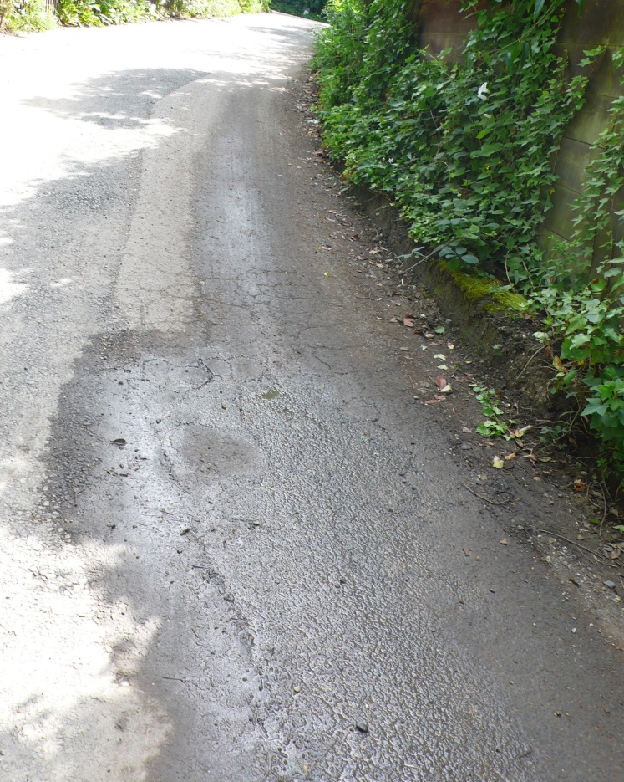
Appendix K

Figure 5 Photograph of a spring coming through the road in Highgate
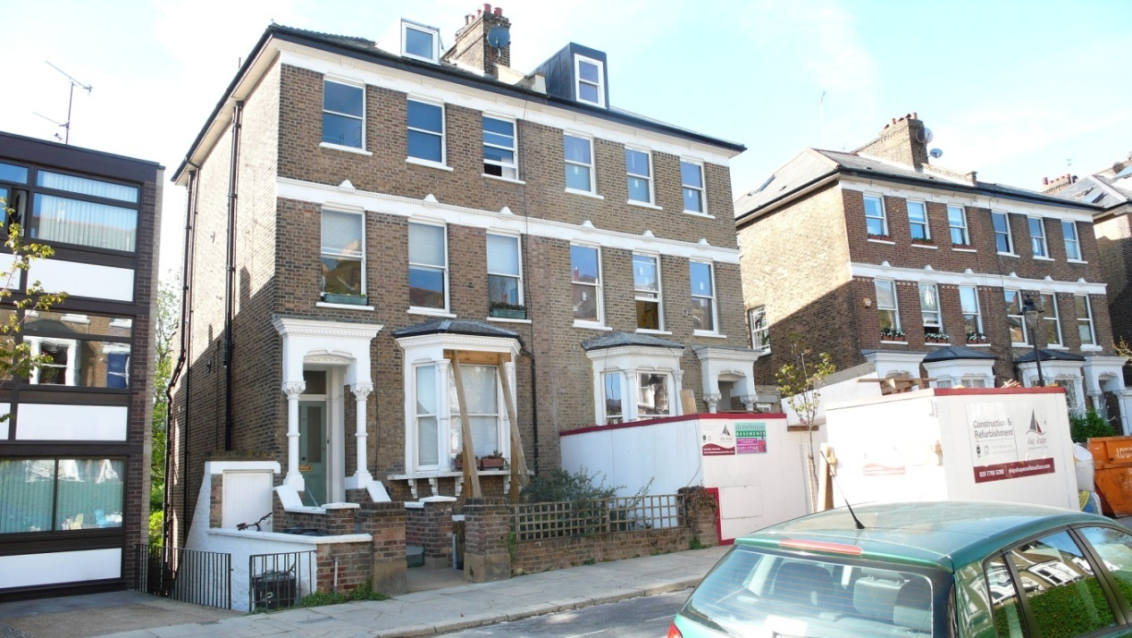
Appendix L

Figure 6 Photograph of a property in South Hill Park which required underpinning as a result of its neighbour constructing a basement
Appendix M
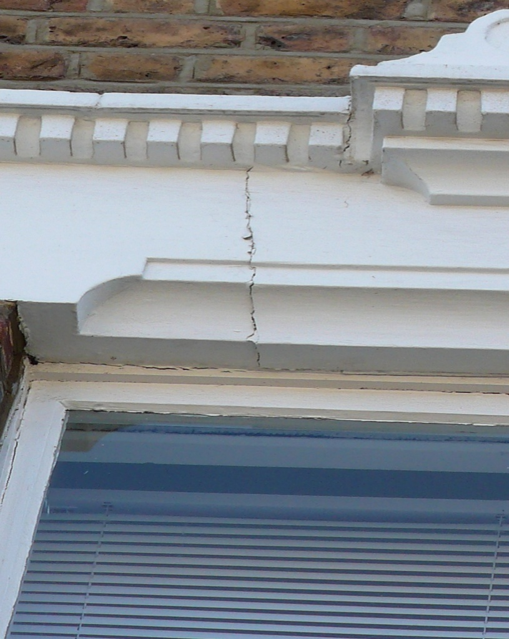

Figure 7 Photograph of a the cracking that occurred on a property in South Hill Park due to their neighbour constructing a basement

