
- Home

- Letters

- Gulliver

- Islington

- West End

- Arts & Entertainment

- Jobs

- Competitions

- Shop

- Area Guide

- Classifieds

- Search

- Directions


'Sinkhole' appears in New End sparking fears over impact of nurses' home development
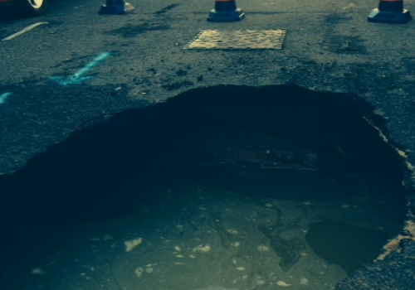
Water poured from the burst water main in New End this morning
Published: 6 January, 2015
By WILLIAM McLENNAN
A "sinkhole" has appeared in a Hampstead lane just yards from the site of a controversial development that will include a three-storey basement excavation.
A taxi fell through the 6ft hole in New End, caused by a burst water pipe, at around 7am this morning, blocking the road to traffic.
Residents in New End said it demonstrated "how fragile things are even just below the surface" of road and feared it would worsen with the demolition of the nearby nurses' home.
Developers Karawana were given the green-light this week to bulldoze the building and replace it with 17 luxury homes and multi-storey basement carpark.
ADVERTISING
inRead invented by Teads
The council had rejected the plans in 2013, but Karawna appealed and an inquiry by the Planning Inspectorate ruled on Monday that works could go ahead.
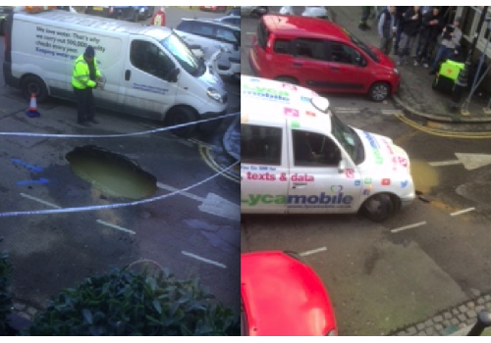
Thames Water are still working on the burst water main
Christina Moore, who lives in New End, said this was the latest in a long line of burst water mains, adding: "All this without the added impact of major disturbance caused by building work that will be the inevitable consequence of rebuilding the former Nurses' home."
She said the decision to override Camden Council and allow builders to move in had "outraged and demoralised" many in the Hampstead community.
She said the impact of excavating tonnes of earth to make way for the triple basement was a "huge worry," adding: "Is it too late for the developers and authorities to see sense and give serious consideration to the refurbishment and reuse of this handsome building?"
Thames Water are on the scene and pumping water from the hole. Works are expected to continue tomorrow to repair the broken pipe.
A spokesman said: “We’re really sorry to anyone affected by the burst pipe today.
“Our engineers have stopped the flow of water and are now focused on repairing the pipe and getting the road back to normal as soon as possible.”

