Crater big enough to fit a man in opens up in Hampstead
13:18 21 October 2011
By Josh Pettitt
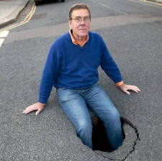
Cllr Chris Knight with his feet in the giant hole in Redington Road, Hampstead. Picture: Nigel Sutton
A vast hole in the road leading to an underground chasm opened up in Hampstead over the weekend.
Comment
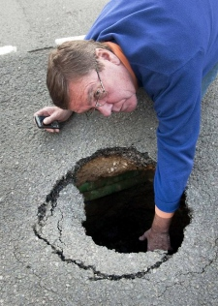The hole led to a much larger underground chasm. Picture: Nigel Sutton
Cllr Chris Knight discovered the apparent pothole in the middle of Redington Road on Saturday afternoon.
But it turned out to a small opening leading to a gaping cavern below – sparking renewed fears about the effects of basement developments on Hampstead’s foundations.
The former cabinet member for environment said: “The hole is big enough to swallow a small car.
“This is precisely the sort of thing that’s very worrying for people. It does not bode well for basement construction in the area if one small water flow can do this.”
He believes the hole formed because of sand being eroded over a long period of time.
He laid down a hazard sign and spent the next hour directing traffic around the hole until Camden Council made it safe.
A council spokesman said: “Work to repair the road, investigate the cause of the hole and to estimate the cost of repair will be carried out and the repair work will take two or three days to complete.”

